Name _______________________________
Date ________________________________
Activity 3
Exploring Data and Linear Equations

Objectives
In this activity you will:
- Develop and use correct mathematical vocabulary.
- Enter the equation of a line in slope-intercept form.
  - y = mx + b
- Calculate the slope, m, and y-intercept, b, of a line.
- Observe and investigate the effects of m and b on the graph of a line.
  - y = mx
  - y = x + b
- Enter data into lists.
- Be able to name lists.
- Create a scatter plot of the data.
- Find the Line of Best Fit by doing a Linear Regression on data.
- Look at the graphs and write your conclusion as to the effect m has on the lines.
- Use the Transformation Graphing Application to enhance your skills with slopes and y-intercepts.

Materials need:
- TI-84+SE
- Transformation Graphing Application

California Mathematics Standard:
Algebra 6.0: Students will graph a linear equation and compute the x- and y-intercepts (e.g., graph 2x + 6y = -4). They are also able to sketch the region defined by a linear inequality (e.g., sketch the graph defined by 2x + 6y < -4).

Overview:
In this lesson, students will explore linear equations, input data into lists, create scatter plots, use an application to further explore linear equations, and use correct mathematical vocabulary in explanations and discussions.

Vocabulary:
Cartesian Coordinate System Axes
Ordered Pair Plot Points
X-Coordinate Y-Coordinate
Domain Range
Independent Variable Dependent Variable
Abscissa Ordinate
Quadrants Graphing
Slope Intercept
Linear Equation Non-Linear Equation
Standard Form Slope-Intercept Form
X-Intercept Y-Intercept
X-intercept in Ordered Pair Form Y-Intercept in Ordered Pair Form
Prediction Estimation

We will begin by going over the graphs of liner equations. In order to graph equations on the TI-84+SE, the equations must be in slope-intercept form, y = mx + b.

Begin in Function (Func) mode and turn off any plots or equations previously turned on.  To turn off a plot, press □, use cursor keys () to move to the highlighted plot, and press .  To clear an equation, position the cursor anywhere in the right side of the equation, and then press ❻ | 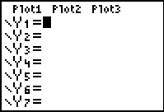  All Stat Plots are off and all equations are cleared.

Enter the equations into the □ screen. Look at the graph of Y₁ = -7X; Y₂ = -3X; and Y₃ = -1X.  Use the  to check values. | 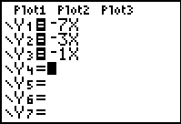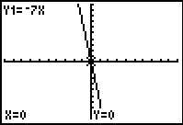  The equations are entered Y₁ = -7x  Separately.
What effect does m have on the lines? What would the lines look like if the slopes were positive? | 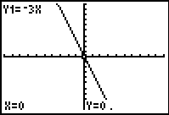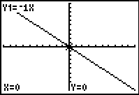  Y₂ = -3x Y₃ = -1x
Next, look at the graphs of  Y₁ = X - 5; Y₂ = X - 1; Y₃ = X + 5. | 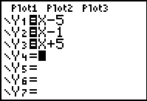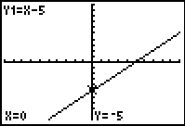  Y₁ = x – 5
What effect does b have on the lines? | 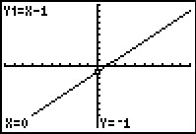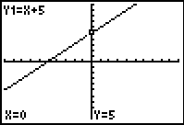  Y₂ = x - 1 Y₃ = x + 5

We will now look at data that you will enter into lists.

U. S. Life Expectancy at Birth

Birth Year | Female | Male | Combined
1940 | 65.2 | 60.8 | 62.9
1950 | 71.1 | 65.6 | 68.2
1960 | 73.1 | 66.6 | 69.7
1970 | 74.7 | 67.1 | 70.8
1975 | 76.6 | 68.6 | 72.6
1980 | 77.5 | 70.0 | 73.7
1985 | 78.2 | 71.2 | 74.7
1990 | 78.8 | 71.8 | 75.4
1995 | 78.9 | 72.5 | 75.8
1998 | 79.4 | 73.9 | 76.7
(2000 World Almanac, p. 891)

Questions:
- Which set of data will be your independent variable, or x-values?

- Which set of data will be your dependent variable, or y-values?

- Find the Minimum and Maximum values of the Domain and Range for each set of data.

Clear all lists by going to  4:ClrList , , , , ,  then press .  When entering the data into lists, you can use the generic L₁, L₂, L₃, and L₄. | 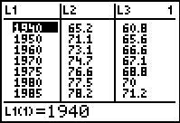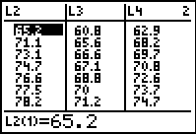  Standard Headings for Lists
Or you can enter the name as a title of the list. Go to the blank lists and enter the title of the list using only five letters. The lists have been changed to BYEAR for Birth Year in L₁, WOMEN for Female in L₂, MEN for Male in L₃, and COMB for Combined in L₄. | 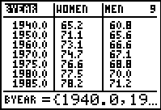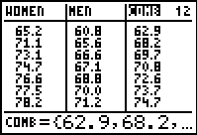  Changed Headings for Lists
Press  1 to select 1:Plot1 and press . Turn the plot on and enter the settings as shown in the diagram. For Xlist and Ylist, be sure to use the correct lists in which your data were entered. Press  9 to select 9:ZoomStat and display the plot using the data in the lists. | 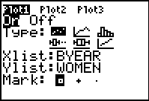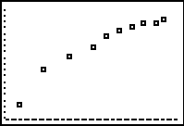  BYEAR vs WOMEN StatPlot using Zoom 9.  Remember to choose different marks for each Stat Plot.
Create Plot1 for BYEAR vs WOMEN and enter as in the diagram. Do as above. Create Plot2 for BYEAR vs MEN. | 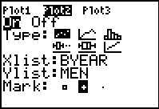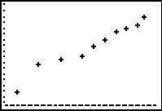  BYEAR vs MEN StatPlot using Zoom 9.
Create Plot3 for BYEAR vs COMB and enter as in the diagram. Do as before. | 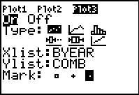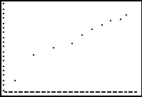  BYEAR vs COMB StatPlot using Zoom 9.

Display the three Plots by turning on all three ’s. What can you say about the three plots? Do you see any trends? Is there a consistent trend in the relationship between the birth year and women, men, and the combined data? | 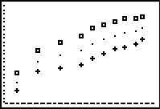  Turn on all Stat Plots and use Zoom 9.  Use ▫ for Women, ⁺ for Men, and . for Comb.
To find the Linear Regression Equation, go to  CALC 4:LinReg(ax+b) . Then …include _{L}BYEAR, _{L}WOMEN, Y₁  for the linear regression equation for BYEAR vs WOMEN. In the □ screen, the Linear Regression Equation is entered as Y₁. | 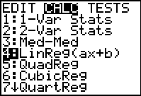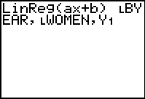  By putting Y₁ in the LinReg, the  equation will be entered into Y₁  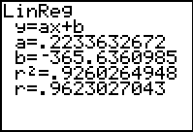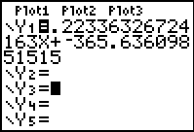
When you go to , press  9:ZoomStat.  Why would you use ZoomStat? Could you have used another method to plot BYEAR vs WOMEN? | 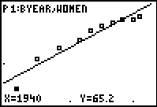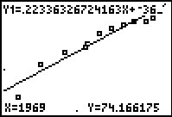

By using an application called Transformation Graphing, we will explore the slope and y-intercept of a linear equation in more depth.

Press ❶ key. Select Transfrm. (This may have a number, letter, or nothing in front of it depending on the number of applications you have loaded).  Press any key (except  or ) to install the application. | 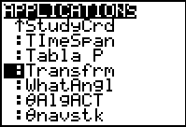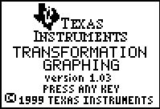  This is a built-in App for the TI-84+SE but can be loaded from the TI Website.
Begin in Function (Func) mode and turn off any plots or equations previously turned on. To turn off a plot, press □, use the cursor keys () to move to the highlighted plat, and press . To clear an equation, position the cursor anywhere in the right side of the equation, and then press ❻. | 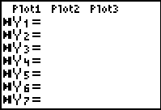  Plots turned off, equations cleared. Notice that the left-hand markings are different and note that this App will only graph one equation at a time.
Move the cursor to Y₁ = , and enter A   B | 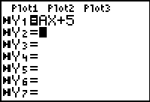  Initial starting set up. The only active variables in this App are A, B, C, and D.

Press  to display the plot with the app enabled. The line Y=AX+B is displayed with the most recent values of A and B. These values will probably have no relationship to your plot. Enter your estimated values for the slope and y-intercept for A and B. To enter these values, use the up and down cursor keys ( and ) to highlight either A= or B=. Adjust the values for A and B till you have a reasonable visual model. | 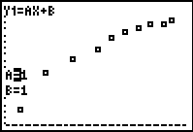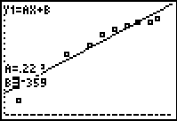  Initial set up After trial and error or using a strategy  to find the equation of the line.

Questions:
- As the value of A increases, what happens to the graph?

- As the value of A decreases, what happens to the graph?

- Would the value of A be negative? Why or why not?

- As the value of B increases, what happens to the graph?

- As the value of B decreases, what happens to the graph?

- Could the value of B be negative? Why or why not?

- Looking at y = mx + b, why do you think it is called the slope-intercept form of a line?

- What other strategy could you have used to find the equation of the line of best fit?

Name _______________________________
Date ________________________________
Student Worksheet
Exploring Data and Linear Equations
Life Expectancy
The table of values shows the relationship between the number of years a person might be expected to live and the year he or she was born. Life expectancy is a prediction that is very useful in professions like medicine and insurance.

U. S. Life Expectancy at Birth

Birth Year | Female | Male | Combined
1940 | 65.2 | 60.8 | 62.9
1950 | 71.1 | 65.6 | 68.2
1960 | 73.1 | 66.6 | 69.7
1970 | 74.7 | 67.1 | 70.8
1975 | 76.6 | 68.6 | 72.6
1980 | 77.5 | 70.0 | 73.7
1985 | 78.2 | 71.2 | 74.7
1990 | 78.8 | 71.8 | 75.4
1995 | 78.9 | 72.5 | 75.8
1998 | 79.4 | 73.9 | 76.7
(2000 World Almanac, p. 891)

Clear all lists by going to  4:ClrList , , , , , .  When entering the data into lists, you can use the usual L₁, L₂, L₃, and L₄. | Standard Headings for Lists
Or you can enter the name as a title of the list. The lists have been changed to BYEAR for Birth Year in L₁, WOMEN for Female in L₂, MEN for Male in L₃, and COMB for Combined in L₄. | Changed Headings for Lists
Press   1 to select 1:Plot1 and press . Turn the plot on and enter the settings as shown in the diagram. For Xlist and Ylist, be sure to use the correct lists in which your data were entered. Press  9 to select 9:ZoomStat and display the plot using the data in the lists. | BYEAR vs WOMEN StatPlot using Zoom 9.
Create Plot1 for BYEAR vs WOMEN and enter as in the diagram. Do as above. Create Plot2 for BYEAR vs MEN. | BYEAR vs MEN StatPlot using Zoom 9.
Create Plot3 for BYEAR vs COMB and enter as in the diagram. Do as before. | BYEAR vs COMB StatPlot using Zoom 9.

Display the three Plots by turning all three on. What can you say about the three plots? Do you see any trends? Is there a consistent trend in the relationship between the birth year and men, women, and the combined data? | Identify the three Stat Plots.
To find the Linear Regression Equation, go to  CALC 4:LinReg(ax+b) . Then …don’t forget to include _{L}BYEAR, _{L}WOMEN, Y₁ . In the □ screen, the Linear Regression Equation is entered as Y₁.
When you go to , press  9:ZoomStat.
Why would you use ZoomStat? Could you have used another method to plot BYEAR vs WOMEN?

- What is the unit of measure of the slope, m, for Birth Year vs Female? Birth Year vs Male? Birth Year vs Combined?

- What is the meaning of the slope of your model?

- What does b represent in your model? Explain what happens when b equals 0.

- Explain what the trend is as you look at the graphs.

- Which line would you use to predict the life expectancy of a person who will be born in 2022. Why?

- Compare the slope of your lines of best fit to the slope of the Regression Line for Female, Male, and Combined. What does the slope for each data tell you?

- Look up other occupations that use predictions and write a short paper on how predictions are used.

- Why do you think making predictions would be beneficial to a business.

Here are more real-world data for you to explore linear equations.

The table lists the concentration of dissolved oxygen (DO) in parts per million (ppm) at various temperatures in degrees Celsius (°C) from a sample of lake water.
Dissolved Oxygen
Temperature (°C) | DO (ppm)
17 | 8
15 | 9
13 | 11
16 | 10
11 | 14
13 | 11
10 | 14
8 | 14
6 | 16
7 | 13
8 | 14
4 | 17
5 | 15
9 | 13
6 | 16
(Data collected by using probes and sensors and a CBL2)

- Define the variables and enter the data into lists.
- Graph the data using .
- Use the Transformation Graphing Application to find the linear equation.
- Write an equation in slope-intercept form that models the data.
- Graph your equations to confirm that the line fits the data.
- Use your equation to predict the concentration of dissolved oxygen in parts per million when the water temperature is 2°C.
- Use your equation to predict the water temperature in degrees Celsius when the concentration of dissolved oxygen is 11 ppm.
- What would be the y-intercept for your equation? Does its real-world meaning make sense? Explain why or why not. Do the same for the x-intercept.
- Find the Linear Regression Line to double check your equation and predictions.

Carbon dioxide is one of several greenhouse gases that are emitted into the atmosphere from a variety of sources, including automobiles. The table shows the concentration of carbon dioxide (CO₂) in the atmosphere measured from the top of Mauna Loa volcano in Hawaii each January. The concentration of CO₂ is measured in parts per million (ppm).
CO₂ Concentration
Year | CO₂ (ppm)
1976 | 332
1978 | 335
1980 | 338
1982 | 341
1984 | 344
1986 | 346
1988 | 350
1990 | 354
1992 | 356
1994 | 368
1996 | 362
(Carbon Dioxide Information and Analysis Center)

- Define the variables and enter the data into lists.
- Graph the data using .
- Use the Transformation Graphing Application to find the linear equation.
- Write an equation in slope-intercept form that models the data.
- Graph your equation to confirm that the line fits the data.
- Use your equation to predict what the concentration of CO₂ will be in 2020.
- What would be the x-intercept for your equation? Does its real-world meaning make sense? Explain why or why not. Do the same for the y-intercept.
- Find the Linear Regression Line to double check your equation and predictions.

A scientist collected some data by using two thermometers simultaneously. The scientist suspects that one or both of the thermometers are somewhat faulty.
CO₂ Concentration
Celsius (°C) | Fahrenheit (°F)
14.5 | 55.0
20.0 | 67.0
28.4 | 86.7
39.5 | 105.6
32.3 | 87.1
29.0 | 81.6
26.2 | 82.3
25.7 | 75.2
31.2 | 88.6
(Carbon Dioxide Information and Analysis Center)

- Graph the data using .
- Which is the independent variable and dependent variable? Would your graph change if you exchanged the variables? Why or why not?
- Use the Transformation Graphing Application to find the linear equation.
- Write an equation for the data in slope-intercept form from the data.
- Graph your equations against the data previously plotted to confirm that the line fits the data.
- The freezing point for water is 0°C, which is equivalent to 32°F. The boiling point for water is 100°C, which is equivalent to 212°F. Use this information to write another equation in slope-intercept form that models the true relationship between the Celsius and Fahrenheit temperature scales.
- After comparing the equations, do you think the thermometers are faulty? Explain why or why not.

The table below shows the federal minimum hourly wage for 1974-1997.
United States Minimum Wage
Year | Hourly Minimum
1974 | $1.90
1975 | $2.00
1976 | $2.20
1977 | $2.30
1978 | $2.65
1979 | $2.90
1980 | $3.10
1981 | $3.35
1990 | $3.80
1991 | $4.25
1996 | $4.75
1997 | $5.15
(Bureau of Labor Statistics, U.S. Department of Labor)

- Identify the independent and dependent variables. Use  to plot the data.
- Find the line of best fit by using the data above.
- Use the Transformation Graphing Application to find the line of best fit. Then compare it with the model found before.
- Give the real-world meaning of the slope.
- Use your model to predict the minimum hourly wage for 2010.
- Predict when the minimum hourly wage would have been $1.00.

The table below shows the winning heights for the Olympic Women’s High Jump.
Women’s High Jump
Year | Champion | Country | Height (m)
1952 | Esther Brand | South Africa | 1.67
1956 | Mildred McDonald | United States | 1.76
1960 | Iolanda Balas | Romania | 1.85
1964 | Iolanda Balas | Romania | 1.90
1968 | Miloslava Rezkova | Czechoslovakia | 1.82
1972 | Ulrike Meyfarth | West German | 1.92
1976 | Rosemarie Ackerman | East Germany | 1.93
1980 | Sara Simeoni | Italy | 1.97
1984 | Ulrike Meyfarth | West Germany | 2.02
1988 | Louise Ritter | United States | 2.03
1992 | Heike Henkel | Germany | 2.02
1996 | Stefka Kostadinova | Bulgaria | 2.05
2000 | Yelena Yelesina | Russia | 2.01
(2000 World Almanac, p. 920, and www.olympics.com)

- Identify the independent and dependent variables. Use  to plot the data.
- Find the line of best fit by using the data above.
- Use the Transformation Graphing Application to find the line of best fit. Then compare it with the model found before.
- Explain whether or not you think the line of best fit is a good model for the data graphed.
- Give the real-world meaning of the slope.
- Use your model to predict the winning height for the 2012 Olympics to be held in England.

