
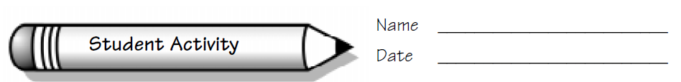
Focus: Relate fraction quotients and decimal quotients.
Patterns in Division
Collecting and Organizing Data
# of Cookies  (Dividend) | # of People  (Divisor) | Integer Quotient and Remainder | Fraction Quotient | Decimal Quotient

Analyzing Data and Drawing Conclusions
After you have collected the data in the chart above, discuss this exercise as
a group and record your findings. Enter any questions you come up with in the space below, and be prepared to discuss them.
Think of a situation in which you might want to use the constant function. Write about it.

Questions we thought of while we were doing this activity:

Patterns in Division
Cookies
