Open the TI-Nspire document Visualizing_Integers.tns.  This activity uses a virtual balance scale to let you explore equations involving positive and negative integers.  Click on the question mark on bottom right of the screen to see directions again. | 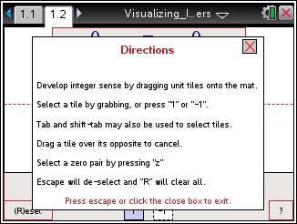

Move to page 1.2. | Press / ¢ and / ¡ to navigate through the lesson.
1. Move two tiles to the left side of the platform on the balance-scale. Describe the changes that you observe.

2. Move one tile to the right side. Describe the changes that you observe.

3. How do you know from the balance-scale that the values are unequal?

4. What tiles can you add to balance the scale? Illustrate or describe your strategies to support your answer.

Click on the Reset box at the bottom left of page 1.2 to reset all tiles to a position below the platform.
5. What value makes the statement –1 + _?_ = 1 true? Move tiles to represent this number sentence. Then explain how the balance-scale confirms that it is true.

6. What value makes the statement –1 + _?_ = –3 true? Move tiles to represent this number sentence. Then explain how the balance-scale confirms that it is true.

Click on the Reset box at the bottom left of page 1.2 to reset all tiles to a position below the platform.

7. In how many ways can you use four tiles to make a true statement? Write each of the possible number sentences represented by your tiles.

8. Using what you learned in questions 1 through 7, fill in the blank with the value that makes each of the following true.
a. –2 + ______ = 0 | b. 3 + ______ = 0 | c. 38 + −20 +______ = 0

9. Use six tiles on one side of the scale to make a true statement. Describe your reasoning. Then draw a sketch of the model that you created.

10. Is it possible to balance the scale using five tiles? Justify your answer.

