Introduction
When you drop a basketball, it does not rebound to the same height from which you dropped it. But how high does it bounce? The rebound height of a basketball can be used to determine whether the ball is inflated to the correct pressure. You will sometimes see basketball referees drop the ball from a certain height to see if it rebounds correctly prior to officiating a game.
In this activity, you will determine the rebound percentage of a ball and how that percentage and the drop height relate to the height of a ball bounce as a function of bounce number.
Before collecting data, predict how the graph of bounce height as a function of bounce number would look. Sketch your prediction to the right. Be sure to label the axes.  Write a sentence to explain why you think the graph will look like your prediction. | 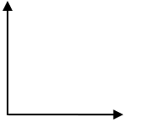
Setup
- This activity is best performed with at least three students: one to hold the CBR™ 2 and press the trigger, one to release the ball, and one to run the handheld.  - Lift the pivot head on the CBR 2 and set the sensitivity on the CBR 2 to Normal. | 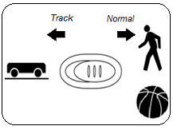
- Open a new document on the TI-Nspire™ CX handheld. Connect the CBR 2 to the handheld with the USB CBR 2 to handheld cable. The Vernier DataQuest® App should open.  Note: The default unit of measurement for the CBR 2 in the DataQuest App is meters. | 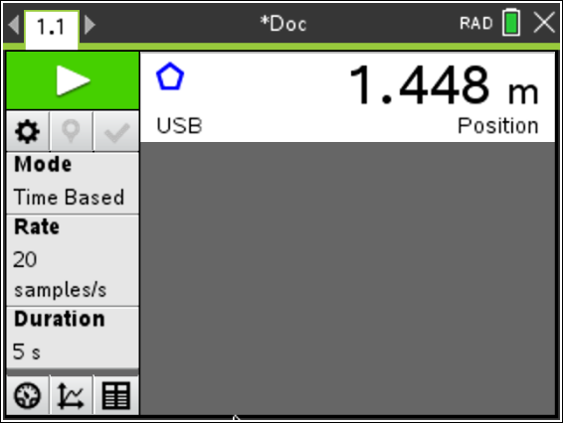
- Practice dropping the ball under the CBR 2. This is a practice run to determine if the ball is bouncing on a flat surface.  - Position the CBR 2 at least 15 centimeters (approximately 6 inches) above the ball.  - Hold the sensor directly over the ball and make sure that there is nothing in the Clear Zone.  - Hold the sides of the ball and then quickly move your hands outward to release the ball. Drop the ball (do not throw it). | 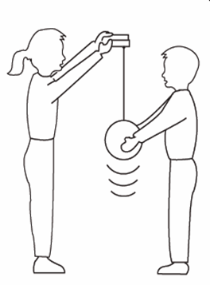
Data Collection
- You cannot place the motion sensor on the floor and bounce the ball on it, but you can reverse the positions so that the data will appear as though it was collected with the floor as the zero height.  - Set the CBR 2 to a fixed height approximately 1.5 meters above the ground.  - Select Menu > Experiment > Set Up Sensors > CBR 2/Go!Motion, and then select Zero.  Note: Be sure to hold the CBR 2 at this height when collecting data.  - To reverse the readings, select Menu > Experiment > Set Up Sensors > CBR 2/Go!Motion.  - Select the Reverse Readings setting, and then click OK. |  | 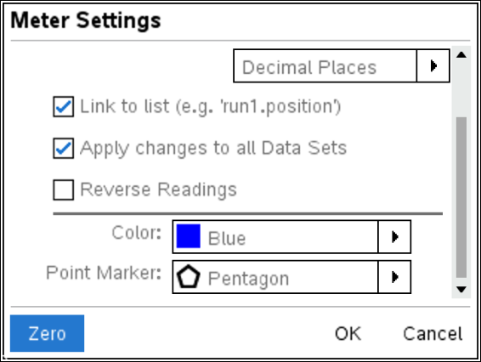  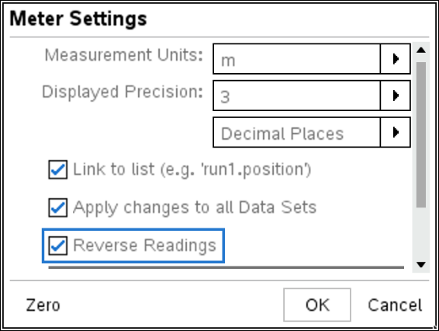
- To show only the position versus time graph, click the Graph View tab . Select Menu > Graph > Show Graph > Graph 1. |  | 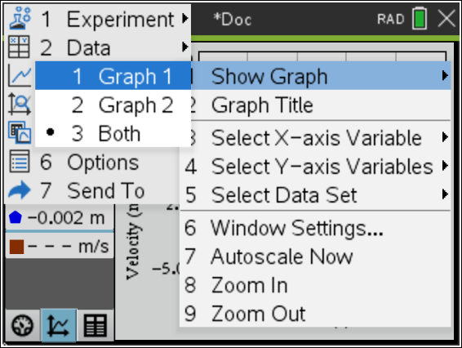  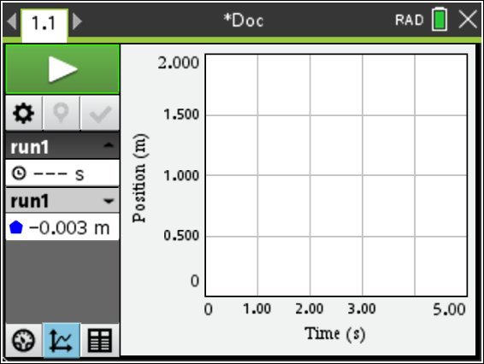
- Press Tab until the Start Collection button  is highlighted. One person holds the CBR 2 while another person holds the ball at least 15 centimeters beneath the CBR 2. Start the data collection by pressing Enter just before dropping the ball. You want the CBR 2 to record the initial height of the ball as well as the bounce heights.
- The position versus time graph should contain a series of at least five parabolas. If it does not, try again. (If it’s necessary to repeat the data collection, press the Start Collection button again.) Show the graph to your teacher before proceeding to the next section of the activity. Once your graph is approved, send the document to your other group members.
Data Analysis
- Use the tracing cursor to determine the maximum height of the first bounce. Record it in the data table as the maximum height for Bounce Number 1. Then move the cursor to each successive maximum bounce height, and record the maximum heights of bounces 2 – 5 in the table below.
Record each maximum bounce height in meters, rounded to three decimal places.
Bounce Number | Maximum Bounce Height (m) | Ratio of Bounce Heights
1 | H₁ =
2 | H₂ =
3 | H₃ =
4 | H₄ =
5 | H₅ =

- Examine the maximum bounce height data in the table. Is the relationship linear? How can you tell?

- Is the relationship quadratic? How can you tell from the differences in heights?

- Divide each bounce height by the previous bounce height. For example, divide the height of Bounce 2 by the height of Bounce 1. Write each ratio as a decimal value, rounded to two decimal places, in the right column of the table.

- What do you notice about the bounce height ratios shown in the right column of the table?

- Find the average of these bounce height ratios. _____________________
- How could you use the average of the bounce height ratios and the height of the first bounce (H₁) to estimate the drop height of your ball? Show your work and record the drop height (in meters). Round your answer to two decimal places.
Estimated Drop Height = _______________

- If you didn’t know the height of the first bounce, H₁, you could use the average of the bounce height ratios and the estimated drop height of your ball to predict that height.
H₁ = (drop height) * (average bounce ratio)

If you didn’t know the height of the second bounce, H₂, you could still use the average of the bounce ratios and the estimated drop height of your ball to predict the height of the second bounce.
Since H₂ = (H₁) * (average bounce ratio), we know that
H₂ = ((drop height) * (average bounce ratio)) * (average bounce ratio)

How could you predict the height of Bounce 3 using only the estimated drop height and the average bounce ratio?
H₃ = ________________________________________________________________________

- Using only your estimated drop height and the average of your bounce ratios, write an equation for each bounce height in the table below.

H₁ =
H₂ =
H₃ =
H₄ =
H₅ =

- Exponential decay (this type of relationship) and exponential growth occur when an amount decreases or increases, respectively, at a rate proportional to the preceding amount. An exponential function has the form y = a(b)^{x}. In this example, b is the average rebound percentage written as a decimal. What does a represent?

- Write the equation for the height of the ball at any bounce as a function of bounce number, x, for your data.

y = _____________________
- To check your equation, create a graph of bounce height as a function of bounce number. Enter the data into the Lists & Spreadsheet application by adding a new page to the document. Press / ~ to add a new page, and select Add Lists & Spreadsheet.  - Name the first column number and the second column height.  - Enter bounce numbers 1 – 5 in the number column.  - Enter the maximum heights of bounces 1 – 5 in the height column. | 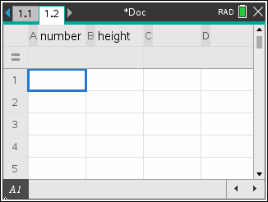
- Add a new page and select Add Data & Statistics. Click on the horizontal axis and select number for the independent variable. Click on the vertical axis and select height for the dependent variable.
- Sketch the graph of your data at the right.  - How does it compare with the prediction that you made prior to data collection? | 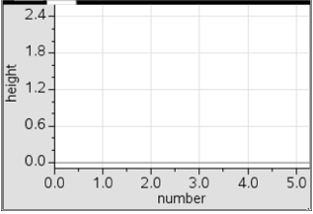
- Check to see how well the equation you found in Step 11 matches the data.
- On the Data & Statistics page, select Menu > Analyze > Plot Function.
- Enter your equation for the maximum bounce height as a function of the bounce number. You must use x for the bounce number in the equation. Press · to graph.
- Is the function you entered a good model the data? If not, make adjustments in the equation, and regraph. If any adjustments were made, record your new equation.

- Use your equation to predict the height of a tenth bounce. Show your work. Is your answer reasonable?
- Jackie bounced a different type of ball and determined that it had an average rebound percentage of 71%. Her drop height was 1.45 meters.

- Write an equation for bounce height, y, as a function of bounce number, x.

- Predict the height of the ball’s 7th bounce.

- At what bounce number would the height of the bounce be approximately 0.5 meters?

