Introduction
Linear approximation uses a tangent line to estimate values of a function near the point of tangency. For this reason, linear approximation is also referred to as tangent line approximation.
On the graph to the right, let the graph let a be the point where the tangent touches the graph, L(x) be the tangent and f(x) be the function.  On the picture, the point x is the x coordinate of the vertical line.  Draw a vertical line from a to the x-axis.  Draw horizontal lines from a, f(x), and the intersection of the vertical line with the tangent line. | 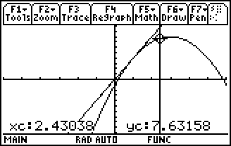
At this stage, you should have three points on the y–axis: f(a), f(x), L(x). Label them.
- Which of these points can you use to represent the estimate, or linear approximation, of f(x) near a?

- How can you use these labels to represent the error associated with this estimate?

- Is this estimate an overestimate or an underestimate? Explain.
Investigating linear approximation
On the graph at the right, f1(x)=x³– 3x² – 2x + 6 is shown. The tangent line at a = –1 is L(x)=7x+11. The trace object q is at the point (0.2, 5.488).  If you draw a vertical line from the x–axis through this point, you will get the point p = (0.212658, 12.4886).  The distance pq=7.039997 or 7.04. | 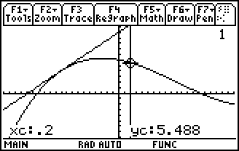
- What numerical value represents the linear approximation of f1(q) near a = –1?

- What numerical value gives the error associated with this linear approximation?

- What is the true value of f1(q)?

- Is this an underestimation or an overestimation?
Repeat the process above and complete the table below for the x-values given.
 | p | distance  pq | linear approx.  of f1(q) | real value  of f1(q) | error | underestimation/  overestimation
x = –0.2
x = –0.5
x = –0.6
x = –1.2

- At what x-value(s) is the error less than 0.5?

- What do you notice about graph of the function and the graph of the tangent line as you get close to the point of tangency?

- Based on your observations, explain why the relationship between a tangent and a graph at the point of tangency is often referred to as local linearization.

Typically, you will have a function but not a graph to find the linear approximation.
- Find the derivative of f1(x)= x³ – 3x² – 2x + 6. Evaluate it at x = –1. This is the slope of the line. Use the slope and the point (–1, 4) to get the equation of the line.

- The tangent line L(x) =

- What is L(–1.03)? What does this value represent?

- Calculate the error with this estimate.

Underestimates versus overestimates
Graph the function f1(x) = x³ – 3x² – 2x + 6 and place a tangent line a = 1.
- If you were to draw a point p on the graph to the left of a = 1, is the approximation an overestimate or an underestimate?

- If you draw a point p on the graph to the right of a = 1, is the approximation an overestimate or an underestimate?

- What is the significance of the point of tangency?

- Generalize your findings about when a linear approximation produces an overestimate and when it produces an underestimate.

Finding intervals of accuracy
Suppose we have the following question.
How close to –1 must x be for the linear approximation of f1(x) = x³ – 3x² – 2x + 6 at a=–1 to be within 0.2 units of the true value of f1(x)?
Graph f2 = f1 + 0.2 and f3 = f1 – 0.2 with f1 and the tangent line.
- How would you use the graphs to answer the question posed in this problem?

- How close to –1 must x be for the linear approximation of f1(x) = x³ – 3x² – 2x + 6 at a = –1 to be within 0.2 units of the true value of f1(x)?

Now we want to ask the same questions when the point of tangency is at a = 1.
- How does this situation differ from the one we just had?

- Use graphical or algebraic methods to find an interval that ensures the linear approximation at a = 1 is accurate to within 0.2 units of f1(x).

