Vertical and Horizontal Translations
by – Laura Harney, Whitesboro High School, Marcy, NY

Activity overview
Students will analyze function graphs to determine the family of functions, the parent function, and the translation performed.

Concepts
Functions
Parent Functions
Translations
Domain
Range

Teacher preparation
Load the verticalandhorizontaltranslations.tns file onto all student calculators.
The Vertical and Horizontal Translations.doc is a handout for the students to record their answers on as they work through this activity. A worksheet key, Vertical and Horizontal Translations key.doc, is also provided for teacher use.

Classroom management tips
The instructor should direct students to open the verticalandhorizontaltranslations.tns file. Once students have opened the file, the teacher should monitor the students, assisting them as needed. This activity was designed to be student-centered and may work well with students arranged in pairs. A worksheet has been provided for completion by the students.

TI-Nspire Applications
Graphs & Geometry, Notes

Step-by-step directions

This activity was designed to guide students through an exploration of several different functions with the intention that seemingly complicated-looking functions may become viewed as simply horizontal and/or vertical translations of much more familiar functions.

Begin by calling on students to name functions that have already been studied:
Linear, absolute value, power (quadratic, cubic), exponential, and logarithmic

A good exercise for both mind and body is to get students up and “graphing” the basic functions above by using their arms rather than just grabbing their handheld and entering the function. Students should be familiar with parent functions, the most basic graphs of a family of functions before translations.

Students will be shown a function as listed on the document and then asked:
a. to determine to which family of functions it belongs,
b. to determine the parent function, and
c. to describe the vertical and horizontal translation that would map the parent function to the
given function.

Since it was intended that students would begin by counting spaces from the parent function to the given function to determine the vertical and/or horizontal translation, page 2.1 contains an empty coordinate plane with the grid turned on so that students may determine the appropriate scale which has been used in all graphs in this activity.

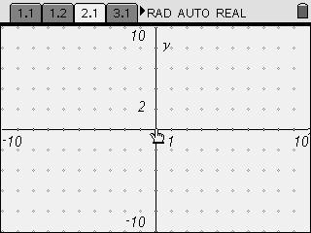

It is important to note here that each function graphed is immediately followed by its parent function.
Therefore, students should have already recorded the function’s family and parent function before proceeding. The graphing of the parent function provides a check to students and also aids them in calculating the translation.

Example:
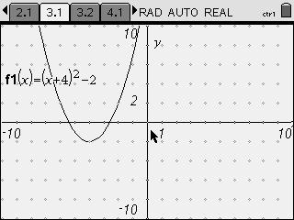
1. Students will look at this graph and determine
that the family of functions is the quadratics.
The parent function would be f(x) = x²

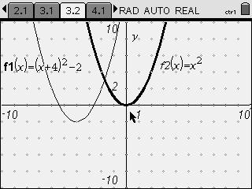
2. On the following page, students can check
their solution for the parent function and then
use the graph of the parent function to
identify (count) the translation.

From the vertex of the parent function,
count left 4 units and down 2 units to
meet the vertex of the given function.

Ultimately, students will be able to generalize a rule for determining if the translation of a function will be a left-right or an up-down shift.

Assessment and evaluation
- Collect student documents and evaluate with teacher answer key provided or assess students orally in a whole group discussion upon completing the activity. Challenge students to generalize what they have observed.

Activity extensions
- For each function graphed, have students identify the domain and range.

Student TI-Nspire Document
verticalandhorizontaltranslations.tns

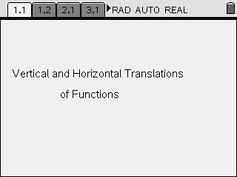 | 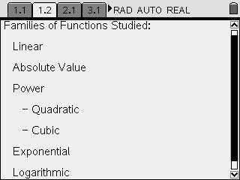

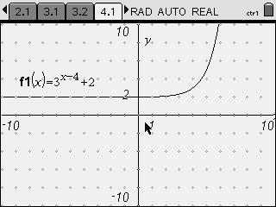

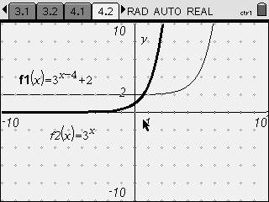 | 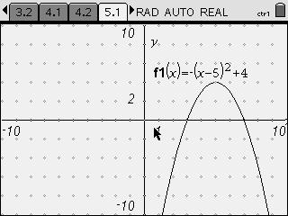 | 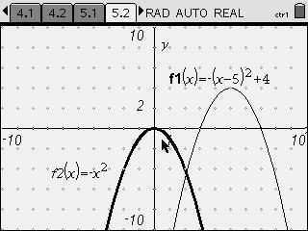

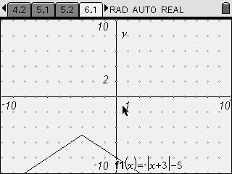 | 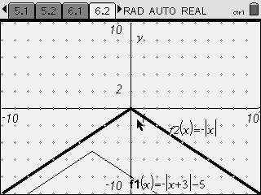 | 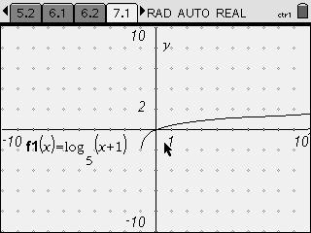
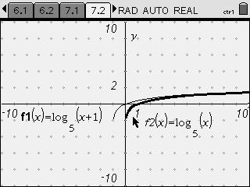 | 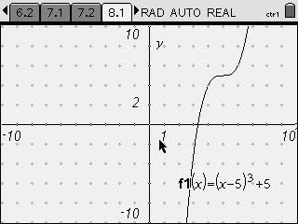 | 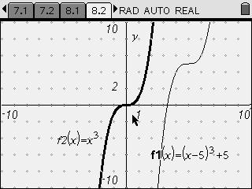
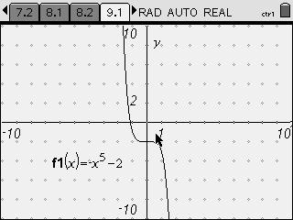 | 