In this activity, you will investigate the inverse of an exponential function. You will also investigate the symmetry of the exponential function and its inverse. | 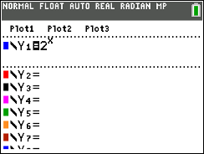
Problem 1 – Reflecting an Exponential Function
- Enter the exponential function $f\left(x\right)=2^{x}$ on the o screen. Then press q and select 4: ZDecimal.  A function is invertible if each output value is mapped from a unique input value. Is the function $f\left(x\right)=2^{x}$ invertible? What would the inverse of this graph look like? Sketch the function $y=2^{x}$ and its inverse on the grid to the right. | 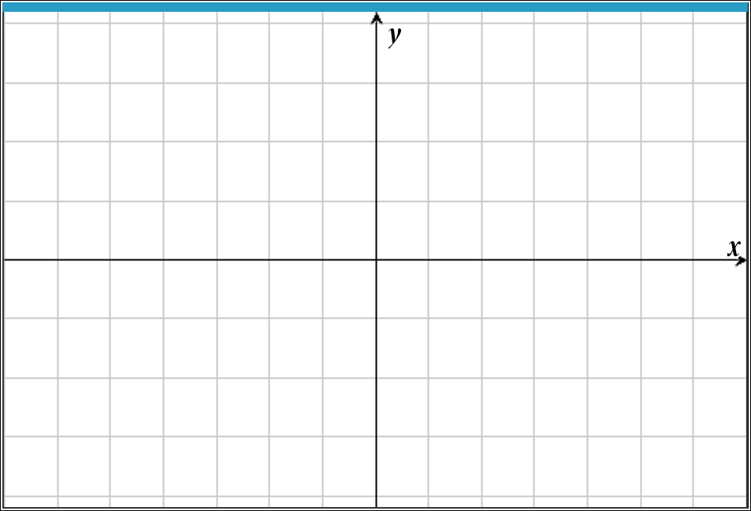
- Press y [table] to access a table of values for your function.

Record the y-values under the original y-value column in the table below. Recall that if the function $f\left(x\right)=2^{x}$ consists of input-output pairs $\left(a,b\right),$ then the inverse function consists of input-output pairs $\left(b,a\right).$ Record the inverses of each point by switching the x- and y-values and recording the results in the inverse columns in the table below.
Original x-value | Original y-value | Inverse x-value | Inverse y-value
–2
–1
0
1
2
3

- Plot these inverse points by pressing … and selecting 1: Edit. Enter the inverse values in L1 and L2.  To set up the scatter plot of the two lists, press y [stat plot] and match the screen to the right. Now press s to observe the plotted values.  Do your plotted points appear to be on the graph of the inverse function that you sketched in Question 1? | 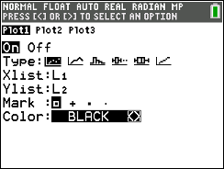
4. The inverse of a general exponential function $f\left(x\right)=b^{x}$ is a logarithmic function of the form
$g\left(x\right)=\log_{b}x.$ Write the inverse function of $f\left(x\right)=2^{x}$.

5. Check your result by graphing this function in Y2 to see if it passes through all the plotted points. Also graph the identity function Y3 $=x$. Are the two graphs symmetric with respect to the line $y=x?$

Note: The $\log_{b}x$ is found by pressing » and A: logBASE(.
Problem 2 – The inverse of $f\left(x\right)=e^{x}.$ This function has a natural base of e.
6. Graph Y1 = $e^{x}$. Repeat the steps in Problem 1 using $f\left(x\right)=e^{x}.$
What is the inverse function of $f\left(x\right)=e^{x}?$
Note: The inverse of $f\left(x\right)=e^{x}$ is called a Natural Logarithmic function.

Problem 3 – The inverse of $f\left(x\right)={10}^{x}$.
7. Graph Y1 = ${10}^{x}$
Find the inverse function of $f\left(x\right)={10}^{x}$. Check the symmetry of the function and its inverse by graphing.
Note: The inverse of $f\left(x\right)={10}^{x}$ is called a Common Logarithmic function.

