Algebra II and the TI-83+

By Kim Clark (kimclark@waynecc.edu)

This session will examine how the TI-83+ can be used to improve instruction in Algebra II classes. We will look at different objectives from the Algebra II curriculum and examine several ways that calculators can improve student performance.

Logarithms and Exponentials

Evaluating logs can be done using the LOG or the LN keys. To find the value of Log 34 simply press the LOG key and then type in the number and hit enter.

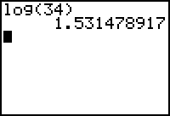

The same is true of LN.

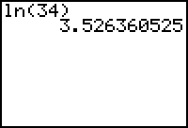

In order to emphasis the meaning of logarithms, let students then raise the value of the log to the base power.

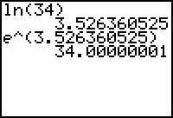

To evaluate at different bases, use the change of base formula.

Ex: ${\text{log}}_{5}\text{25}=\frac{\text{log}\text{25}}{\text{log}5}$

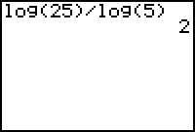

When investigating the meaning of logs, let students look at the graphs and trace to investigate for answers.

Example: pH = $−\text{log}x$ is the formula for the pH of a solution where x is the concentration of hydrogen ions in the solution in moles per liter. When will the pH be 1.5? Shown below are the screens used.

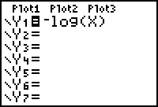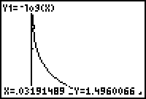

Many of the same ideas can be used for exponentials.

Ex: Soup is taken from the stove and placed in a room. The temperature, T of the soup after t minutes is given by,$T=\text{75}+\text{120}e^{−0\text{.}\text{051}t}$. Trace to find the temperature of the soup when it was first taken form the oven, when will it be $\text{85}°$? Will it ever be $\text{60}°$?

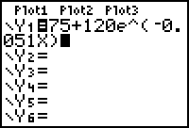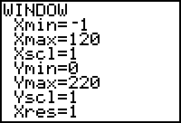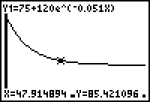

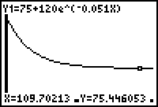

Factoring

Factoring problems can be checked on the TI83+. The calculator will not check for common factors, but students can gain confidence by checking answers.

Ex. Factor $6x^{2}+\text{17}x−\text{14}$. Is the answer $(3x−2)(2x+7)$?

Have students type the problem into $Y_{1}$ and the answer into $Y_{2}$, then darken the line for the solution as shown.

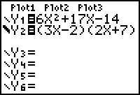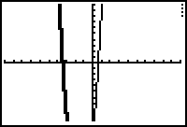

Notice that the second line is darkened by entering with the cursor located to the left of Y=. If the two graphs line up the answer is correct. This can also be used for rational expressions.

Ex: Simplify $\frac{x^{2}}{x+7}−\frac{\text{49}}{x+7}=x−7$?

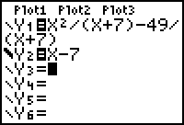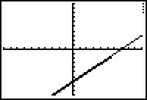

Circles, ellipses, parabolas, and hyperbolas

These can be addressed by using an APP.

To access this APP hit the APP key. Cursor down to Conics, and choose the one you want to graph. Below are a few examples. You may have to hit quit to get out of the app.

Graph $(x−3)^{2}+(y+4)^{2}=\text{25}$.

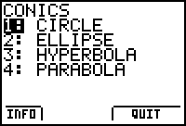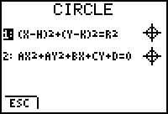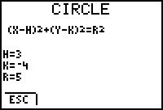

Press graph. 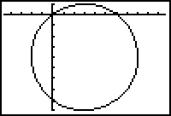

Notice that the calculator reinforces the ideas about graphing the circle because students must know which sign to take for h and k and also to square root in order to get the radius.

Ex: Graph $x^{2}−4x+y^{2}+6y=2$

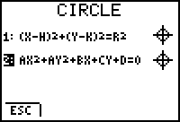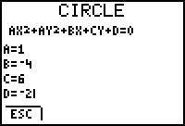

Now try graphing these problems yourself.

1. $x^{2}+y^{2}=\text{25}$

2. $x^{2}−y^{2}=6$

3. $y^{2}+2x^{2}=4x+6$

4. $\frac{(y−4)^{2}}{4}+\frac{(x+5)^{2}}{\text{16}}=1$

5. $x^{2}+4x=y$

Notice that students still need to be able to recognize the different types of equations.

Function notation

Function notation is most easily addressed through the equation editor, or y=. It is possible evaluate functions and compositions of functions.

Ex. $f(x)=3x−6$. $g(x)=x^{2}$. Find $f(4)$. Find $g(f(3))$.

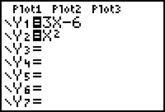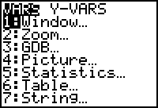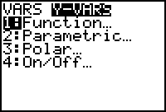

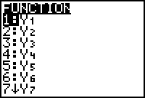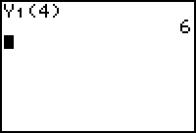
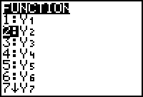

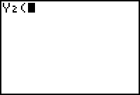 Repeating steps to get, 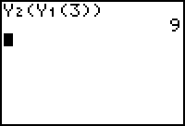

To examine a function and its inverse, graph both and then press zoom square. Look at the table, and finally evaluate the composition.
Example: Are $y=3x−1$ and $y=\frac{x+1}{3}$ inverses?

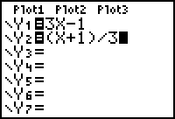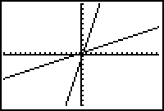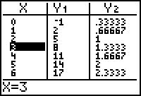

Note that one function contains (1,2) and the other contains (2,1).

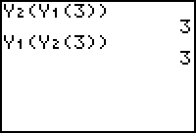 Compositions can be used to check for inverses.

