Days Between Dates
Generally, the term of a financial contract is stated in days, months, or years. In this activity, students will determine the number of days between dates and find the amount due on a loan at the end of a term. | Objectives:
- Determine the number of days between dates.
- Determine the amount due on a loan at the end of a term.
Example:
If you borrow $4,000 from December 1, 2023 to January 15, 2024 at an annual simple interest rate of 12%, how much is due January 16, 2024?
- In this example, we need to calculate the number of days between two dates, 12/1/2023 to 1/15/2024. Press Œ and select Finance.  Choose dbd( from the CALC menu.  The syntax is dbd(beginning date,ending date) where the beginning date is 12.0123 and the ending date is 01.1524.  Note that the U. S. date format is MM.DDYY where  MM is the month number,  DD is the day of the month,  YY is the last two digits of the year.  The years must be between 1950 and 2049. A period Ë must be placed between the entries for month and day and a comma ¢ must be placed between the beginning date and the ending date. |  | 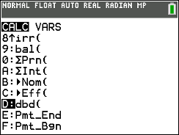  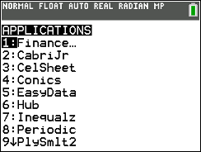
- Input the month for the beginning date, then enter a period followed by the day and year. Enter a comma, and then input the ending date in the same manner.  Press Í. The number of days between the two dates is 45. |  | 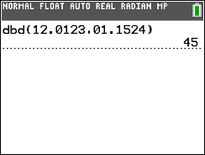
- Use this result to calculate the amount due on January 16. The amount includes the principal and the interest for the 45-day period.  $4,059.18 is due on January 16.  Note: The mode DECIMAL SETTING was changed to FIX2 to round the computation to two decimal places.  To change the Mode to FIX2, press z, arrow down to the DECIMAL SETTING row, arrow to the right to highlight 2, and press Í. |  | 