About the Lesson  A pendulum moves so that the pendulum bob is directly across from a CBR™ 2 motion sensor. Distance and time data are collected for several swings. The graph of the data can be modeled by a sinusoidal function.  Students will:  - Collect and graph distance versus time data for several swings of a pendulum.  - Model the graph of the data with a sinusoidal function of the form f(x) = a(cos(b(x - c))) + d.  Vocabulary  - Mean of the distance data  - Sinusoidal function  - Amplitude and period of a sinusoidal function  - Vertical and horizontal translations  Teacher Preparation and Notes  - This activity provides an opportunity for math-science connections.  - Students should be familiar with sinusoidal functions and their characteristics as well as vertical and horizontal translations.  - This activity is best performed in groups of three: One person will operate the calculator, one person will hold the CBR 2, and the third person will pull and release the pendulum.  Activity Materials  - CBR 2 motion sensor, USB CBR 2 to calculator cable, and TI-84 Plus CE  - String (approximately one meter long) and pendulum bob (ball or other mass)  - Recommended: TI-SmartView™ CE Emulator Software for the TI 84 Plus Family | 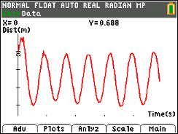  Tech Tips:  - This activity includes screen captures taken from the TI-84 Plus CE. It is also appropriate for use with the rest of the TI-84 Plus family. Slight variations to these directions may be required if using other calculator models.  - Access free tutorials at http://education.ti.com/calculators/pd/US/Online-Learning/Tutorials
Activity Overview
This activity will introduce the Calculator-Based Ranger™ 2 motion sensor and the Vernier EasyData® App. You will collect distance and time data using a swinging pendulum and fit a model to the data.
Background Information
Pendulum motion has fascinated people for hundreds of years. Galileo studied pendulum motion by watching a swinging chandelier and timing it with his pulse.
In 1851, Jean Foucault demonstrated that the earth rotates by using a long pendulum which swung in the same plane while the earth rotated beneath it.
Equipment
- TI-84 Plus CE
- CBR 2 motion sensor
- USB Connection Cable for CBR 2 motion sensor
- Note: To plug the CBR 2 into the computer, a mini-standard USB adaptor is needed.
Materials for Each Group
- String (approximately one meter long) and pendulum bob (ball or other mass)

Set Up
Step 1:  Connect the CBR 2 to the TI-84 Plus CE with the USB cable. If the EasyData® App does not open, press Œ and select EasyData. The CBR 2 will begin collecting distance data, the distance of the closest object from the CBR 2.  Note: In the EasyData App, the tabs at the bottom of the screen indicate the menus that can be accessed by pressing the calculator keys directly below the tabs. |  | 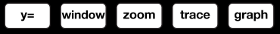  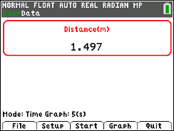
Step 2:
Work in groups of three. One person will operate the calculator, one person will hold the CBR 2, and the third person will pull and release the pendulum.
Step 3:
Hang the pendulum bob from a rigid support or over the edge of a desk or table. Arrange the support so the bottom of the pendulum bob clears the table or other surface by several centimeters.
Position the CBR 2 so that it points at the pendulum bob.
Questions (before data collection)
- Pull the pendulum back from its at rest position, release it, and observe its swing. What is your estimate for the straight-line distance between the two extreme points of the pendulum’s swing? Record this estimate.

- Estimate the distance of the pendulum bob from the CBR 2 when the pendulum is at rest. Record this distance.

- What is the approximate time for one swing of the pendulum? (Consider recording the time for multiple swings and then determine the average time for one swing.)
Step 4:  Before collecting data, make a prediction of what the graph of distance versus time should look like for several swings of the pendulum. Sketch your prediction on the graph to the right. |  | 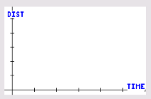
Step 5:
When ready to collect data, the calculator operator should press the q key to select Start.
Step 6:
A graph of distance versus time is displayed.
How does the graph compare with your prediction?
Step 7:
Sketch the actual graph of your distance versus time graph on the graph to the right. Label the tick marks on each axis.
Step 8:  Exit the EasyData App by pressing s to select Main. Press s again to select Quit.  - The screen indicates data lists. Time is in L1, distance in L6, velocity in L7, and acceleration in L8.  - Press s to select OK.  - The connection cable can be removed from the calculator. |  | 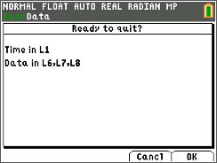
Step 9:  - Press y ,. If Plot 1 is not turned on with the configuration shown at the right, turn Plot1 on with L1 and L6 for the Xlist and Ylist, respectively.  - Press q ® to select ZoomStat, and your data will be displayed. |  | 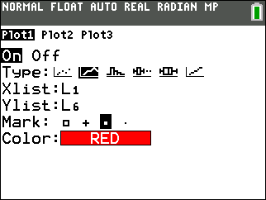
Step 10:  - Press o. Enter Y1 = cos(x), and press s.  - Note that the function does not fit the data well. The function will need to be transformed. |  | 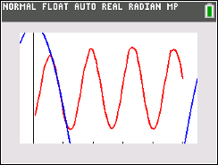
Step 11:  - Press y 5 to go to the Home Screen.  - Determine the mean of the distance data by pressing y 9, arrow to MATH, and select mean(. Enter y i ¤, and press Í.  - Record the mean rounded to two decimal places. ________  Sample Answer: 0.66 meters |  | 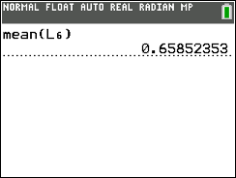
Step 12:  Press o. Enter the mean of the distance data to the right of Y2 =. Press s. |  | 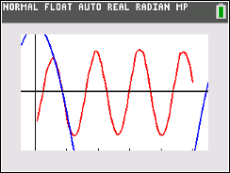
Questions
- How does the mean of the distance data relate to the motion of the pendulum?

Answer: This is the distance from the CBR 2 to the pendulum ball when the pendulum is at rest.

How does the mean of the position data compare to your answer to Question 2?

Answer: The values are similar.

Note: The general form of the cosine function is f(x) = a(cos(b(x - c))) + d. In the equation f(x) = cos(x), the parameters have these values: a = 1, b = 1, c = 0, and d = 0.
Do not change the values of these parameters until you determine a new value for a parameter based on your data.

- Use your value for the mean of the position data to determine the appropriate parameter in the equation y = a(cos(b(x - c))) + d.  Answer: Parameter d (For the sample data, d = 0.66.)  What does this parameter represent?  Answer: The vertical translation.  Write your equation. ________________________  Sample Answer: Y1 = cos(x) + 0.66  Edit Y1 to graph this equation. | 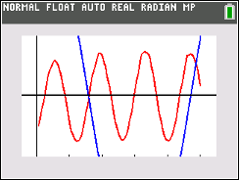
- On the Home Screen, determine the maximum of the distance data. Press y 9, arrow to MATH, and select max(. Enter y i ¤, and press Í.  Edit Y2 to graph the maximum of the distance data. Adjust the maximum value, as needed, to align with the peaks of the graph of the data. Regraph.  Use this maximum distance value and the mean of the distance data to determine the appropriate parameter in the equation y = a(cos(b(x - c))) + d.  Answer: Parameter a (For the sample data, a = 0.22 (maximum (0.88) – mean (0.66)))  What does this parameter represent?  Answer: The amplitude of the function.  Write your new equation. __________________________  Sample Answer: Y1 = 0.22cos(x) + 0.66  Edit Y1 to graph this equation. Adjust the value of this parameter, as needed. | 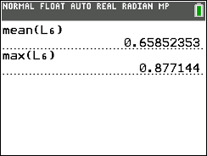  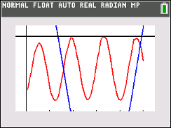  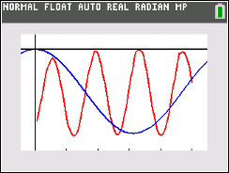
- Press r, and use the trace feature to explore the graph of the pendulum data. Locate the coordinates of a maximum point. Explain how a coordinate of this point could be used to determine a horizontal translation for the function.  Sample Answer: The y-coordinate of this point can be used to determine the horizontal translation. Using the maximum point selected with the sample data, the horizontal translation is 1.95 seconds.  Which parameter does this represent?  Answer: Parameter c.  Write the equation that includes this transformation. ________________________  Sample Answer: Y1 = 0.22cos(x – 1.95) + 0.66  Edit Y1 to graph this equation. | 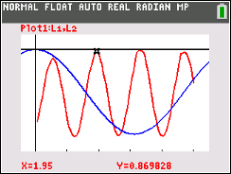  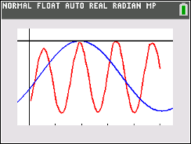
- The time required to complete one swing of the pendulum was estimated in Question 3. Trace on the graph to determine the time it takes to complete one swing. How do these values compare?  Sample Answer: The answers should be similar. For the sample data, the time to complete one swing is approximately 1.4 seconds.  Use this information to determine the number of swings that would take place in 2π seconds.  Sample Answer: $\frac{2π}{1.4}$= 4.48. There are approximately 4.5 swings in 2π seconds.  What does the number of swings in 2π seconds represent?  Answer: The period of the function.  Which parameter does this represent in the function?  Answer: Parameter b.  Write the equation that includes this transformation. ________________________  Sample Answer: Y1 = 0.22cos(4.5(x – 1.95)) + 0.66  Edit Y1 to graph this equation.  Note: Y2 was deleted. | 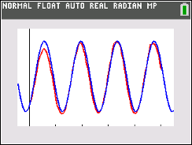
Note:
Alternative method to determine b:
Use the time it takes to complete one cycle to determine the value of b in the function.
Solve $\frac{2π}{b}$= 1.4 for b.
b is equal to approximately 4.5.
This is the approximate number of swings in 2π seconds.
- Edit your equation, as needed, to better match the graph of the data. Record your final equation.

Y1= _______________________

Sample Answer: Answers will vary.
- How would the equation differ if the sine function were used rather than the cosine function?

Sample Answer: Answers will vary. Sine and cosine graphs only differ by a horizontal shift.

- Using the sine function, develop an equation that models the data.

Sample Answer: Answers will vary.

