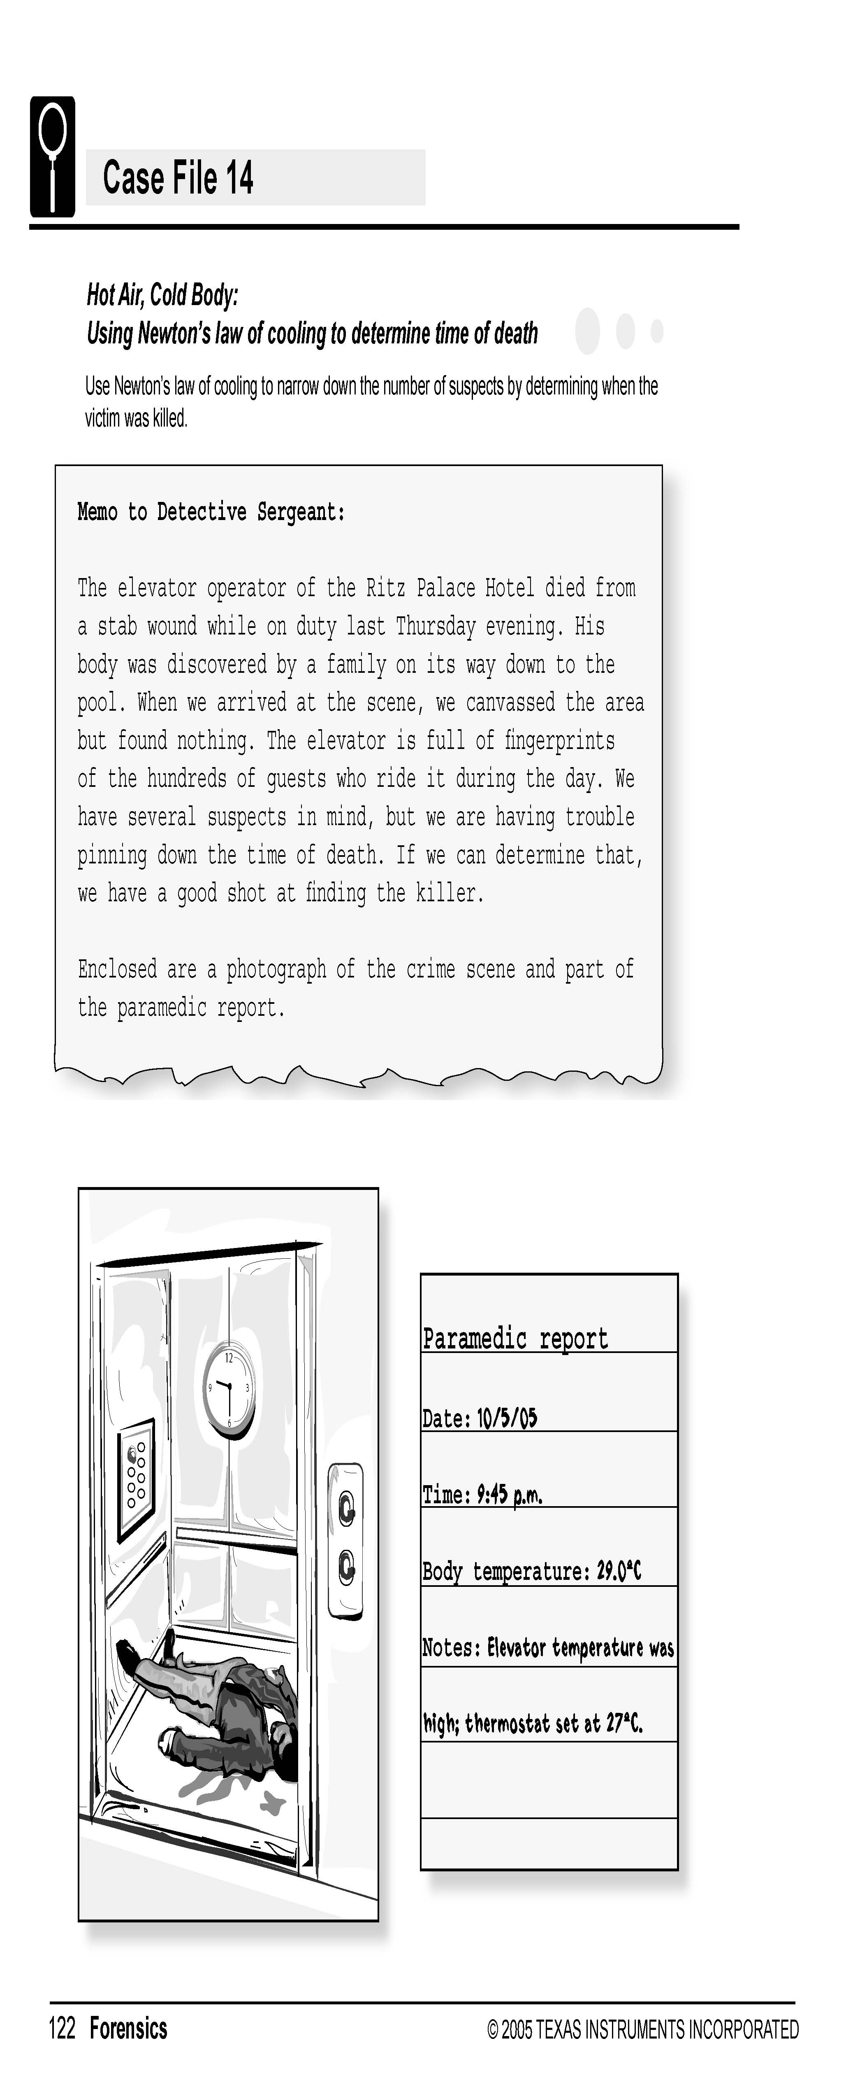
Science Objectives
- Determine the time of death of a person who has died within the last few hours.
- Create a temperature vs. time graph for cooling.
- Model the temperature data with an exponential function.
- Use the model to estimate time of death.

Activity Materials
  - TI-NspireTM technology
  - Case 14 Hot Air Cold Body.tns file
  - Vernier EasyTemp® Probe
  - a “potato/body”
Procedure
Open the TI-Nspire document Case 14 Hot Air Cold Body.tns.  In this data-gathering activity, you will create a temperature vs. time graph for cooling, model temperature data with an exponential function, and then use the model to estimate time of death. |  | 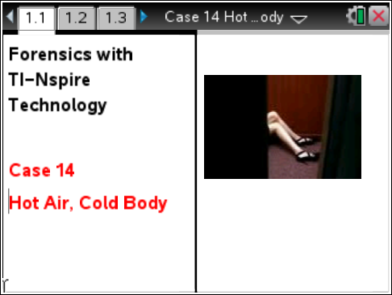
Part 1 – Collecting Data
Move to pages 1.2–1.5.
1. Look at the paramedic report above. Record the temperature of the body and the time the body temperature was measured into the “From the Evidence Report at Crime Scene” section of the Evidence Record on the worksheet.
2. Obtain a "body" from your teacher.
3. On page 1.3, connect the EasyTemp Probe to the TI-Nspire. DataQuest should recognize the EasyTemp probe and display the ambient (room) temperature. Be sure to hold the Temperature Probe in the air away from heat sources and sunlight. Make sure the tip of the probe is not touching anything warmer or cooler than room temperature (such as your hand). Record the room temperature (a) in the “From the Model” section of your Evidence Record on the student worksheet.
4. Now insert the EasyTemp Probe into the “potato/body”. Be sure to not have the probe stick all the way through the “potato/body”. You want the probe firmly in the middle of the “body”.
5. Wait for the temperature sensor to stabilize. Start data collection. You will collect data for 20 minutes.
Follow your teacher’s direction on cleaning up the “bodies”.

6. When data collection is complete, trace the temperature vs. time graph or select menu analyze statistics to view the max, min, mean, etc.
- Locate the maximum temperature reached by the “potato/body” during the data collection. Record this temperature as the initial temperature (i) of the “potato/body” in “From the Model” section of your Evidence Record.
- Record the time (in seconds) at which the max temperature occurred. This is the initial time.
- Locate the minimum temperature reached by the model, and record it in your evidence record as the final temperature (f). Record the time it occurred as the time of minimum model temperature. This is the final time. (This should be the last point on the graph).
- Finally, subtract the initial time from the final time to find how long your ”potato/body” was cooling. Enter this time in your evidence record as the duration of the temp measurement (t).
Part 2 – Analyzing the Data
Move to pages 2.1–2.4.
7. You will now you use your collected data from the “potato/body” to determine time of death at the crime scene. We can use Newton’s law of cooling:
Newton’s law of cooling is an exponential relationship that states:
$$T=T_{o}∙e^{-kt}+T_{room}$$

Where T is the temperature of the object at any time t. To find T₀, calculate the temperature difference between the initial temperature of the object and the room temperature. k is a constant that represents the cooling rate and T_{room} is the room temperature.
Using the data collected from your “potato/body”, you will first need to determine the cooling rate, k, and then apply it to the crime scene data to ultimately determine the Time of Death.

To do this, you will use the data collected from the model “Potato/Body”. This data will replace the variables used in the cooling equation, as follows:
a (ambient room conditions), i (initial temperature) f (final temperature) and t (the amount of time between the high and low temperature (in seconds).
You should have recorded these values in the “From the Model” section of your Evidence Record.

8. On page 2.2, the cooling equation (rearranged to solve for k) is entered for you on the left side of the page. Using the spreadsheet on the right side of the page, you will replace the zeroes with your data “From the Model” section of your evidence record. (note: the spreadsheet and equation uses an m after each variable, to indicate this is the data from your model. m= model.)
The k value (cooling constant) will be calculated and displayed on the left side (under the equation), once all the data has been entered into the spreadsheet. Record this value as k (cooling constant) in the “From the Model” section of the Evidence Record.
9. Now that you know the Cooling Constant (k), you can use it to determine how long the body cooled at the crime scene before the paramedics measured its temperature. To figure this out, you need to solve the cooling equation again, this time for the unknown variable t, (cooling time). In this case, we assume the body cooled from normal body temperature 37°C .

On page 2.3, enter the data from the Crime Scene in the spreadsheet and t will be calculated on the left side. (note- the k value you calculated is carried over automatically from your previous work on page 2.2).

- Record the t “cooling time” it in the Evidence Record. On page 2.4, the cooling time from seconds to minutes is calculated for you. Record the cooling time in minutes in your Evidence Record.
- Finally, to determine time of death, subtract the number of minutes that the body was cooling from the time that the temperature was measured. Enter the time of death into the Evidence Record.

Evidence Record

From the Model (“Potato/Body”)
Ambient (room) temperature for model(ºC)
Initial temperature of model (ºC)
Final temperature of model (ºC)
Time of maximum model temperature (s)
Time of minimum model temperature (s)
Duration of model temperature measurement (s)
Cooling constant, k
From the Evidence Report at Crime Scene
Ambient (room) temperature in the elevator (ºC)
Time body temperature was measured
Temperature of body (ºC)
Cooling time, t (s)
Cooling time, t (min)
Actual Time of Death

Case Analysis
Move to pages 3.1–3.7.
Answer the following questions here, in the .tns file, or both.
1. The term Troom represents the room temperature. How closely did the room temperature at the crime scene match the room temperature in your experiment with the “Potato/Body”?

2. The T0 term represents the difference between the initial victim’s temperature and the room temperature at the crime scene. How closely does this match the data you collected in the experiment with the “Potato/Body”?

3. Use the elapsed cooling time to estimate the time of death at the crime scene in the case.

4. The experiment performed to model the cooling of a victim (potato) is much simpler than the actual cooling at a crime scene. What other factors could affect the cooling rate of a victim?

5. What would happen to the time-of-death estimate if the victim had a fever when he or she died? What if the person died of hypothermia?

