Activity Overview  In this activity, you will use the construction tools in the Geometry application to explore the relationship between chords of a circle and their perpendicular bisectors.  Materials  - Technology needed (TI-Nspire™ handheld, computer software) | 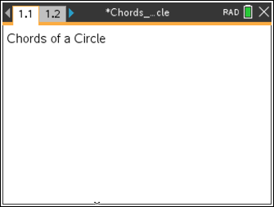
Steps

Step 1: Preparing the document  - Open a new document by clicking on  c > New Document > Add Notes.  - Type: Chords of a Circle.  Note: To obtain capital letters, press the g key, then the letter.  - Press ~ > File > Save As ….  Type: Chords_of_a_Circle.  Tab to ¾ and press ·.  Note: To obtain the underscore, press / _.  4. Add a new page by pressing / ~ > Add Geometry.  5. To hide the scale in the right corner of the screen, go to Menu > View > Hide Scale.  6. Press Menu > Settings. Select “Float 2” for display digits. Tab to Graphing Angle. Select “Degree”. Tab to Geometry Angle. Select “Degree”. Then press e to move from one field to the next and press x to uncheck each of the boxes. Tab to OK and press x or ·. | 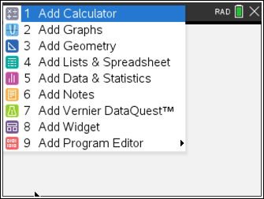  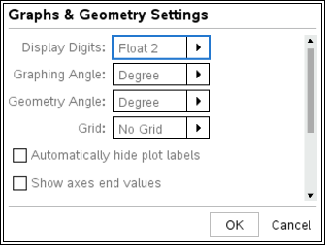
Step 2: Creating a circle  1. Press Menu > Shapes > Circle.  2. Move the cursor to a desired location (close to the center of the screen) and press · to mark the center of the circle. Immediately press g O to label this point O.  3. Use the Touchpad or Clickpad arrows to drag to a desired radius and press · or x.  4. Press d to exit the Circle tool. | 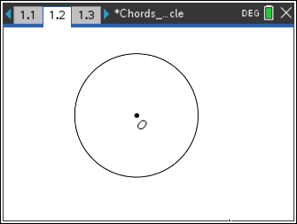
Step 3: Creating a chord  1. Press Menu > Points & Lines > Segment.  2. Move cursor to the circle until the words point on appear. Press · or x to place one endpoint. Immediately press g A to label this point A.  3. Move to another location on the circle and create the second endpoint and label it B (using the directions in number 2 above).  4. Press d to exit the Segment tool.  5. To move a label to a more desired location, move the cursor to the label until label appears and the hand appears ÷. To close the hand, press / x. Move the label to the new location and press d. | 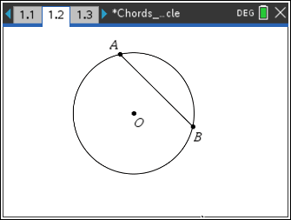
Step 4: Copying a page  1. Press / £ to open the page sorter.  2. While the current page is selected, press / C to copy the page.  3. Press / V three times to paste three new copies of the screen.  4. Press ·. Page 1.5 will be the active page (highlighted).  5. To exit the page sorter and return to the highlighted screen, press / ¤. | 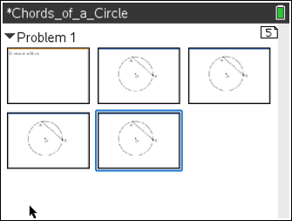
Step 5: Creating a second chord  1. Press Menu > Points & Lines > Segment.  2. Create where C and D are points on the circle.  Move cursor to the circle until the words point on appear. Press · or x to place one endpoint. Immediately press g C to label this point C.  3. Move to another location on the circle and create the second endpoint and label it D (using the directions in 2 above).  4. Press d to exit the Segment tool.  Note: Segments AB and CD do not have to be the same length and they should not be parallel to each other. | 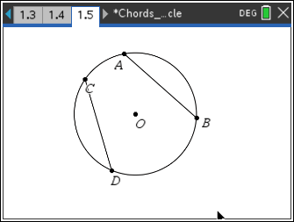
Step 6: Constructing midpoints  1. Press Menu > Construction > Midpoint.  2. Move the cursor until “segment AB” appears. Press · and immediately press g E to label the midpoint E.  3. Move the cursor until “segment CD” appears. Press · and immediately press g F to label the midpoint F.  4. Press d to exit the Midpoint tool. | 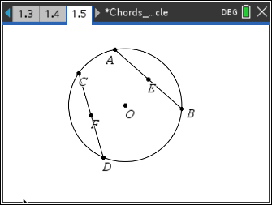
Step 7: Measuring lengths  1. Press Menu > Points & Lines > Segment.  2. Create and (as shown in step 3).  3. Press d to exit the Segment tool.  4. Press Menu > Measurement > Length.  5. Click . A ghost measurement will appear. Move the ghost measurement away from the circle into open space. Press · to place it where you want the measurement.  6. Press d to exit the Measurement tool.  7. To label the measurement, move the cursor to the measurement and press x twice. Left arrow to the beginning of the text box and type FO=. Press ·.  8. Repeat to measure the lengths of, , and .  Note: You may want to turn on the CAPS LOCK by pressing / g. To turn off the CAPS LOCK, press / g again. Also, you may want to grab the measurements and move them so that they are easily read on the screen. | 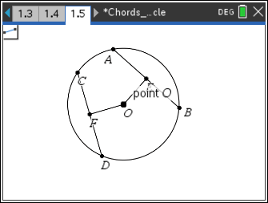  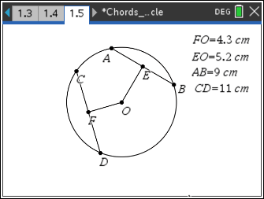
Step 8: Saving the document  1. Press / S. | 