Teacher Notes

The Shortest Path Problem

This is a great follow-up to the Introduction to Properties in Reflections. Students may have trouble producing a scaled drawing. Using a scale of 1 to 5 works well. See the figure below for a possible scaled construction.

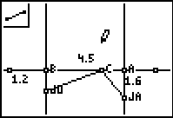

The shortest path from JA to the wall to Jo is the intersection point of the line segment drawn from JA’ to JO and the line that is the wall. So the path from JO to the intersection point to JA is the shortest path. This is relatively easy to prove.

