Discovering Quadratics with Graphing Calculators

Let's start with Multiplying Two Binomials

1) Put the expression into the Y= menu. Every equation has a picture (a visual)
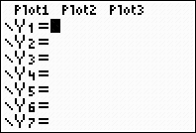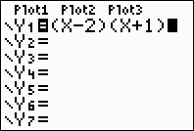

2) Set the window to Zoom 6 Standard
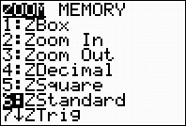

3) Graph the equation by hitting the Graph key.
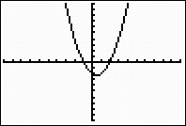

4) Go back to the Y= menu and Distribute your terms
5) Backspace all the way to the left and hit the enter key until a thick line is displayed

6) Press the Graph key and notice a thicker curve graphs on top of the original curve
*** the equations are equal since one curve is on top of the other

7) Go to Y= menu, combine like terms and enter your new expression into Y=
Then backspace all the way to the left and hit the enter key until the trail appears

8) Now hit the graph key and notice the third curve trails on top of the other two visually representing the equality of the three equations. Note: If one curve does not lie on top of the previous one, there lies the error – either with distribution property or combining like terms.

Created by: Melody DeRosa, Texas Instruments

