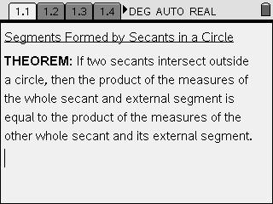
In this lesson you will investigate the relationship among the segments formed by 2 secants drawn to a circle, from a common external point.

Open secant segments.tns on your TI-Nspire handheld and follow along with your teacher, using this worksheet as a reference throughout the lesson.

On page 1.2, you will find circle O with secants PBA & PDC, with each external segment and the secants themselves labeled with their lengths. As you drag any of the endpoints of the 2 secants or common external point P, notice how “a  b” and “c  d” change to reflect the products of each of the secants’ and their external segments. The congruent products indicate that the products of the measures of the external segments of the secants, and the secants themselves, are consistently equal.

Applying the Theorem
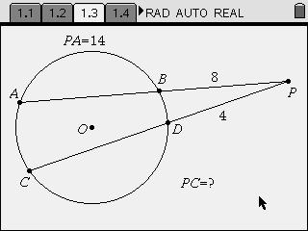
Now, use the theorem, and the diagrams below, to answer the questions on pages 1.3 to 1.6.
#1.3
1.4
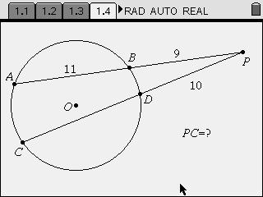

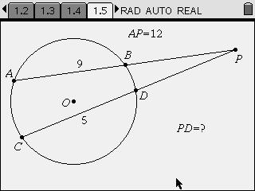
1.5

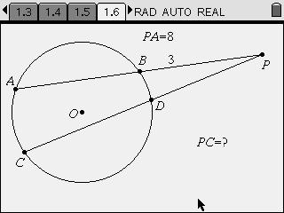
1.6
Geometric Proof
On page 1.8, you are presented with a 2-column proof of the theorem. Complete the theorem by filling in the missing items in both the Statements and Reasons columns.
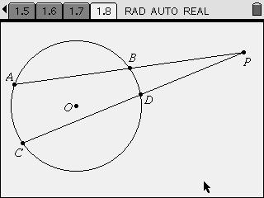

STATEMENTS | REASONS
1. Circle O with secants PBA and PDC, drawn  from a common external point, P. | 1. Given
2. •BAD  m •DCB | 2.
3. •P  •P | 3.
4. | 4. AA  AA
5. | 5. Corresponding sides in similar triangles are in  proportion.
6. PA  PB = PC  PD | 6.

