Science Objectives  - Use a Gas Pressure Sensor and a gas syringe to measure the pressure of an air sample at several different volumes.  - Determine the relationship between gas pressure and volume.  - Use the results to predict the pressure at other volumes.  Math Objectives  - Mathematically describe the relationship between gas pressure and volume.  - Evaluate an inverse mathematical relationship.  - Generate and analyze a power regression model.  - Linearize an inverse relation.  Materials Needed  - TI-Nspire™ CX II (required if using Go Direct)  - Calculator Connection Cable (Mini-A to Micro-B USB)  - Vernier Gas Pressure Sensor  - 20 ml syringe  Vocabulary  TI-Nspire™ Navigator™ System (If available.)  - Class Capture to monitor student progress.  - Live Presenter allows students to show their graphs to the class. | 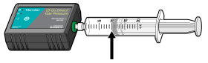  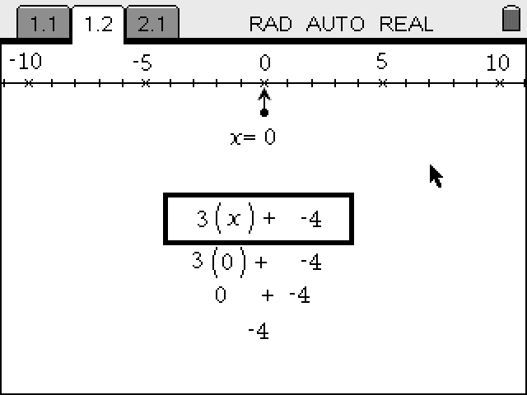  Figure 1.  TI-Nspire™ Technology Skills:  - Open a document  - Move between pages  - Entering and graphing data  - Tracing and interpolating  Tech Tip:  Access free tutorials at http://education.ti.com/calculators/pd/US/Online-Learning/Tutorials  Lesson Files:  Student Activity  - Boyles_Law_Student.pdf  - Boyles_Law_Student.doc
  - pressure
  - volume
  - inverse
  - linear
  - correlation coefficient (r)
TI-Nspire Navigator Opportunity
Use the TI-Nspire Navigator System to monitor student progress using Class Capture.

Activity Overview
- Please print the student worksheet and make available to students before beginning the lab. Lab background information as well as lab procedures are included only in the student worksheet. Always remember to review any safety precautions thoroughly with your students prior to starting the lab.
- Vernier Go Direct® (GDX) probes and sensors can be either directly connected to the TI-Nspire CX II with a Calculator Connection Cable (Mini-A to Micro-B USB) or through TI’s Bluetooth Adapter. For this activity, we used the USB direct connection method. Note: A TI-Nspire CX II is required to use the Go Direct probes, but this activity can also be done with the Vernier LabQuest Gas Pressure sensor, which can also be used with the TI-Nspire CX or TI-Nspire CX II.
- Optional procedure for the Bluetooth Adapter (instead of the USB cable), follow these pairing directions:
  - Turn the TI-Nspire™ CX II on.
  - Turn on the GDX Probe or Sensor of choice.
  - Plug the Mini-A end of the cable into the Npsire CX II and the Micro-B into the Bluetooth Adapter.
  - Press [Menu] on the TI-Nspire unit and choose Add Vernier DataQuest.
  - Select Add Bluetooth Sensor on the Handheld screen.
  - On the next screen, > Connect for the Probe or Sensor that you wish to add.
  - Choose OK on that screen and OK on the following screen.
  - The Probe or Sensor is now ready for use wirelessly.
  - For more information on Go Direct Sensors, and TI Technology visit https://education.ti.com/en/product-resources/go-direct

Note: TI-Nspire CX II’s Vernier DataQuest app can also support many of the newer Vernier GoDirect sensors, while also continues to support some of Vernier’s older sensors and probes.

- Time Required: One 45-60 minute class period.

DATA ANALYSIS
Is Boyle’s Law k = P/V or k = P•V? Explain.
Answer: Boyle’s Law is k = P•V. a value from the Power Regression most closely matches the P•V column of the Lists and Spreadsheet. Boyle’s Law is an inverse relationship where as one value increases the other must decrease meaning that P time V must equal a constant (a).
Questions
- What happens to the pressure when the volume is doubled? Show the pressure values in your answer.
Answer: The pressure is halved.
- What occurs to the pressure if the volume is halved from 20.0 mL to 10.0 mL? Show the pressure values in your answer.
Answer: The pressure is doubled.
- How is the pressure changed when the volume is tripled from 5.0 mL to 15.0 mL? Show the pressure values in your answer.

Answer: The pressure is reduced to one third.

- From your data, do you think the relationship between the pressure and volume of a confined gas is direct or inverse? Explain your answer.
Answer: The relationship is inverse because as one quantity increases, the other decreases.
- Based on your data, what would you expect the pressure to be if the volume of the syringe was increased from 10.0 mL to 40.0 mL? Explain or show work to support your answer.
Answer: The pressure would decrease to one fourth due to the inverse relationship.
- Based on your data, what would you expect the pressure to be if the volume of the syringe was decreased from 10.0 mL to 2.5 mL? Explain or show work to support your answer.
Answer: The pressure would be four times as much due to the inverse relationship.
- What experimental factors are assumed to be constant in this experiment?
Answer: The number of molecules and the temperature are considered to be constant.
- Of the two which is more constant k = P/V or k = P•V? Explain your answer.
Answer: k = P•V is more constant because as P increases V must decrease and vice versa.
This activity was adapted from Experiment #19: Boyle’s Law from the Science with TI-Nspire Technology™, ©2019 Vernier®.

