Activity Overview
This activity is intended to provide students with an opportunity to discover a few interesting properties of an ellipse. The first property students will explore forms the basis of the definition of an ellipse, i.e., the set of all points such that the sum of the distances from these points to two fixed points is constant.

Topic: Conics
- Identify the conics produced by the intersection of various planes with a cone.

Teacher Preparation and Notes
- This activity should be used as an introduction to the ellipse. Students may have previously explored the other conic sections, although knowledge of these concepts is not required for this activity.
- Only ellipses centered at the origin with their major axes on the x-axis are studied in this activity.
- As an extension to this activity, you may decide to derive the general equation of an ellipse centered at the origin and with the major axis on the x-axis. By referring to the definition of an ellipse from Problem 1, students can use the distance formula to write expressions for the distances from each focus to P(x, y), where the coordinates of the foci are (±c, 0). It can be shown that the sum of these distances is equal to 2a, where a is the absolute value of the x-intercepts. By simplifying this relationship, and using the fact that b² = a² – c² where b is the y-intercept, students can derive the formula
x2 y 2
  - = 1. A similar analysis can be used to derive the formula for an ellipse centered
a2 b2

at the origin with major axis along the y-axis:

x2 y 2

+ = 1.
b2 a2

- Notes for using the TI-Nspire™ Navigator™ System are included throughout the activity. The use of the Navigator System is not necessary for completion of this activity.

Associated Materials
- Properties_Of_An_Ellipse_Student.doc
- Properties_Of_An_Ellipse.tns

Introduction
Two focus questions define this activity:  - How can we construct an ellipse on a coordinate plane?  - What interesting properties does an ellipse possess?  Before answering these questions, direct students to the diagram shown on page 1.2. Tell students that conic sections get their name from the intersection of a right circular cone and a plane. If students know about  the other conic sections, challenge them to think about | 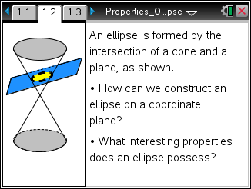
ways to orient the plane to produce an intersection that will yield these other conics. Students can then advance to page 1.3, where they will investigate conic sections on a coordinate plane.
Problem 1 – Investigating the Definition of an Ellipse
Step 1: It is recommended that students work cooperatively on page 1.3.  As students drag point P, they will trace out the ellipse, as shown in the diagram at right.  They should note that the sum of lengths PF1 and PF2 remain constant, while the individual lengths continuously change. | 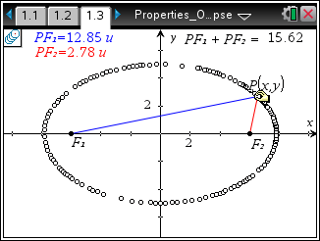
TI-Nspire Navigator Opportunity: Class Capture
See Note 1 at the end of this lesson.

Step 2: From their observations, students are asked to write the definition of an ellipse in their own words. This definition should closely resemble the definition below:
An ellipse is the locus of points in a plane where the sum of the distances from any point on the curve to two fixed points is constant. The two fixed points are called foci (plural of focus).

Check student responses to ensure their definitions are mathematically correct. Provide clarification as needed.

Problem 2 – An Interesting Property of an Ellipse
Step 1: This problem is intended to show students that the foci of an ellipse are equidistant from the center (in this case, the origin) and lie on the major axis (here, the x-axis).  The screenshot to the right shows an example of incorrectly placed foci. As students drag point P, they should notice that F2 does not remain in a fixed location. Have them reposition F1 until the foci remain fixed. The screenshot below shows the correct position of the foci: (–3, 0) and (3, 0). | 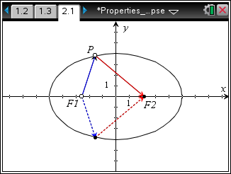
Step 2: Students are also asked to examine the reflective properties of an ellipse. The screenshot to the right (or select MENU > Actions > Hide/Show) demonstrates that a tangent to the ellipse at point P was used to construct the rays that enter and leave point P. This should help students see that the outgoing ray is a reflection of the incoming ray. By observing this effect, students should recognize that any ray leaving one focus is reflected off the ellipse and directed to pass through the second focus. | 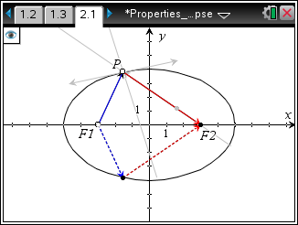
Problem 3 – Another Interesting Property of an Ellipse
Step 1: Students will observe that the position of the foci affects the shape of the ellipse. The screenshot to the right shows that the ellipse becomes narrower (or flattens out) as the foci are moved away from one another.  The next screenshot shows the opposite—that ellipse becomes more circular when the foci are moved towards one another. | 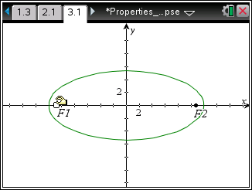

Step 2: When the foci coincide, the ellipse is actually a circle. Students should note that the definition of the ellipse still holds and therefore this shape is still an ellipse.  Furthermore, students should understand that the circle is actually a special case of the ellipse.  These observations are related to the  eccentricity of an ellipse, given by the formula  e = c , where c is the absolute value of the  a | 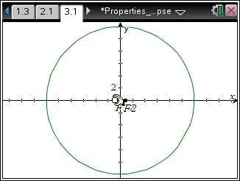
x-coordinate of the foci and a is the absolute value of the x-intercepts of the ellipse. This is a concept that you may wish to have students explore as an extension to this activity.
TI-Nspire Navigator Opportunity: Quick Poll
See Note 2 at the end of this lesson.

TI-Nspire Navigator Opportunities
Note 1
Page 1.3: Class Capture and/or Live Presenter

Use Class Capture to verify that students are following the instructions correctly and are able to use Geometry Trace to trace out the ellipse.

Note 2: Quick Poll
You may want to use Quick Poll to engage the class in a discussion on how the location of the foci affects the shape of the ellipse.

