Problem 1 – Derivative Using the Power Rule
Recall the Power Rule 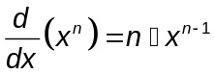.
- Based on the Power Rule, what do you think the derivative of f(x) = (2x + 1)² is?

Graph the derivative of the function and your conjecture about the derivative. Go to the Y= Editor. In y1, type (2x+1)^2. In y2, type nDeriv(y1(x),x). To access the nDeriv command, go to the Math menu ( + ) and select B:Calculus > A:nDeriv(. In y3, type your conjecture for the derivative of f(x) = (2x + 1)². Highlight y1 and press  to unselect this function, and press  +  to graph y2 and y3.

Note: The graphs may take a minute to appear. If the graphs of y2 and y3 coincide, your conjecture for the derivative may be correct. If your conjecture is incorrect, the graphs of y2 and y3 will not coincide.

2. Does your conjecture appear to be correct? If not, how can you change your conjecture?

3. Expand the binomial (2x + 1)². Take the derivative of each term. How does this compare with your answer to Question 1?

Problem 2 – The Chain Rule
The following are ‘true’ statements that can be verified on the TI-89.
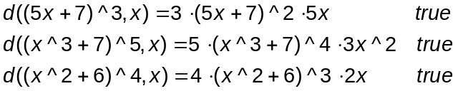

- What patterns do you see? Using any information that you can infer from these statements, create a rule for finding the derivative of these functions. Discuss the patterns you see and the rule you created with a partner.

- Using your rule from Question 4, what is 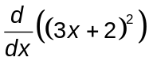?

Verify your answer by typing your statement on the entry line of your TI-89. If you are correct, the TI-89 will return the word, ‘true’. If you are incorrect, the TI-89 will return a false statement. If you are incorrect, try again by editing your statement and pressing  again.

6. What is 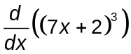? Verify your answer.

7. What is 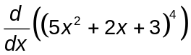? Verify your answer.

The derivative rule you have just observed is called the Chain Rule. It is used to take the derivative of composite functions. The Chain Rule is 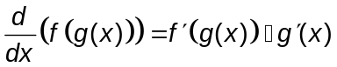. First, take the derivative of the “outside function” at g(x). Then, multiply this by the derivative of the “inside function.”

8. Use the Chain Rule to create three additional true statements. Verify your answers.

Problem 3 – Homework Problems
Evaluate the following derivatives using the Chain Rule. Verify your answers.

1. 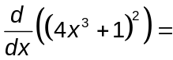

2. 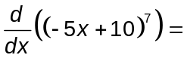

3. 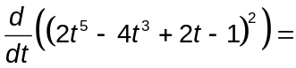

4. 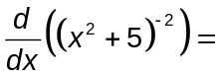

5. 

