Open the TI-Nspire document The_Classic_Box_Problem_Exploration.tns.  In this activity, you will create an open-box by taking an 8 ft by 10 ft sheet, cutting out square corners with sides of length x, and then bending up the sides. The goal of this activity is to figure out how to determine the size of the squares that result in the largest volume for the box. | 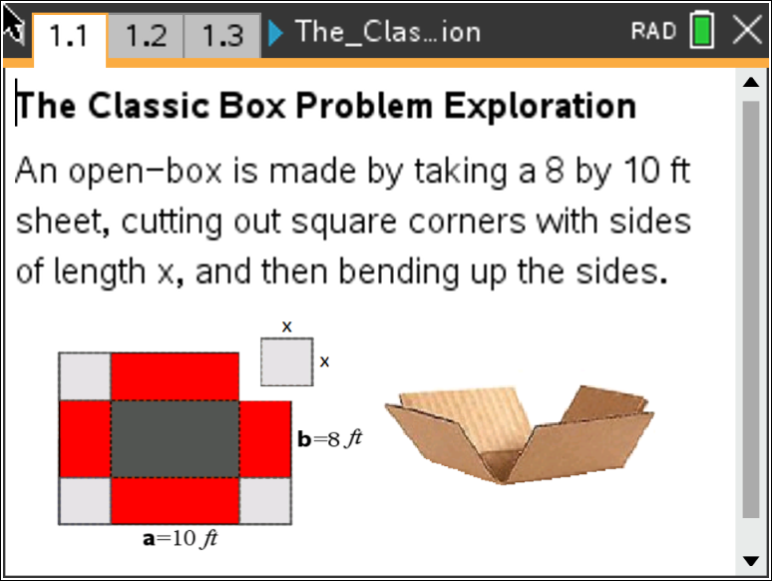
____________________________________________________________________________________

Problem 1 – Creating the Box

Move to page 1.3.

- Before we start the actual box problem, answer this question on page 1.3. If you graphed the volume versus length of x, what shape do you think the graph will take? Explain your choice.

Move to page 2.1

Follow the directions on this page to help navigate through the box problem on page 2.2.

- As you observe what happens to the plotted values of volume versus length of x, discuss with a classmate why doesn’t the graph only increase. Record your discussion on page 2.3.

Move to page 3.1

Now, create a formula for volume using the 8x10 ft net. With respect to x...

- What is the expression that represents width?

- What is the expression that represents length?

- What is the expression that represents height?

Move to page 3.2

- Put it all together. What is the function that represents the volume?

Move to page 3.3

Check your function by graphing it on the right side of this page, then grab the point on the left side of
the page and drag it to see if your function matches the data points. Explain what you notice.

Problem 2 – Optimization of the Box Problem

A square of side x-inches is cut out of each corner of a 10 in. by 14 in. piece of cardboard and the sides are folded up to form an open-topped box. $V(x)$ represents the volume of the box formed with respect to $x$.

- Write the value of $V$ as a function of $x$.

- State the domain of the function $V(x)$.

- Graph the function to find the maximum volume of the box. What is the maximum volume and what value of $x$ gives the maximum volume?
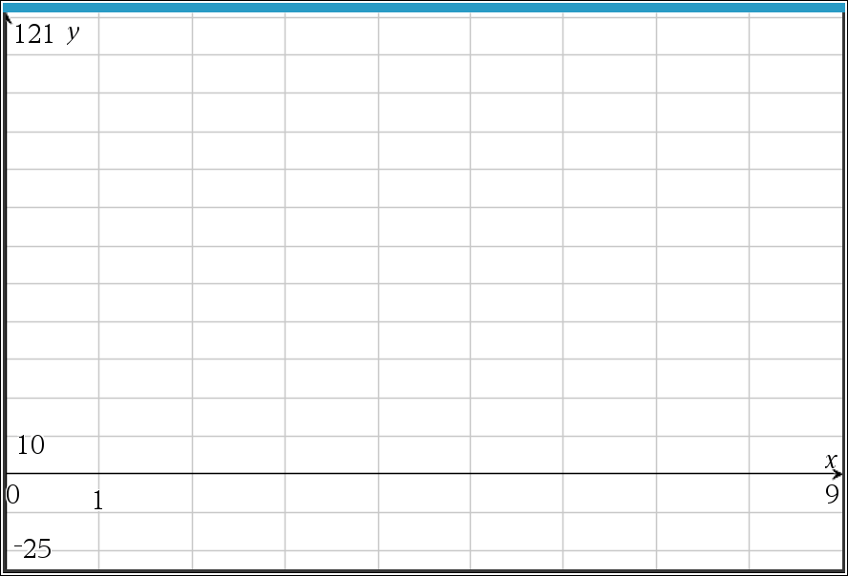

- How can you tell that this is the maximum value? Explain what is happening to the function, $V(x)$, before this maximum value and after the maximum value.

