Let’s Play Ball with Families of Graphs
ACTIVITY SHEET

Name Date

Class Hour/Period

Objective(s)

Warm-Up Problems/Activities: (Review nonlinear relationships)

1. If the graph represents f(x) = x², sketch: g(x) = .5x² and h(x) = -x²

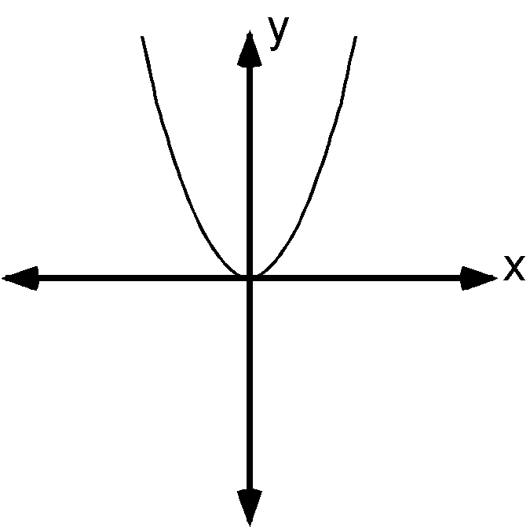

2. Graph each set of equations on the same coordinate system then compare the graphs.
a. $y=x^{2}$, $y=x^{2}+2$, and $y=x^{2}−3$

b. $y=x^{2}$, $y=(x+2)^{2}$, and $y=(x−3)^{2}$

c. $y\text{=-}x^{2}$, $y\text{=-}\frac{1}{2}x^{2}$, and $y\text{=-}2x^{2}$

Activity Procedures:
See CBL System Experiment Guidebook, pp.36-38.
http://education.ti.com/downloads/guidebooks/eng/cblwork.pdf

1. Explain the responsibility or each group member.

2. Describe the results.
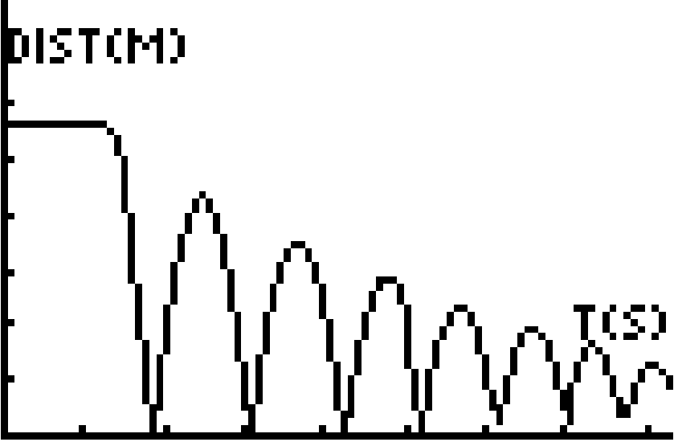

3. How are the parts of the graph (parabolas) different? the same?

4. Determine the equations of three of the parabolas resulting from the experiment and explain how they were derived.

a.
b.
c.

5. Observe the group’s results with results from other groups. How do they compare?

