Problem 1 – Finding Zeros Graphically
Function | Zeros
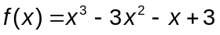
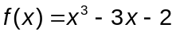
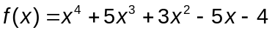
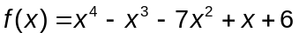
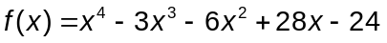

1. Make a conjecture about the number of real zeros of a polynomial in relation to the degree of the polynomial.

2. A fourth degree polynomial has four zeros: Sometimes Always Never.

3. A polynomial can have more zeros than the highest degree of the function. True False.

4. What is the greatest number of zeros possible for the function 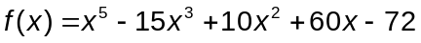?

5. Determine the number of real zeros for .

6. What are the real zeros of ?

Problems 2-6 – Rational Root Theorem
For each polynomial given, use the Rational Root Theorem to list the possible rational zeros. When you have the possible zeros, use the handheld to determine which values are actual zeros of the function.
On each spreadsheet, type the possible rational zeros of f(x) into the first column. The second column will return a zero if it is an actual zero.
Function | Possible Zeros | Actual Zeros
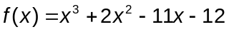
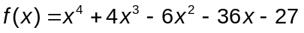
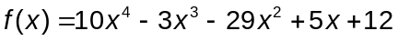
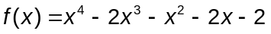

CAS EXTENSION
If a, b, and c are zeros of a polynomial, then the polynomial can be written in the factored form 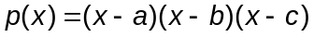.

1. What happens to the factored form if there are less zeros than the degree?
2. How does the factored form change if a zero is a multiple (double or triple, etc.) root?
3. How does the factored form change if there are imaginary zeros?

Use the information from the three questions to write the polynomials in the table above in factored form. On a Calculator page, select MENU > Algebra > Factor, then type in the equation. Explain why the equation factors as given by the handheld.

Function | Factored Form

