

Focus: Find patterns when counting with decimals.
Patterns in Counting with Decimals
Collecting and Organizing Data
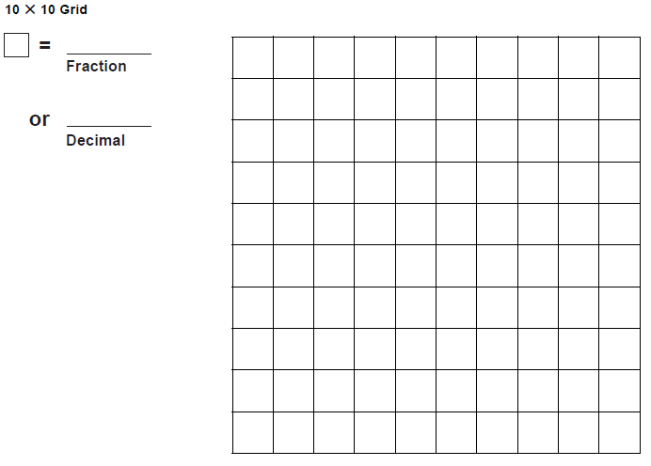
Analyzing data and Drawing Conclusions
- The patterns we saw in the symbols:
- The patterns we saw in the fraction symbols:
- The connections we saw between the two kinds of symbols:

