PROJECT OVERVIEW: Building Paper Bridges
In this project, you and your group will collect data to explore the relationship between force, mass and acceleration due to gravity, g. In the context of the challenge, you will be engaged in a competition to determine which group can build the strongest bridge, and then predict and verify a model for the system prior to making any measurements on the system. Finally, we will collect the data and determine how well your model fits the outcome you observe.
PROJECT OUTLINE:
The goal:
The goal here is to explore two things: First, which group can build the strongest bridge while following the guidelines and then to verify that the model that you predict for relating mass and force makes sense. The intent is for your group to model the system prior to building or taking measurements. You should think about what kind of data you are collecting, how increasing the mass in the cup will show up in the force measurements and how the two are related. The coolest part – the slope and y-intercept will have real physical meaning.
The challenge:
Build the strongest bridge possible using only one sheet of paper. You may use only a single sheet of paper to fold the strongest bridge you can following the guidelines.
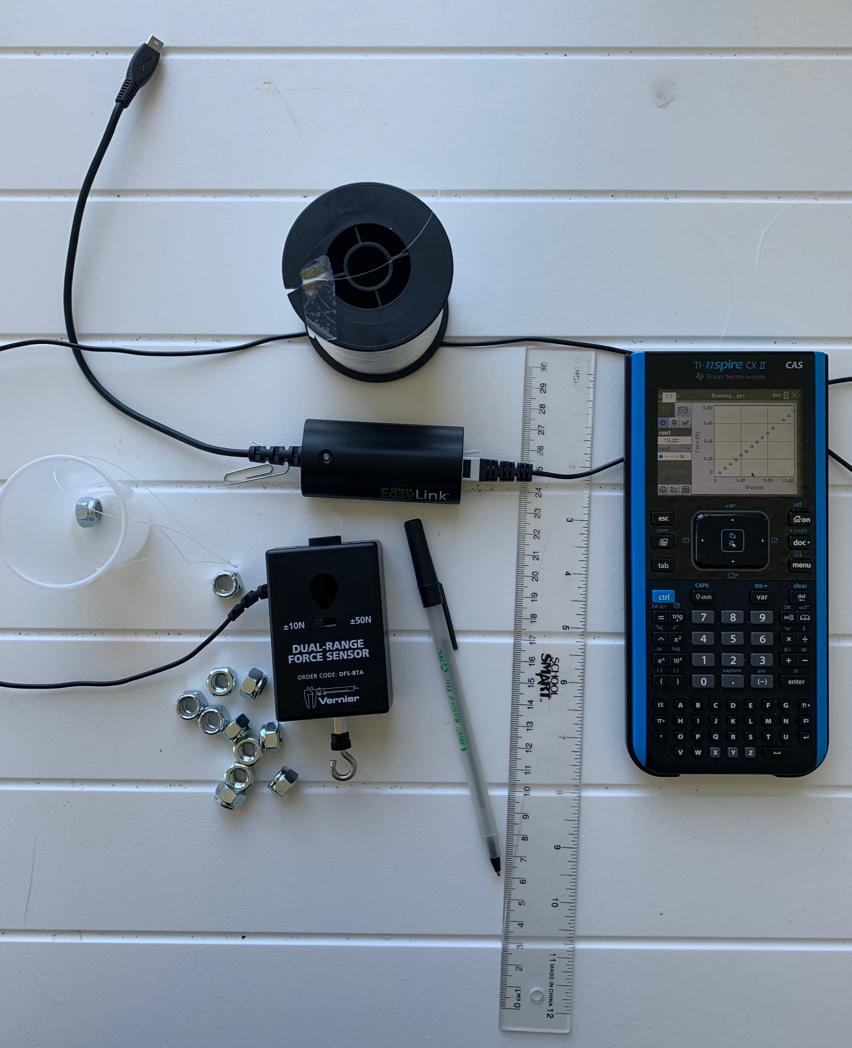
Materials list (per group):
- 1 – 8.5”X11” sheet of paper
- 1 sheet of graph paper
- 20 identical washers (or other small weights)
- 1 – popsicle stick
- 12” to 24” of string or fishing line
- 1 – ½” screw eye
- 1 – small paper cup
- 1 – Vernier Dual Range Force sensor (in 10 N mode)
- 1 – Vernier EasyLink™ Interface
- TI-Nspire CX/CX II or TI-Nspire CX/CX II CAS Technology

Rules for building your bridge:
- You must span a gap of 8”;
- You have 1 sheet of 8.5”X11” paper and no other materials (no tape, no glue, etc.);
- Your bridge must have a “guardrail” that is at least 0.5” high on both sides;
- You have one “car” represented by the popsicle stick;
- The “car” should be placed at the very middle of the bridge while data is collected;
- The screw eye goes through the bridge and attaches to the “car” and the force sensor hangs from the screw eye;
- Secure the cord for the force sensor so it doesn’t interfere with the data collection.

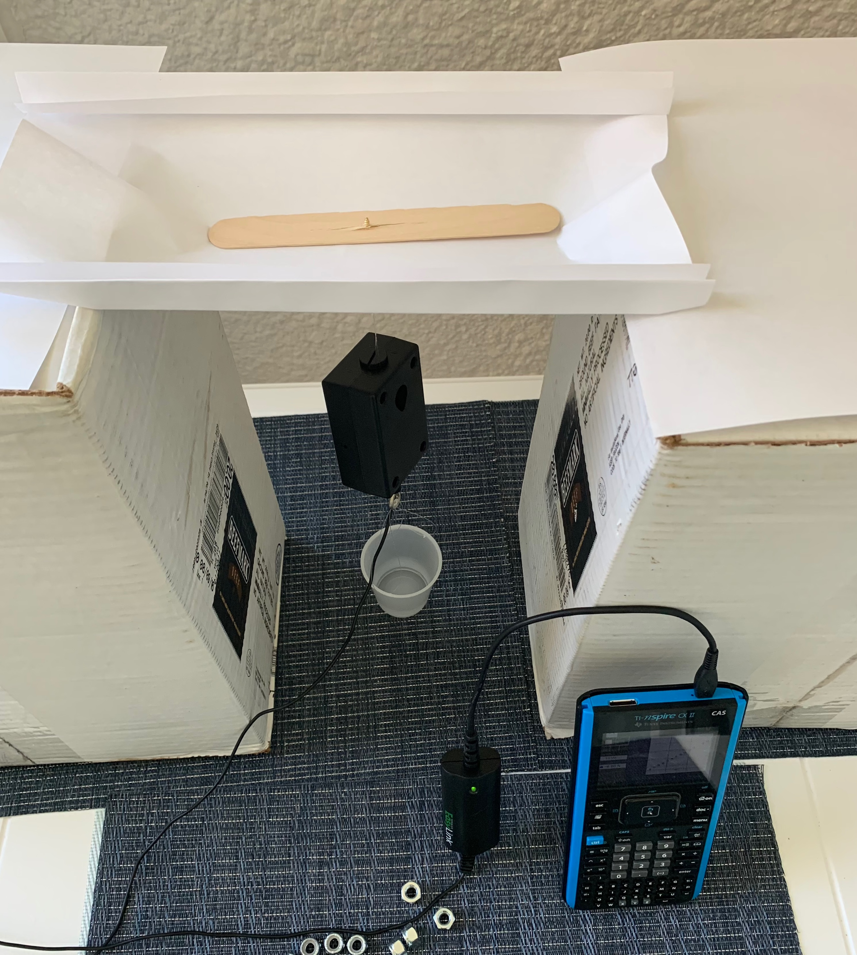
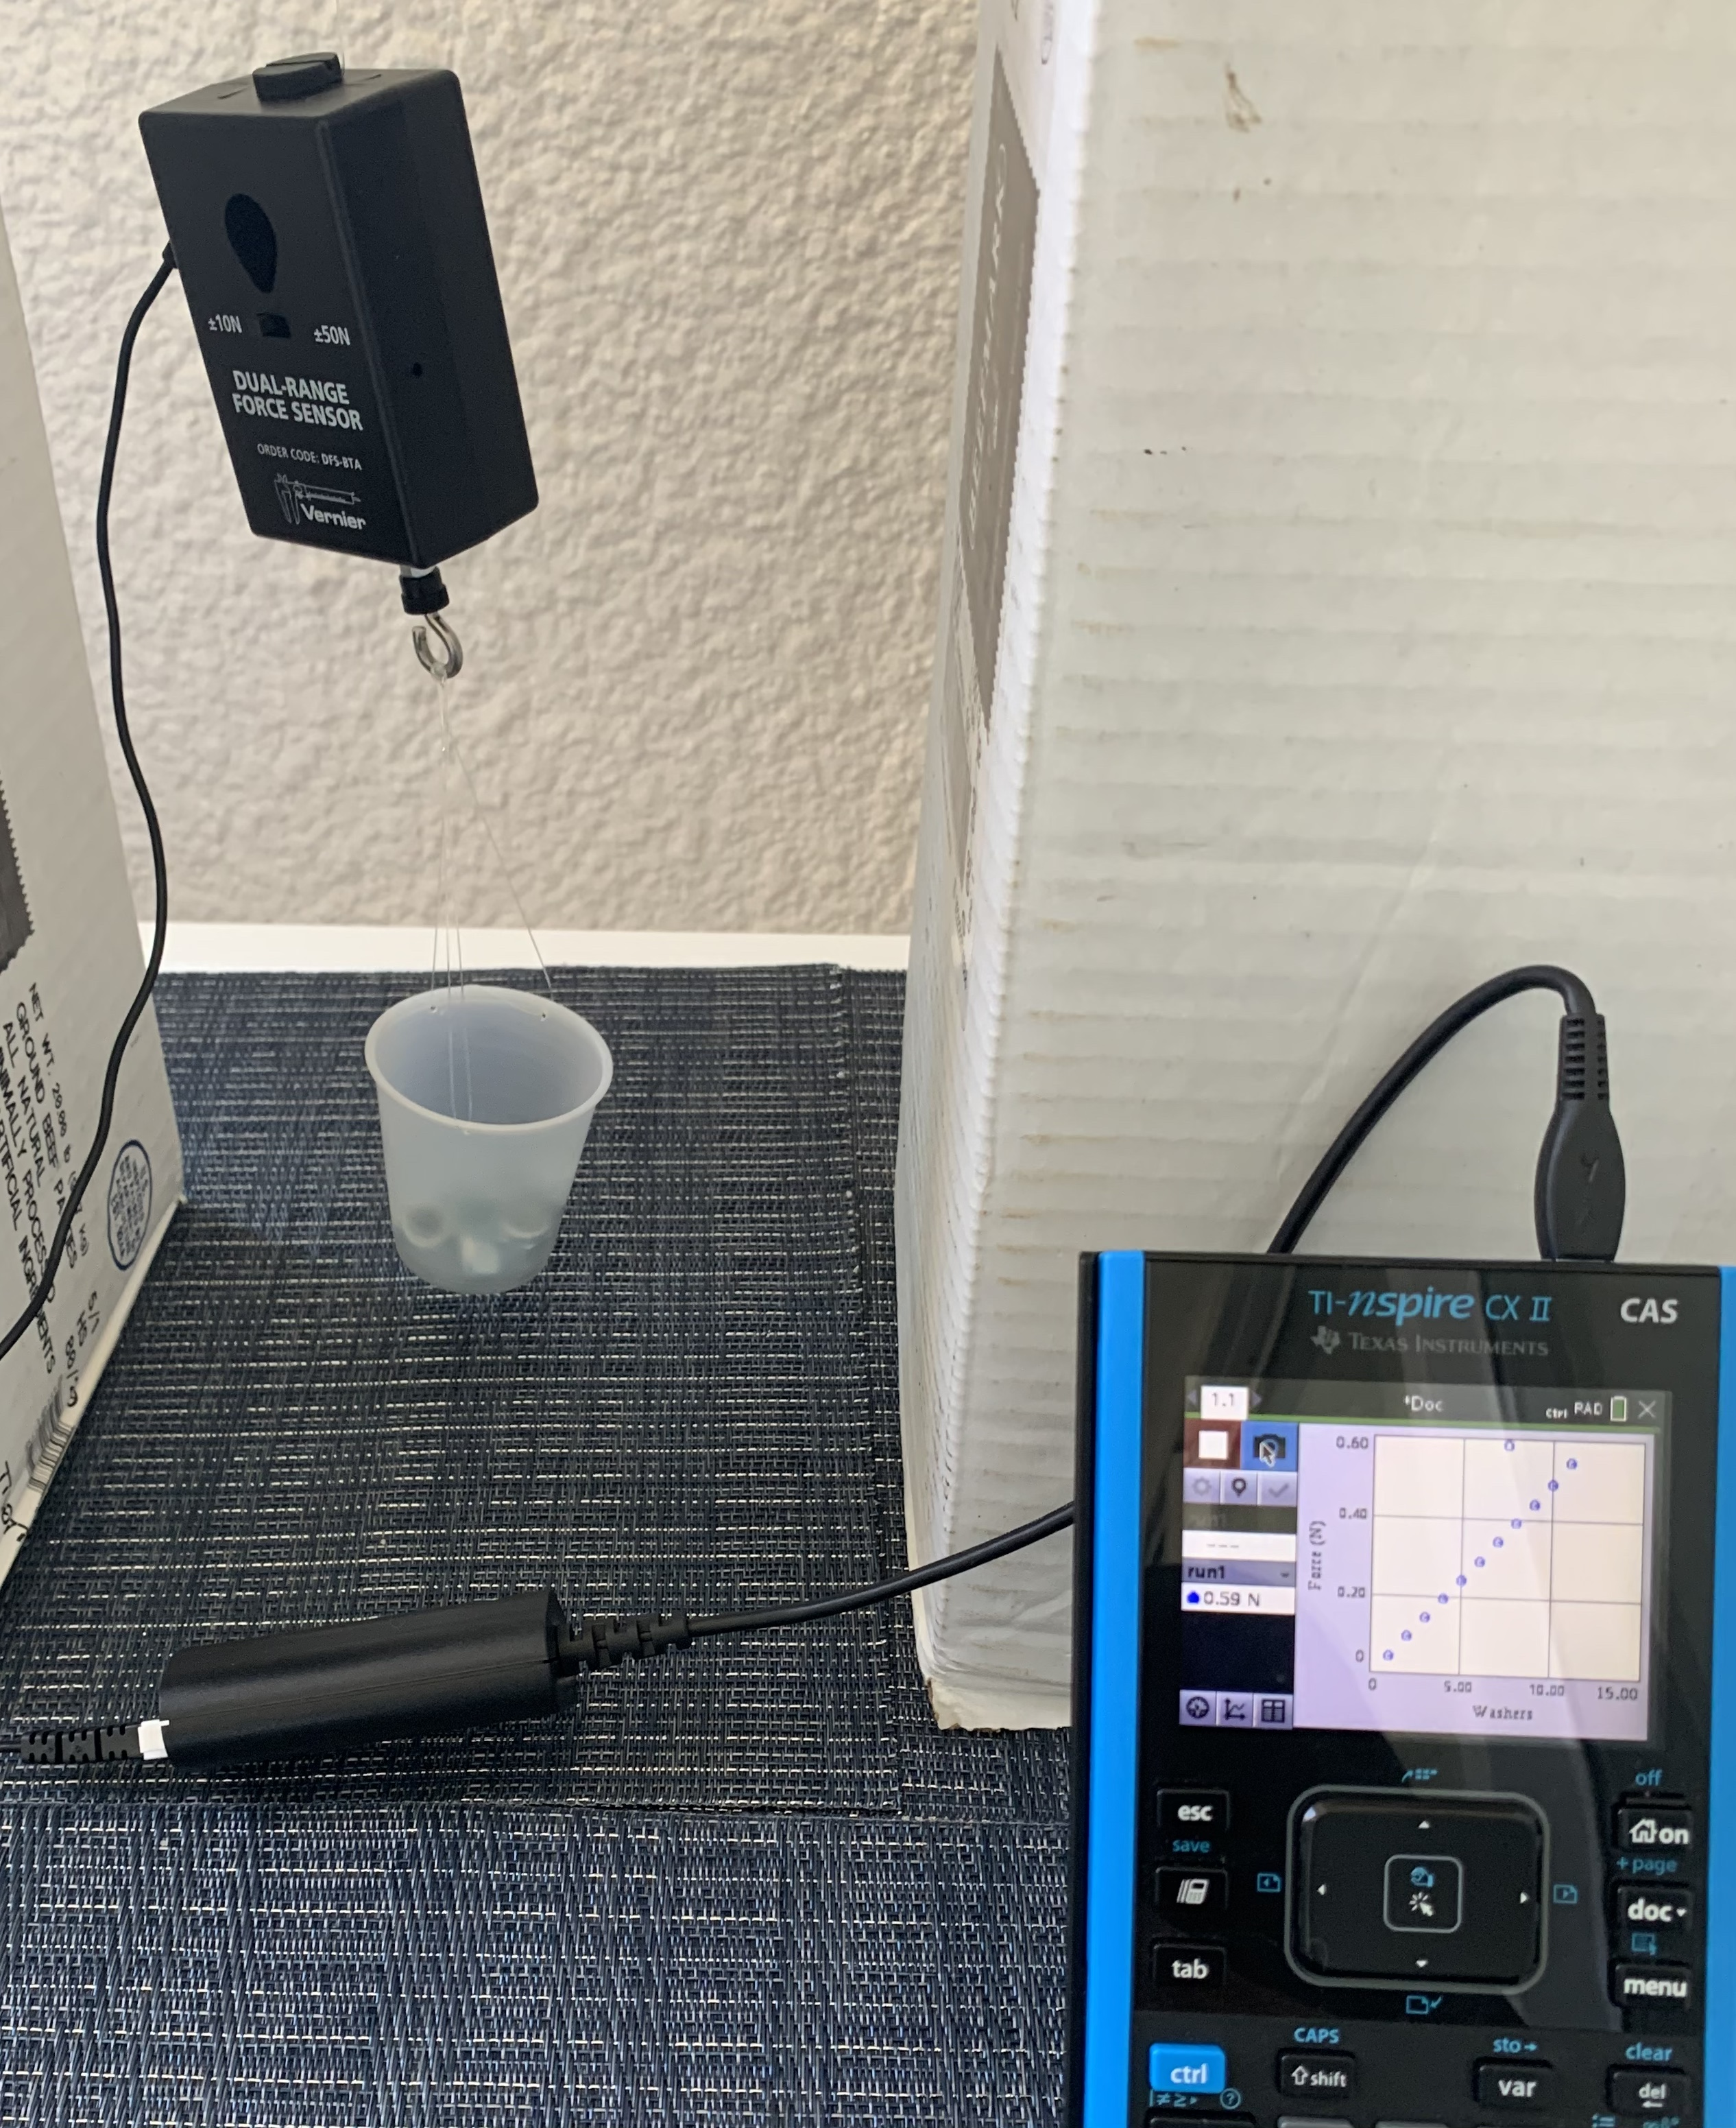

Think it through and build a mathematical model:
Decide what type of relationship you expect to see between the force measured and the number of washers in the cup (linear, quadratic, inverse?). On the piece of graph paper, write down a generic equation to model this relationship and sketch the graph you expect to see from your data.

Ready for Data Collection:
Once you have a model you think will work, begin collecting data. First, you should determine, using a balance, the mass (in kg) of the force sensor and empty cup. You should also measure the mass (in kg) of a single washer. How do you expect to see this information turn up in your data?
Setting up the DataQuest App:
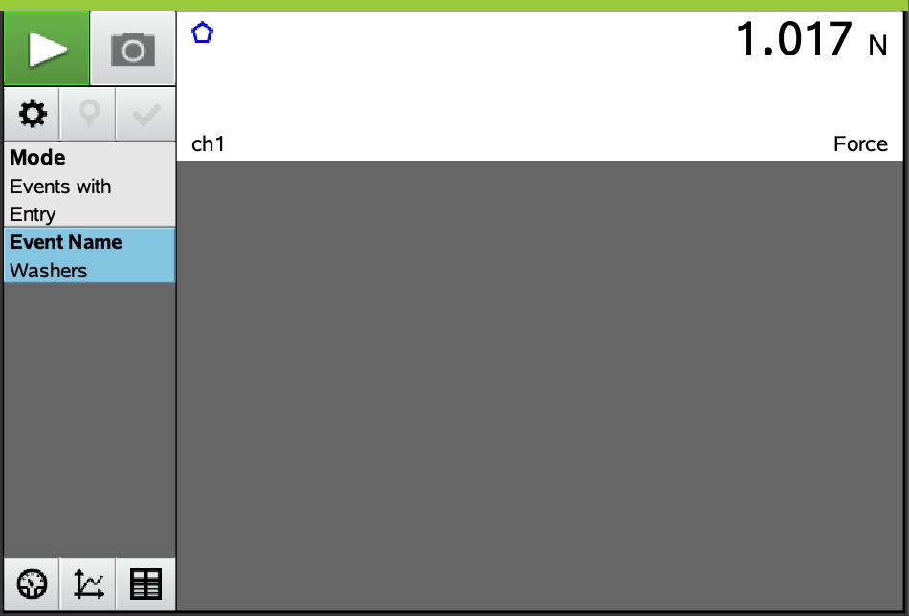
Once the setup is completed as pictured above, connect the force sensor to the Vernier EasyLink™. Make sure the TI-Nspire is on the home screen. Once you connect the sensor to the TI-Nspire through the EasyLink™ interface, the DataQuest app will open. You need to set up the force sensor by selecting Mode > Events with Entry and
Event Name > Washers.
Data Collection:
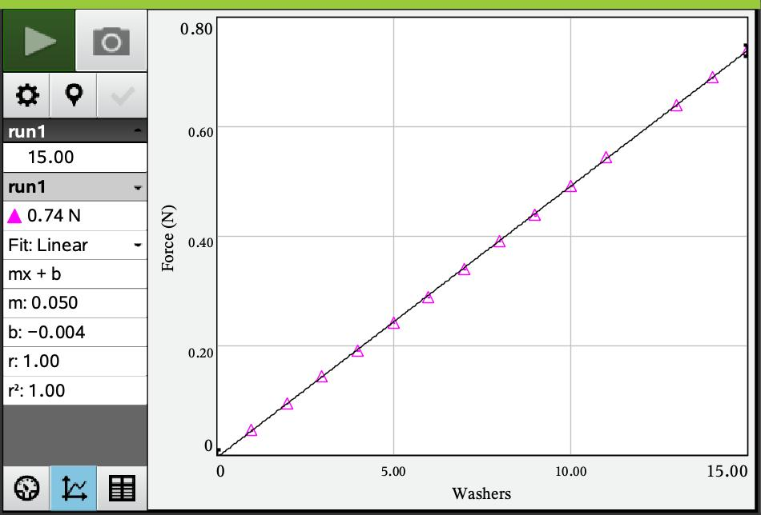
To begin data collection, press the green START arrow and then click the “camera icon” each time to store a data point. You might want to start with one washer in the cup and record that data point. Then add washers, one at a time, taking a data point with each new washer, until you run out of washers or your bridge collapses.
Reminder: Do not to press the red STOP icon until you have collected all data.
Interpreting the Data:
In DataQuest, the data will be stored in a table (number of washers and force in newtons respectively). By clicking on the graph icon on the bottom left, create a scatterplot of Newtons vs. number of washers and discuss whether the model you wrote earlier fits the relationship you see in your data. Using the regression capability of the handheld, analyze the data, using a linear regression model.
Menu > 4-Analyze > 6-Curve Fit >1-Linear. Remember to write down the values for m and b you get from the regression analysis.
- What is the value of the slope? What does it represent?
- What about the y-intercept? What does it represent?

Fun Physics Extension:
Now add two pages to your document, a List and Spreadsheet and a Data and Statistics page. From the table on the DQ page, copy both columns into the L&S page and label columns A and B ‘washers’ and ‘force.’ Now label columns ‘C’ and “D’ mass and ‘inv_force.’ In column ‘C’ multiply the number of washers in column A by the mass of a single washer (in kg). Then multiply the force in ‘B’ by negative 1, since the force is in a downward direction and store the results in ‘D.’
On the Data and Statistics page plot inv_force (in N) vs. “mass of car” (column ‘D’ vs. column ‘C’).
Answer the following questions:
- What does the slope of this relationship represent? Could you have guessed it?
- Compare the y-intercept to the first model. Why do you think that happened?

- Size of the washers
- Sheets of paper
- Height of the “guardrail”

Extension # 2: Changing Variables
Challenge students to change different factors in the setup and see how that impacts the outcome. Possible things to change:
- Length of the span
- Length of the popsicle stick

