Part 1 – Exploring the Normal Curve
Enter the function normalPdf(X,0,1) in Y1. Adjust the window settings so that –5 ≤ x ≤ 5 and –0.1 ≤ y ≤ 0.5.  1. Describe the normal curve in your own words. | 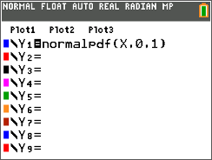
2. Why is the normal curve so useful?

Add the function normalPdf(X,10,2) in Y2. Its arguments are the random variable (x), the mean (10), and the standard deviation (2). Explore the effect of these parameters on the curve by substituting different values into the normalPdf( command in Y2. | 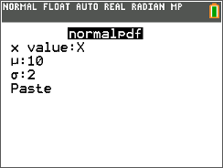
3. How is the shape of the normal curve affected by changing the mean? changing the standard deviation?

Part 2 – Probability as Area
Delete the function from Y2. Use the commands Vertical –1 and Vertical 1 on the home screen to draw vertical lines at x = –1 and  x = 1. View the graph with the lines.  Use the ∫f(x)dx command from the CALCULATE menu ( ) to find the area under the curve and between the two lines. | 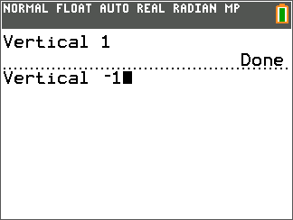
4. What is the percentage of the area?

Use the ClrDraw command by pressing y ¼ [draw] to clear the lines and shading. Then use the ∫f(x)dx command by pressing y r [calc] to open the CALCULATE menu and choosing Option 7: from the list. This command will find the following areas. Generate a picture on your calculator to represent each of the following:
5. a. The area within 1 standard deviation of the mean

b. The area within 2 standard deviations of the mean

c. The area within 3 standard deviations of the mean

Generate a picture on your calculator to represent each of the following:

6. The entire area under the curve

7. The area to the left of the mean

8. The area to the right of the mean

9. The area from 1 standard deviation to the left of the mean to the mean

10. The area from the mean to 2 standard deviations to the right of the mean

11. The area to the right of a line 3 standard deviations to the right of the mean

12. The area to the left of a line 2 standard deviations to the left of the mean

13. The area to the right of a line 1 standard deviation to the left of the mean

Note that all of these areas will be the same no matter what the mean and standard deviation are!

Problem 3 – Application of the Normal Distribution
A farmer harvests a crop of oranges. The oranges’ weights are normally distributed with a mean of 310 grams and a standard deviation of 15 grams.
Graph the distribution in an appropriate window. Use what you’ve learned to answer the following questions.

14. Sketch the graph of the normal distribution for this data. Be sure to label the axes and scale.

15. The farmer sells all the oranges weighing 280 grams or less to a juicer. What percent of the oranges will be sold to the juicer? (Hint: Use your results from Problem 2.)

16. The farmer sells all the oranges weighing 300 grams or more to a commercial buyer. What percent of his oranges will be sold to the commercial buyer?

17. What does it mean if a test score is at the 75th percentile?

18. What is the percentile rank of an orange weighing 320 grams?

19. What is the weight of an orange at the 84th percentile?

