Algebra Town | Name ____________________________
Algebra Town | Class ____________________________

In this activity, you are to explore your TI-Nspire handheld to design a map of a town on a coordinate grid based on the instructions below. You are to use the scale: 1 unit = 1 block.  Open the file Alg1ActXX_AlgebraTown_EN.tns on your handheld and follow along with this document. Record your answers on the worksheet or as directed by your teacher. | 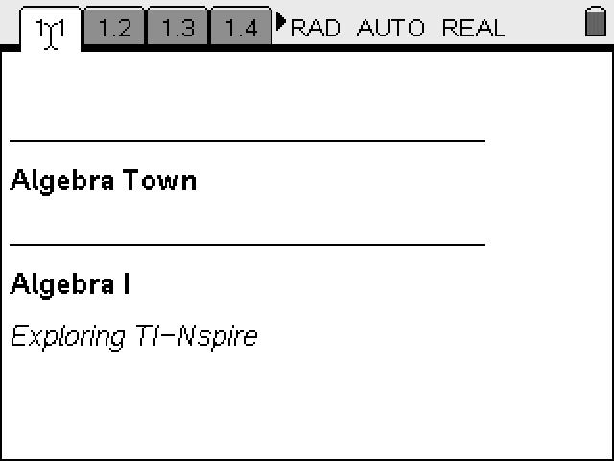
On page 1.3, use the Text menu to indicate a name for your town on the top of your map. Use the Geometry menus to place the following items on the coordinate grid. Label the streets with the letter indicated around the edge of your map so you have room in the center for entering the rest of the map items.  1) The streets have the following equations (Use the Perpendicular tool from the Constructions menu):  a) Main St. (m) y = 0  b) Center St.(c) x = 0  c) Oak St.(o) y = 3  d) Pine St.(p) is 2 blocks north of Oak St. running west to east  e) Apple St.(a) y = -2  f) Birch St.(b) is 5 blocks north of Pine St. running west to east  g) Washington Ave(w) x = -2  h) Lincoln Ave(l) is 2 blocks west and parallel to Washington Ave  I) Jefferson Ave(j) is 8 blocks east and parallel to Washington Ave  j) Hamilton Ave(h) x= 9  k) Roosevelt Ave(r) x = -8 | 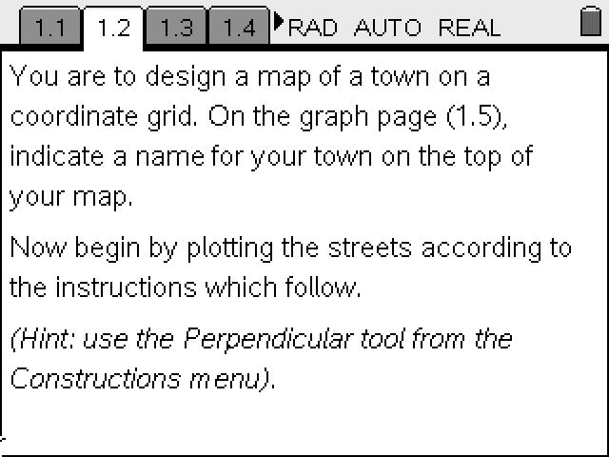  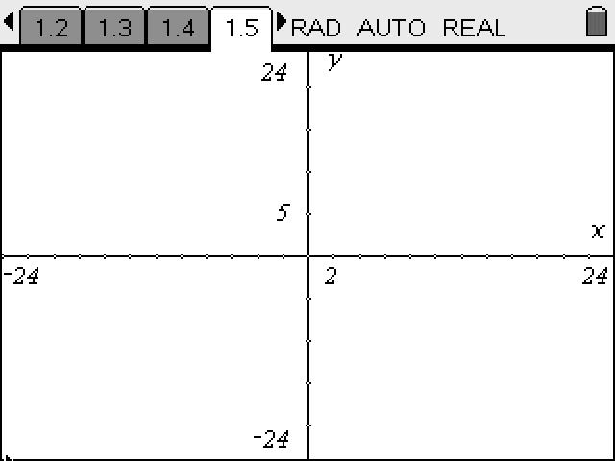
2) Plot the following locations and label them with the letter:
a) Library (l) (8,10) b) Church (c) (-3,4) c) School (s)(-8,-3) d) Gas Station (g) (3, -7)
e) Museum (m) (-6,-8)

3) The park is located with the following boundaries: -15 < x < -9 and -9 < y < -4. Create the park using the Rectangle tool from the Shapes menu (You may like to use the Attributes tool from the Actions menu to shade the park).
4) Find seven points that are on the line y = 2x - 4 and place them in the table. Place the following colored houses white, green, blue, yellow, brown, tan, and gray on the map at the points in the table using Lists & Spreadsheets application on page 1.4.

x
y

5) The ‘Mall of the World’ is located at 1 < x < 18 and -15 < y < -8. Create the Mall. (As with the Park, you may like to use the Rectangle tool and shade it using Attributes).

6) Choose an area to locate the cemetery and label it. Write the boundaries using inequalities.
Boundaries ________________________ ________________________

7) Create the following streets and write the equation of the line that corresponds to the street:
a) running west to east intersecting with the church Eqn: ___________
b) running west to east intersecting with the school Eqn: ___________
c) running north to south intersecting with the gas station Eqn: ___________
d) running north to south intersecting with the library Eqn: ___________

Once your ‘town’ is created, hide the axes.
8) Find the area of: (Note: you may use the calculator page 1.5 if you need)
a) the park b) the mall c) the cemetery
_________ ________ ____________

9) If you live at the corner of Birch St. and Washington Ave,
a) How many street blocks are there to walk to school?
b) If you could go as the "crow flies" like a diagonal line, how many blocks would there be?

10) Create a street that intersects both the library and the church. Name the street and find the distance from the church to the library. ___________
11) Make an entrance to the park, mall, and cemetery on your map using coordinate points. Indicate the coordinates of each entrance:

a)park __________ b)mall __________ c)cemetery__________

12) If you walked diagonally from the upper right corner of the park to the lower left corner, how long would it be in miles? (there are 8 blocks to a mile) _________

13a) How far is it diagonally from the school to the church? _______
b) from library to the gas station? _________
c) from the school to the gas station? ______

