Focus: Find addends to make a sum of 100.
100 or Bust
Collecting and Organizing Data
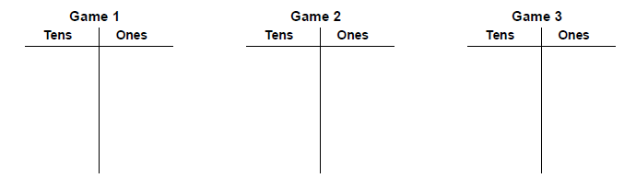
Hundred Grid
Strategies we used while we were doing this activity:

