Creating Word Problems: First Things First
Focus: Identifying operations to solve problems.
The Problem: How do you decide which operation to use to solve an equation?
Working the Problem
- Look at this problem:
Is the solution larger or smaller than the other numbers in the equation?

Circle the operations that give you larger solutions when using whole numbers. + - x ÷ How do you know?

Circle the operations that give you smaller solutions when using whole numbers. + - x ÷ How do you know?

Use your TI-15 to try each of the operations with these numbers. Write the solutions in this table.

Press | Result
14 2
14 2
14 2
14 2

Which operations gave larger solutions?
Which operations gave smaller solutions?
Which operation gave you the solution you needed?

To write a word problem for an addition equation, use similar objects for each set. The set of 14 and the set of 2 need to be combined in some way.
For example, Juan had 14 marbles. He found 2 more marbles. How many marbles does he have now?
The 14 marbles and 2 marbles are combined to make a total of 16 marbles.
Write your own word problem for this equation.

2. Look at this equation:
Is the solution larger or smaller than the other numbers in the equation?

Use your TI-15 to try each of the operations with these numbers. Write the solutions in this table.

Press | Result
1000 50
1000 50
1000 50
1000 50

Which operations gave larger solutions?
Which operations gave smaller solutions?
Which operation gave you the solution you needed?

To write a word problem for a division equation, one number is the total number of objects, one number is the number of objects in one group, and one number is the total number of groups. The largest number is usually the number of objects. The objects are separated into equal groups.
For example, Maria has 1,000 pencils in the school store. She wants to put them in boxes that hold 20 pencils each. How many boxes will she need?
The 1,000 pencils are the objects. There are 20 pencils in each group. She will need 50 boxes, therefore 50 is the number of groups.
Write your own word problem for this equation.

3. Sometimes the solution number is between the other equation numbers.
Look at this equation:
Which operation will give a solution that is smaller than one of the numbers in the equation?
Use your TI-15 to try each of the operations with these numbers. Write the solutions in this table.

Press | Result
150 50
150 50
150 50
150 50

Which operation gave the largest solution?
Which operation gave the smallest solution?
Which operation gave you the solution you needed?

To write a subtraction equation, use similar objects. The largest number is separated into the part that is subtracted and the part that remains.
For example, Mr. Wong had 150 stamps. He used 50 stamps on birthday cards for his friends. How many stamps does he have now?
The 150 stamps are the largest number of objects. The 50 stamps on the birthday cards are the subtracted objects. The solution is the 100 stamps he has left.
Write your own word problem using this equation.

4. Look at this problem:
Which operation do you think will give this solution? Why do you think so?
Use your TI-15 to try each of the operations with these numbers. Write the solutions in this table.

Press | Result
250 50
250 50
250 50
250 50

Which operation gave the largest solution?
Which operation gave the smallest solution?
Which operation gave you the solution you needed?

Use objects and groups of objects in your word problem to write a multiplication equation. The solution will be the total number of objects.
For example: Demetrius is in charge of the prizes for the school carnival. Each booth will need 250 small prizes. There are 50 booths at the carnival. How many prizes does Demetrius need to buy?
The prizes are the objects. The booths are the groups of objects.
Write your own word problem for this equation.

Creating Word Problems
The Problem: Creating word problems
Mrs. Fibonacci is tired of making up math problems for her students to solve. She wants your team to create some problems for her. Use the TI-15 to help you find the numbers for the problems, and then create the words for the problems.
The Facts
- Set to the Problem Solving mode, manual, level 2 or 3. Set the operation to ?. (See Using the TI-15.)
- The TI-15 will give the numbers for the problem. You decide which operation gives you the answer shown on the TI-15.
- For most sets of numbers, only one operation will give you tha answer given on the TI-15.
- Word problems describe the situation where a particular operation is needed. For example, an addition problem will desctibe putting two or more sets together in some way.

The Task
1. Your team will
- Use the TI-15 to give you the numbers for five problems.
- Decide which operation will give the answer displayed on the TI-15 for each problem.
- Write a word problem that matches each problem and the operation the team has chosen for each.

2. Make a poster of the five problems your team has created. For each problem
- Show the number sentence with the question mark given by the
TI-15.
- Show the word problem written by your team.
- Do not show the operation needed to solve the problem.

3. Each person on the team will write an explanation of the team’s solution. This explanation will answer the following questions:
- How did your team decide which operation to use for each equation?

- How did the size of the answer to the number sentence help your team?

- How did the operation help you write the word problems?

- What happens in an addition problem? A subtraction problem?
A multiplication problem? A division problem?

- If you are given a word problem, how do you decide which operation to use?

4. Your team will present your five problems. The rest of the class will decide which operation is needed to solve each problem.

Using the TI-15
Creating Word Problems
To set up the problems for the activity:
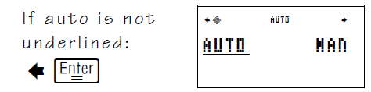
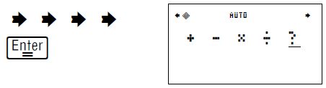
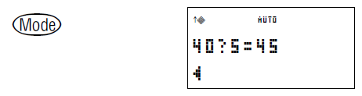
Problems are random.

