About the Lesson  This activity examines the motion of a ball as it falls under the influence of gravity. The parameters in the vertex form of the quadratic equation y = A(x – H)² + K are determined to describe the behavior of a ball bounce. As a result, students will:  - Collect motion data and graph scatter plots.  - Determine the equation of a quadratic function.  - Determine the value of the coefficient A in the vertex form of a quadratic equation.  - Explore the effect of A on the shape of the graph.  - Interpret the meaning of the value of A in the context of the problem situation as one half of the acceleration due to gravity.  Vocabulary  - Vertex  - Vertex form of a quadratic function  - Vertical reflection, vertical stretch, and vertical compression  Teacher Preparation and Notes  - Students should have worked with translations, reflections, and vertical stretches and compressions of functions.  - This activity provides an opportunity for math-science connections.  - This activity is best performed with at least three students: one to hold the CBR™ 2 and press the trigger, one to release the ball, and one to run the calculator.  Activity Materials  - CBR 2 motion sensor and USB CBR 2 to calculator cable  - Bouncing ball (Avoid using a soft or felt-covered ball such as a tennis ball.)  - TI-84 Plus CE or TI-84 Plus CE Python  - Vernier EasyData® App  - Recommended: TI-SmartView™ CE Emulator Software for the TI-84 Plus Family |  |  | 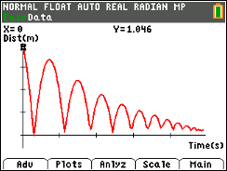  Tech Tips:  - This activity includes screen captures taken from the TI-84 Plus CE. It is also appropriate for use with the rest of the TI-84 Plus family. Slight variations to these directions may be required if using other calculator models.  - Access free tutorials at http://education.ti.com/calculators/pd/US/Online-Learning/Tutorials
Demonstrate this activity using the SmartView emulator so the entire class can see the process. If you only have one CBR 2 motion sensor, link the data lists to each student’s calculator after running the activity. If you have enough CBR 2 devices, have students work in small groups and collect data.
Setup
- This activity is best performed with at least three students: one to hold the CBR™ 2 and press the trigger, one to release the ball, and one to run the calculator.  - Lift the pivot head on the CBR 2 and set the sensitivity on the CBR 2 to Normal. | 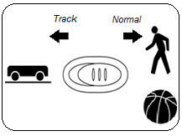
- Attach the CBR 2 to the calculator using the USB CBR 2 to calculator cable. The EasyData App launches automatically when you plug in the sensor.  Note: In the EasyData App, the tabs at the bottom of the screen indicate the menus that can be accessed by pressing the calculator keys directly below the tabs.  Note: The default unit of measurement for the CBR 2 in the EasyData App is meters. | 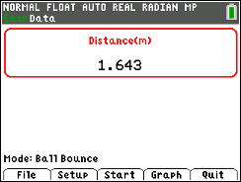
- Practice dropping the ball under the CBR 2. This is a practice run to determine if the ball is bouncing on a flat surface.  - Position the CBR 2 at least 15 centimeters (approximately 6 inches) above the ball.  - Hold the sensor directly over the ball and make sure that there is nothing in the Clear Zone.  - Hold the sides of the ball and then quickly move your hands outward to release the ball. Drop the ball (do not throw it). | 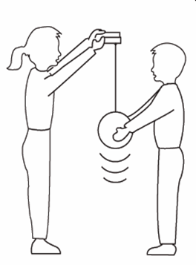
Data Collection
- You cannot place the CBR 2 on the floor and bounce the ball on it, but you can use the Ball Bounce Setup option to reverse the positions so that the data will appear as though it was collected with the floor as the zero height.  - Press o to access the File menu, and select New to reset the application. | 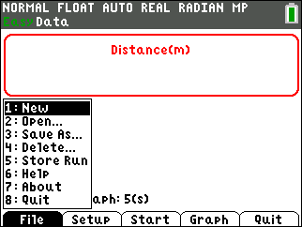
- Press p to access the Setup menu. Select Ball Bounce.  - After selecting Ball Bounce, press q to select Start.  - Follow the instructions displayed. | 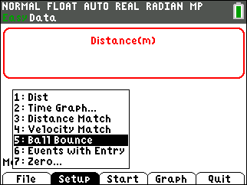
- One person holds the CBR 2 while another person holds the ball at least 15 centimeters beneath the CBR 2. Press q to select Next. | 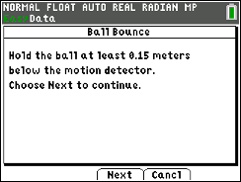
- Follow the on-screen directions. At this time you may disconnect the CBR 2 from the calculator or you may leave it connected.  Important: Whether you leave the CBR 2 connected or not, you will need to press the TRIGGER on the CBR 2 to begin collecting data. (Do not press q to select Next yet.) | 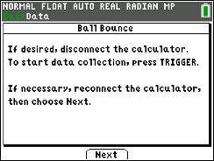
- When the CBR 2 begins clicking, release the ball, and then step back.
- The program will collect data every 0.05 seconds for 5 seconds.
- If the ball bounces to the side, move to keep the CBR 2 directly above the ball, but be careful not to change the height of the CBR 2.
- When the clicking stops, reconnect the CBR 2 to the calculator (if necessary), and press q to select Next.
- The collected data is transferred to the calculator. A screen displays a notice to wait as it is transferred.
- As soon as the data are sent, the calculator displays the distance versus time graph from within the program. The plot should look like a series of ball bounces.
The Ball Bounce setup automatically flipped the distance data.
Guide your students in a discussion to help them realize that when the ball is at its highest point, its distance from the CBR 2 is the smallest.
- To repeat the sample, press s to return to the Main screen. Press q to select Start and repeat the data collection process.  You will get a warning screen telling you the new data will overwrite any previous data. Press s to select OK. | 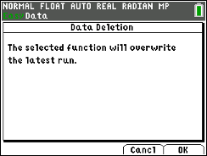
- Use the right and left arrow keys to view the coordinates of the points. (Do not press r.)
If you accidentally return to the Main screen of the EasyData app, press r to select Graph to return to the Graph screen.
- What quantity is represented along the horizontal axis? Answer: time
What are the units? Answer: seconds
- What quantity is represented along the vertical axis? Answer: distance or height
What are the units? Answer: meters or feet
- What does the highest point on the plot represent? Answer: the maximum height of the ball
What does the lowest point represent? Answer: the floor
Select a Region of the Graph and Graph Data for One Bounce
- To display the graph of one bounce, press q to select Anlyz, and then choose Select Region.  - Press s to select OK.  - The message “Set Left Bound” is displayed.  - Arrow to the beginning of the graph of one of the parabolas, and press s to select OK.  - The message “Set Right Bound” is displayed.  - Arrow to the end of the graph of the parabola, and press s to select OK.  - The graph of the parabola is displayed. Note that the window settings have been changed. |  | 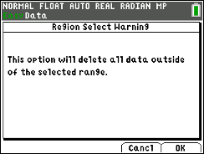  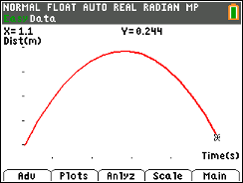
- Exit the EasyData App by pressing s to select Main. Press s again to select Quit.  - The app will display a screen telling you where the data are located on the calculator. For Ball Bounce, time is in L1, distance in L6, velocity in L7, and acceleration in L8.  - Press s to select OK. | 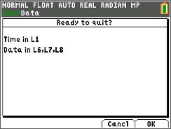
- Press y ,. If Plot 1 is not turned on with the configuration shown at the right, turn Plot1 on with L1 and L6 for the Xlist and Ylist, respectively.  - Press q ® to select ZoomStat and your data will be displayed. | 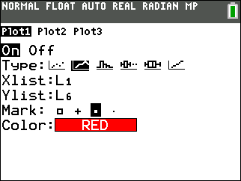
Data Analysis
After all students complete Method 1, you may wish to have them select either Method 2 or Method 3. Alternatively, students could be assigned all three methods.
Method 1 – Vertex Form of a Quadratic Function; Determining the Value of A
- With the data displayed in the graph window, press r, and use the arrow keys to reach a point as close to a vertex as possible.
The x- and y-coordinates displayed at the bottom of the screen will remain in the memory of the calculator (stored in x and y, respectively) until you trace to a new point or store new values in x and y.
- For any one bounce, a plot of distance vs. time has a parabolic shape. One form of the quadratic equation that describes this motion is y = A(x – H)² + K where (H, K) is the vertex of the parabola and A is the vertical stretch or compression factor of the graph. This equation is called the vertex form of a quadratic equation.
- Record the x- and y-coordinates of the vertex as H and K here:
H = K =
Sample Answer: Answers will vary.
- Press y 5 to return to the home screen.  - Store the x-coordinate of the vertex in the variable H:  „ ¿ ƒ H Í  - Store the y-coordinate of the vertex in the variable K:  ƒ Y ¿ ƒ K Í  Note: Sample data have been stored for H and K in the screen on the right. | 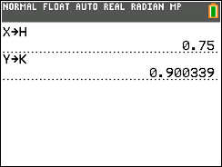
- Press o to enter the formula of the parabola in vertex form. | 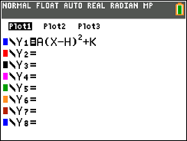
- Before storing a value for A, predict what the graph would look like if A = 1.
Answer: The graph will be concave up. It needs to be vertically reflected and vertically stretched to match the bounce.

- Before storing a value for A, predict what the graph would look like if A = 0.
Answer: The graph will be the horizontal line y = K.

- To find an equation of the parabola, use a guess-and-check method to find the value of A.
- Store a value for A on the home screen, and then press s to view the graph.
- Adjust A, as needed, by storing new values for A on the home screen.
- For each new value of A that you store, press s to view the new parabola.
- Experiment until you find a value of A that provides a good fit for the data.
- Record the value of A that works best: A =
Answer: Answers will vary but the value of A should be approximately one-half the acceleration due to gravity, −4.9 meters/second² or −16 feet/second².
- Using this value of A and the H and K values you reported in Step 2, write the vertex form of the quadratic equation. y =
Sample Answer: Answers will vary.

- What effect does each have on the graph of the parabola?
  - The sign (positive or negative) of A?

Answer: Positive A value, the graph opens up; negative A value, the graph opens down. If A < 0, the graph is concave down; if A > 0, the graph is concave up.

  - |A| > 1?
Answer: If |A| > 1, the graph is a vertical stretch of y = x².

  - |A| < 1?
Answer: If |A| < 1, the graph is a vertical compression of y = x².

- For the same bounce, press r to trace along the plot to identify the x- and y- coordinates of a point that is not the vertex. Record the coordinates here.
x = ________ y = ________ (to 2 decimal places)
Answer: Answers will vary.
- Substitute the coordinates of the vertex (from Step 2) and the coordinates of a point on the parabola ((x, y) from Step 11) into the vertex form of a parabola, y = A(x – H)² + K, to solve for the value of A.
A =

Record the equation of the parabola in vertex form.
y =
Answer: Answers will vary but the value of A should be approximately one-half the acceleration due to gravity, −4.9 meters/second² or −16 feet/second².
- Press o. Enter your equation in Y2, and press s.

- How does the value of A from Question 8 compare to the value of A from Question 12? Which graph (Y1 or Y2) provides a better fit for the bounce? Explain.
Sample Answer: Answers will vary.
Method 2 – Using the Transformation Graphing App to Fit an Equation
- Press o, and delete any equations.  - Using the data graphed for one bounce (in a ZoomStat window), use the Transfrm App to fit a quadratic function to their data.  Press Œ, and select Transfrm. |  | 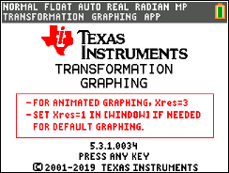
- Press o, and arrow to the left of Y1. Press Í. Arrow down to the Y1 row and use the spinner on the right to select the vertex form of a quadratic equation.  Note: The coordinates of vertex are (B, C).  - Arrow down to OK. Press Í. |  | 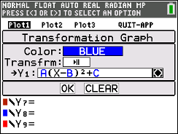
- Press s to display the data for one bounce and the graph of the equation in Y1 with the last values stored for A, B, and C.  Note: Depending on the last stored values for A, B, and C, the graph of the equation may not be visible.  - To change values of A, B, or C, enter a value for the parameter, and press Í. To move from one parameter to another, press the up or down arrow key.  To increase or decrease the value of a parameter by 1, press the right or left arrow key. (Note: To increase or decrease all parameters by a different value, change the Step value. Press s to select SETUP. Arrow down to Step and enter a new Step value. Press s to return to the graph.) |  | 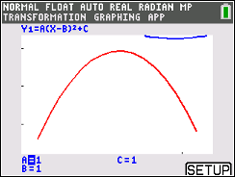
- Change values of A, B, and C until the graph of the function provides a good model for the data.

- Substituting the values determined for A, B, and C, record your equation. y = _______________

Sample Answer: Answers will vary.

- How does the value of A compare to the value of A determined using other methods?

Sample Answer: Answers will vary.

- To exit the Transfrm App, press o, arrow to QUIT-APP, and press Í. Select Quit Transfrm Graphing.
Method 3 – Using QuickPlot&Fit-EQ to Fit an Equation
- Using the data graphed for one bounce (in a ZoomStat window), determine the equation of the parabola using the Quick-Plot & Fit-EQ feature on the calculator.  - Press o, and delete any equations.  - Press …, and arrow to the right to CALC.  - Press the up or down arrow to scroll to QuickPlot&Fit-EQ, and then press Í.  - A blinking cursor will appear on the graph screen. Use the arrow keys to move on the graph formed by the bounce. |  | 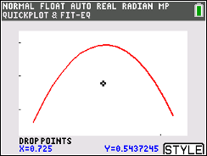
- To select a point on the parabola, press Í. Select at least five points – select the vertex and two points to the left and two points to the right of the vertex. (Note: At least three points must be selected to compute a quadratic regression equation.)  - A marked point will appear each time Í is pressed.  - When all points have been selected, press s to select FITEQ.  - Then, select QuadReg. Press s to select STORE.  - Use the arrow keys to select L3 for the XList, L4 for YList, Plot2 for Setup Plot, and Y1 for Store RegEQ. Arrow to OK and press Í.  Note: Do not select L1 or L6 as that would overwrite the time and distance data from the ball bounce.  - Once OK is selected, the regression equation is no longer shown on the graph screen. The regression equation is stored in Y1. |  | 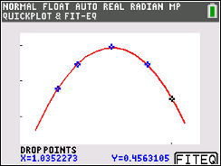  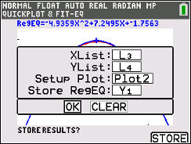
- Press o to view the equation stored in Y1. Record the value of A. A = __________

Sample Answer: Answers will vary but the value of A should be approximately one-half the acceleration due to gravity, −4.9 meters/second² or −16 feet/second².

- How does the value of A compare to the value of A determined using other methods?

Sample Answer: Answers will vary.
Extension:
- Would you expect your classmates to have the same value of A for their trials, or do you think the A value would vary? Explain your answer.
Sample Answer: Same; student explanations will vary depending on their previous experiences.

- Determine the values of A found by other groups of students in your class. How do these values compare to your value of A?
Sample Answer: Same or very close.

- If a ball that was more or less bouncy was used, would it affect the value of A in the equation? Explain your response.
Answer: No, it would only affect the vertices of the bounces.

Lead students into a discussion about the acceleration of falling objects due to gravity.
- Remember, the ball was not thrown; it was dropped. After an object is released, it is acted upon by gravity (neglecting air resistance). So A depends on the acceleration due to gravity, −9.8 meters/second² or −32 feet/second².
- The negative sign indicates that the acceleration is downward.

Note: Depending on students’ knowledge of physics, decide how far to take this discussion.

