Open the TI-Nspire document AppsOfCriticalPoints.  In this activity, you will see several different applications of critical points and local extrema (maxima or minima). | 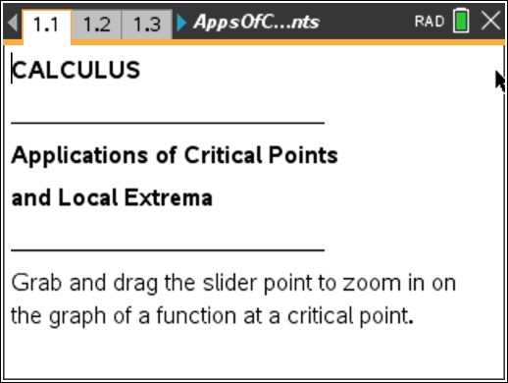

Move to page 1.3. | Press / ¢ and / ¡ to navigate through the lesson.
The function graphed on pages 1.3 and 1.5 is a cubic regression representing data of the number of births in a hospital between 1975 and 1990. A tangent line to the curve is graphed in the right window. The graph on the right represents only the shaded area of the graph on the left.
1. Grab and drag the slider point to zoom in on point P.
a. When you zoom in, what do you notice about the shape of the graph at point P?

b. What does point P represent in the context of this problem?

Move to page 1.5.
2. The graph from page 1.3 is repeated with a tangent line to a point on the function. The slope of the tangent line has been calculated for you. Grab and drag the point along the graph.
a. What do you notice about the slope of the tangent line to the left of point P? To the right of point P?

b. What is the derivative of the function at point P?

c. When is the derivative of the function positive? Negative? Explain.

Move to page 2.3.
Gina started her own business with $5,000 she had saved. For the first two weeks, she lost money buying supplies. After two weeks, she received a contract that paid $1,000 per week.

3. The graph on page 2.3 shows Gina’s income, in thousands of dollars, for each week in business. Grab and drag the slider point to zoom in on the graph of the function at the critical point.
a. What type of critical point is point S? What is the meaning of this point in the context of Gina’s business?

b. What do you notice about the shape of the graph when you zoom in on the critical point?

Move to page 2.5.
4. The graph on page 2.5 is a magnified view of the graph from page 2.3. A tangent line to a point on the function is graphed, and the slope is calculated. Grab and drag the point along the graph.
a. What is the slope of the tangent line to the left of the critical point? To the right of the critical point?

b. What does the slope mean in the context of this problem?

c. What is the slope of the tangent line to the function at the critical point? Why?

Move to page 3.1.
The function f1(x) = (x – 3)⁵ + 8 is graphed on page 3.2. A tangent line to the function is graphed, and the slope is calculated.
5. Grab and drag the point along the graph to find the slope to the left and to the right of point W.
a. What do you notice about the derivative of the function to the left of point W? To the right of point W?

b. Is point W a critical point? Why or why not?

c. Is point W a local maximum or minimum? Why or why not?

