Problem 1 – An introduction
A password must contain 5 unique lowercase letters. How many possible passwords are there?
A. 3,125 B. 100,000 C. 7,893,600 D. 11,881,376
- Explain why you chose the answer you did.

Problem 2 – Factorials and the Fundamental Counting Principle
- Evaluate the following. 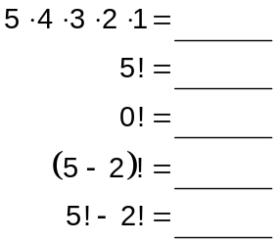
- A spinner with four equal sections colored red, green, blue,
and yellow is spun, and a penny is flipped. List all possible outcomes.

- A penny is flipped three times. List all possible outcomes.

- State the Fundamental Counting Principle in your own words.
Problem 3 – n objects taken n at a time
- List all the ways in which the letters a, b, and c can be arranged.

- What multiplication expression can be used to find the answer? _____________
- Complete this equation: 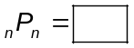
- Find how many different ways you can arrange the letters in the
word NUMBER. _____________

Problem 4 – n objects taken r at a time
- List all of the ways to arrange two of the following 4 letters: a, b, c, and d.

- What multiplication expression can be used to find the answer? _____________
- Complete this equation: 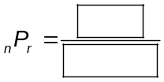
- A collector has 16 statues. In how many ways can the collector
arrange 5 of the statues on a shelf? _____________
Problem 5 – Practice
- A certain password must contain 5 unique lowercase letters.
How many possible passwords are there? _____________
- Use permutations to find the number of ways the letters in the
word FLOWER can be arranged. _____________
- Ten people are in a race. Use permutations to find the number
of ways 1st, 2nd, and 3rd places can be awarded. _____________
- CHALLENGE: A password must have 3 unique lowercase letters and 5 unique
digits. Find the number of possible passwords if the letters must
stay grouped together and the digits must stay grouped together. _____________
Extension
Read page 6.1. Find the number of distinguishable permutations
of the letters in each of these words.
- PIZZA _____________  - SUCCESS _____________ | - COOKBOOK _____________  - MISSISSIPPI _____________

