Extreme Punkin’ Chunkin’: Application of Quadratic Functions in standard form

Activity Overview
Time Required
20 minutes

In this activity, students will explore extrema, zeros, and other key values of quadratic functions in real world contexts.

Topic: Polynomial Functions
- Roots/Zeros
- Maximum/minimum

Teacher Preparation and Notes
- Load the Pumpkin.tns file onto student handhelds.
- There are four problems in this activity. Problems 1 and 2 go together and can be completed in class. Problems 3 and 4 can be used as an extension or for homework.
- Consider showing video of the Punkin’ Chunkin’ contest or other pumpkin launches. Videos are available at a variety of Web sites, including YouTube and TeacherTube.

Associated Materials
- Pumpkin_Student.doc
- Pumpkin.tns
- Pumpkin_Soln.tns

Problem 1 – Punkin’ Chunkin’ Team 1
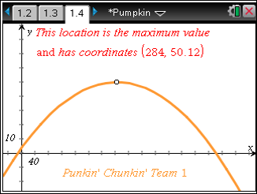
On page 1.3, an equation is given to describe the motion of a pumpkin launched from a trebuchet. This equation is graphed on page 1.4 and students are instructed to drag the plotted point to find points of interest. This graph is used to answer questions involving maximum height, horizontal distance, and the ability of the pumpkin to clear a fence.
Remind students to move slowly as they trace along the graph by dragging the points they place on their graphs. If students move too quickly, they will likely miss the text that appears when a critical point is reached.
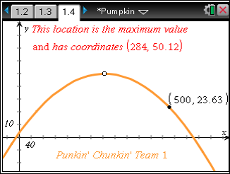
A method that is helpful for students in answering question 3 from the worksheet is to plot a point on the function and edit the point. This question seeks to find s desired height. The student must find the y-coordinate when the related x-coordinate is 500.
To plot a point on the function, Press b > Points & Lines > Point On. Then click twice on the function. Now, move the cursor to the coordinates of the point, click on the x-coordinate twice to enable editing, change the x-coordinate to 500, and press ·.
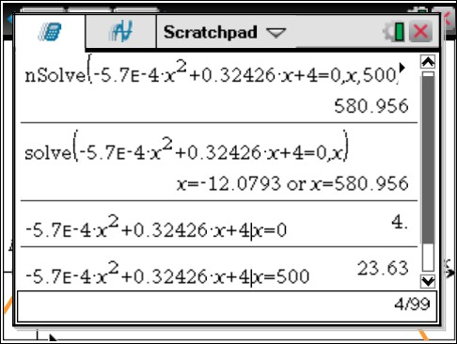
Discuss with students the difference in domain and range in the context of the problem versus the graph of the function.
Also discuss how the zero, extremum, coordinates of the vertex, and y-intercept are represented in this problem. Challenge students to calculate the zero, y-intercept, and height at 500 ft using the Scratchpad.
Note: The solve command can only be used with CAS technology.

Problem 2 – Punkin’ Chunkin’ Team 2
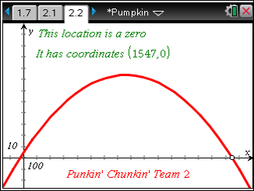
Students use what they’ve learned in Problem 1 and apply it to the function representing the winning team in the Punkin’ Chunkin’ contest. Again, they will drag the plotted point to find the values of interest.
On the worksheet, students are to compare the trajectories of Team 1 and Team 2’s pumpkins. They can do this by looking at the values they’ve recorded or graph Team 1’s function on page 2.2, along with Team 2’s function.

Problem 3 – Cost of Kayaks
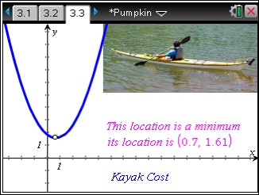
Students explore a problem that models the cost of production, C, for a kayak company. In this problem, they are asked to find the minimum cost and the associated number of kayaks produced.
Discuss with students what the y-intercept represents (fixed cost or cost when no kayaks are produced).

Problem 4 – Espresso Yourself
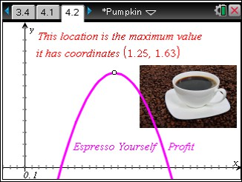
This problem involves profit, P, for an espresso stand as a function of cups of espresso sold.
The x-axis represents the number of cups and the
y-axis represents the amount of money.
Discuss with students why there is no y-intercept for this function (no profit if nothing is sold).

Solutions – student worksheet
1. 50 ft, 581 ft 2. 4 ft 3. yes, 23.63 ft
- The zero is the total horizontal distance traveled, the extremum is the maximum height of the pumpkin, and the y-intercept is the starting distance from the ground of the pumpkin.
- 74 ft , 1547 ft 6. 5 ft
- Team 2’s maximum height was greater at a farther distance from the trebuchet.
- 65 kayaks 9. $161 10. $1631.25,$1.25 11. $2

