Lesson 11: What happens to matter when it is burned?
Previous Lesson | We analyzed trends in M’Kenna’s weight and height and looked at images of weight loss over time. Then, we read an article that says, when kids lose weight, the fat is being “burned.” We wondered if this is the same “burning” as when we light something on fire. We lit different types of fats on fire and saw that they seemed to disappear too!
This Lesson  Investigation  2 days   | 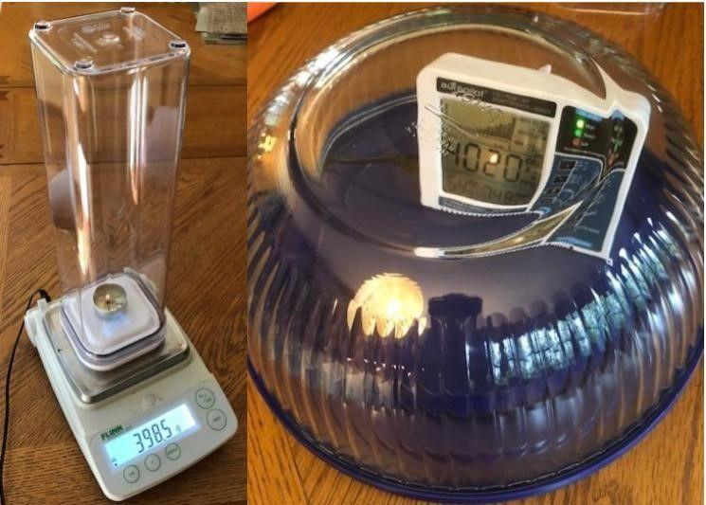 | We conduct two investigations to trap the gases produced by burning food. First, we burn vegetable oil in a closed versus an open system and compare the masses of the systems. Second, we burn vegetable oil in a closed system and track carbon dioxide and water in the air within the system using a sensor. We use the results of these investigations to figure out that food needs to undergo a chemical reaction with oxygen to release energy and that carbon dioxide gas and water vapor are products of that process. We wonder if this reaction could happen inside our bodies. | An alternative to the hands-on version is to use simulations of this lab from Texas Instruments using the TI-Nspire software and/or TI-Nspire CX or CX II graphing calculators
Next Lesson | We will gather multiple sources of evidence to argue that a chemical reaction is occurring to burn food inside the cells of our body. We will consider the purpose of the reaction and analyze activity data to see that, if the activity level changes, then this chemical reaction will happen more or less depending on how much energy our cells need.

BUILDING TOWARD NGSS  MS-LS1-3, MS-LS1-5, MS-LS1-7, MS-PS1-1 (applied in a new context), MS-PS1-2 (applied in a new context)   | What students will do  Construct an explanation using both qualitative and quantitative data and scientific reasoning (that burning food produces energy, in the form of heat and light, and products, such as carbon dioxide and water) to describe why the mass of oil burned in an open system changes, while it stays the same in a closed system.  What students will figure out  - When food is burned, it goes through a chemical reaction that releases energy.  - Fats require oxygen to release energy.  - When a fat or food reacts with oxygen to release energy, carbon dioxide gas and water vapor are products of that pro/cess.

Lesson 11 • Learning Plan Snapshot
Part | Duration | Summary | Slide | Materials
1 | 7 min | NAVIGATION  Facilitate a discussion around the responses to the questions from the What Happens to Fat When It Burns? activity to support an argument from evidence that a chemical reaction is occurring and that some of the products of that reaction are going into the air. | A | What Happens to Fat When It Burns?
2 | 10 min | PLAN AND CONDUCT A CLASS DEMONSTRATION TO CAPTURE THE PRODUCTS FROM BURNING FAT  Have students brainstorm how we could capture the products of the reaction to examine them more closely. As a whole class, conduct the demonstration comparing the masses of a closed and an open system before and after burning vegetable oil, with students recording the weight of the systems before and after a burn. A simulation alternative to this demonstration is the TI-Nspire activity, “OSE 7.3 part 2” which can be found under “OpenSciEd” at www.ScienceNspired.com and used with TI-Nspire Teacher Premium Software and/or TI-Nspire CX or CX II graphing calculators. | B-C | tape, Burning Fat in Open and Closed Systems lab  Alternatively, TI-Nspire file, “OSE 7.3 part 2” used with TI-Nspire Teacher Premium software and/or TI-Nspire CX or CX II graphing calculators
3 | 8 min | BUILDING UNDERSTANDING DISCUSSION: BURNING FAT IN OPEN AND CLOSED SYSTEMS  Facilitate a Building Understandings Discussion to help students argue that (1) some matter must be going into the air; (2) the flame in the closed system went out sooner than the one in the open system because it ran out of something in the air that it needed; and (3) liquid appeared on the sides of the closed-system container walls when the burn was done, and this liquid might be water. | D | Burning Fat in Open and Closed Systems
4 | 4 min | ANALYZE DATA TO DETERMINE WHAT IS IN AIR  Students analyze data for the composition of air. | E
5 | 10 min | PLAN AND CONDUCT A CLASS DEMONSTRATION TO MEASURE THE CHANGING GAS CONCENTRATIONS WHEN BURNING FAT  Show students how to construct part of the data table and make predictions about how the amount of gases in the air within the closed system will compare before and after a burn. Conduct the investigation by burning vegetable oil in a closed system, but this time, track the carbon dioxide and water levels and have students record the results. Discuss and record what the results show. | F-J | Burning Fat in Open and Closed Systems, Burning Fat in Closed Systems and Measuring Gases lab
6 | 5 min | MAKE SENSE OF OUR CLOSED VERSUS OPEN SYSTEM RESULTS  Have students explain how this data compares to what they saw when they were tracking different types of molecules in the graphs of the food we ate as it moved from the mouth and into the stomach, and how this also connects to the claim that they made at the start of the lesson. Students also summarize any clues the claim gives them about what might be happening to food inside our bodies and M’Kenna’s body when it is used for energy, or whatever new questions this raises for them. | K | Making Sense of Burning Fat Investigation Results

End of day 1
7 | 10 min | NAVIGATION  Have students review the responses to the “Making Sense” questions that they recorded in their science notebooks from the last class to discuss what happens when food burns. | L-M | Making Sense of Burning Fat Investigation Results
8 | 10 min | CONSENSUS DISCUSSION ABOUT WHAT HAPPENS TO MATTER WHEN IT’S BURNED  Facilitate a Consensus Discussion around the ideas raised in groups in the previous step. | N | discussion norms poster, chart paper, markers
9 | 5 min | ANALYZE NUTRITION LABELS TO DETERMINE IF OTHER FOODS PROVIDE ENERGY  Students compare the nutrition labels of carbohydrates and proteins to fat to look for evidence of calories. | O
10 | 5 min | COMPARE CARBON DIOXIDE AND WATER TO FOOD MOLECULES  Students revisit structural representations of food molecules that decreased when burning fat in a closed system and compare that with structural representations of air molecules that increased. The molecular representations serve as evidence to explain that a chemical reaction is occurring between air and food when it releases energy. | P-Q | Air Molecule Reference
11 | 10 min | ADD TO OUR PROGRESS TRACKERS  Pull students together to update their Progress Trackers to reflect all of the ideas that students have figured out over the last two lessons that help answer the question, “What happens to matter when it is burned?” | R | Progress Tracker, markers, chart paper
12 | 5 min | NAVIGATION  Ask students to brainstorm what sort of additional evidence we would need to figure out if a similar kind of chemical reaction is happening in our bodies to provide us with energy from food. | S

End of day 2

Lesson 11 • Materials List
 | per student | per group | per class
Burning Fat in Open and Closed Systems lab materials | - safety goggles  - As an alternative, students can use the TI-Nspire simulation, “OSE 7.3 Part 2” with their TI-Nspire CX or CX II graphing calculator |  | - 2 digital balances (with a range going up to at least 500 g  - with 0.01 g accuracy or better)  - 2 tea candleholders  - 1 pipette (for vegetable oil)  - 1/2 cup vegetable oil  - timer  - long-handled lighter or matches  - 2 candle wicks on a metal stand (trimmed)  - tape  - airtight container with sealing lid  - As an alternative, you can demonstrate a simulation version with the TI-Nspire simulation, “OSE 7.3 Part 2” using the TI-Nspire CX Premium Teacher Software. If you need a 90 day trial to the software to demonstrate this simulation go to “Let’s Get Started” at www.ScienceNspired.com.
Burning Fat in Closed Systems and Measuring Gases lab materials | - safety goggles  - As an alternative, students can use the TI-Nspire simulation, “OSE 7.3 Part 3” with their TI-Nspire CX or CX II graphing calculator |  | - long-handled lighter or matches  - 1 pipette (for vegetable oil)  - 1 candlewick on a metal stand (trimmed)  - ½ cup of vegetable oil  - scissors or hobby knife  - 4.75 quart Pyrex bowl with rimmed plastic lid  - detector for both carbon dioxide and humidity  - tape  - As an alternative, you can demonstrate a simulation version with the TI-Nspire simulation, “OSE 7.3 Part 3” using the TI-Nspire CX Premium Teacher Software. If you need a 90 day trial to the software to demonstrate this simulation go to “Let’s Get Started” at www.ScienceNspired.com.
Lesson materials | - What Happens to Fat When It Burns?  - science notebook  - tape  - Burning Fat in Open and Closed Systems  - Making Sense of Burning Fat Investigation Results  - Air Molecule Reference  - Progress Tracker |  | - discussion norms poster  - chart paper  - markers

Materials preparation (75 minutes)

Review teacher guide, slides, and teacher references or keys (if applicable).

Make copies of handouts and ensure sufficient copies of student references, readings, and procedures are available.

Let your front office know that you are burning materials in the lab and make sure that you have temperature-based, rather than smoke-based, fire detectors in the lab.

If your class has a no-flame policy, you can have students use the TI-Nspire CX or CX II graphing calculators with the file titled, “OSE 7.3 Part 2” for day 1, and “OSE 7.3 Part 3” for day 2, which has simulations of the fat burning investigation in an open and closed system, and closed system and measuring gases, or you can show students these videos: closed versus open system https://youtu.be/B72ZvlewPoE , https://youtu.be/zt_z0eyvxtM , and measuring the gases https://youtu.be/6rgVobTmF08 , and they can make their observations and make sense from the data they collect by watching what happens when fat is burned.

Day 1: Burning Fat in Open and Closed Systems Lab
- Setup:
- Lay out and test the lab materials as suggested in https://youtu.be/lTfc-gLDn4s and as outlined in this teacher guide.
- Per class: Make 2 tea candle holders containing 0.5-inch wicks (as you did in Lesson 10) and 3 mL of vegetable oil.
- Alternatively if your students will use TI-Nspire CX or CX II graphing calculators with simulations in the file, “OSE 7.3 Part 2”, the materials below will not be required. Students will interact with virtual materials to conduct the same investigation using virtual duck fat, virtual vegetable oil, and a virtual wick. Follow the procedures for operating the simulation within the TI-Nspire file. For help downloading the TI-Nspire CX Premium Teacher Software and/or loading the file onto the calculators, visit www.ScienceNspired.com and follow the prompts for “Let’s get started” and “Get to know your software”. All OpenSciEd materials are located under the “OpenSciEd” link

- Notes for during the lab:
- Make sure that your balance can hold at least 500 g and is accurate to 0.01 g.
- You can cut Burning Fat in Open and Closed Systems in half so students get Part 1 and 2 separately.

Safety: Make sure you have an area in which you can safely conduct the burn tests. If you do these burn tests in class, make sure they are on non-flammable lab tables. The amount of smoke and ash that will go into the air is minimal, but let your front office know that you are burning things in lab today and make sure that you have temperature-based, rather than smoke-based, fire detectors in the lab. If you are concerned about any of these, you can relocate this lab to be done along a concrete surface outside. Again, let your front office know of this before you take students outside. Be sure to have a fire extinguisher available.

- Disposal: Allow the fats to cool completely after burning. Then, put them into a non-flammable container (e.g., a coffee canister) and place in the garbage. You can also put the oil into a freezer to cool before disposing.

- Storage: All non-perishable items can be stored for later use at room temperature. Opened oil can be stored on a shelf for one year.

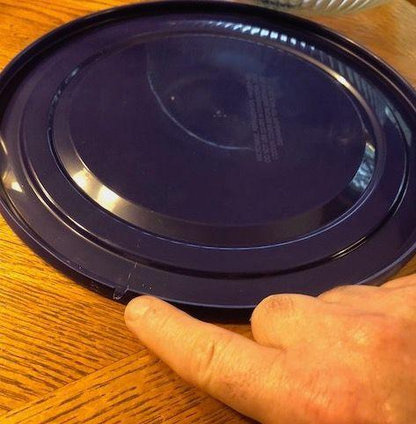
Day 2: Burning Fat in Closed Systems and Measuring Gases Lab
- Setup:
- Lay out and test the lab materials as suggested in https://youtu.be/aI86XxC85s8 and as outlined in this teacher guide.
- Cut a small slot in the lid of the Pyrex bowl so that the cord of the carbon dioxide and humidity detector can just fit through:
- Make sure to test the carbon dioxide and humidity detector. It should turn on automatically and show readings for each condition.
- Per class: Make 1 tea candle holder containing a 0.5-inch wick (as you did in Lesson 10) and 3 mL of vegetable oil.
- Alternatively if your students will use TI-Nspire CX or CX II graphing calculators with simulations in the file, “OSE 7.3 Part 3”, the materials below will not be required. Students will interact with virtual materials to conduct the same investigation using virtual duck fat, virtual vegetable oil, and a virtual wick. Follow the procedures for operating the simulation within the TI-Nspire file. For help downloading the TI-Nspire CX Premium Teacher Software and/or loading the file onto the calculators, visit www.ScienceNspired.com and follow the prompts for “Let’s get started” and “Get to know your software”. All OpenSciEd materials are located under the “OpenSciEd” link

Safety: Make sure you have an area in which you can safely conduct the burn tests. If you do these burn tests in the lab, make sure they are on non-flammable lab tables. The amount of smoke and ash that will go into the air is minimal, but let your front office know that you are burning things in lab today and make sure that you have temperature-based, rather than smoke-based, fire detectors in the lab. If you are concerned about any of these, you can relocate this lab to be done along a concrete surface outside. Again, let your front office know of this before you take students outside. Be sure to have a fire extinguisher available.

- Disposal: Allow the fats to cool completely after burning. Then, put them into a non-flammable container (e.g., a coffee canister) and place in the garbage. You can also put the oil into a freezer to cool before disposing.

- Storage: All non-perishable items can be stored for later use at room temperature. Opened oil can be stored on a shelf for one year.

Lesson 11 • Where We Are Going and NOT Going

Where We Are Going

In the OpenSciEd Scope and Sequence, the chemical reactions units addressing NGSS PEs MS-PS1-1, MS-PS1-2, MS-PS1-3, MS-PS1-5, and MS-PS1-6 come before this unit. In that prior instruction, students learned that the atoms that make up the molecules of the old substance break apart and rearrange to form new molecules made of the same atoms, only in different arrangements; these new substances have new properties, such as color and odor. Students learned that chemical reactions can release or absorb energy from the surroundings. These ideas are reinforced and built upon in Lessons 5-7, 10, and 11.

While in previous lessons students may have had lingering ideas that matter can disappear when it is burned, this lesson provides evidence that matter does not disappear in the chemical reaction during the burning process. This is due to the conservation of mass in a closed system. This also confirms that a chemical reaction has occurred due to the production of two gases—carbon dioxide and water (vapor).

This lesson solidifies the two ideas identified in the Framework for K–12 Science Education (National Research Council, 2012): “By middle school, a more precise idea of energy—for example, the understanding that food undergoes a chemical reaction with oxygen that releases stored energy—can emerge. (page 196)” This lesson also motivates students to think about how, by the end of grade 8: “...in most animals (and plants), oxygen reacts with carbon-containing molecules (sugars) to provide energy and produce carbon dioxide” (page 148).

Where We Are NOT Going

In this lesson, students put together that food molecules have carbon, hydrogen, and oxygen atoms connected together. When food molecules break apart, the atoms in them rearrange to form new substances (different molecules), and energy is released to the surroundings. However, students do not need to know about bonds breaking and forming in this process, as this is above grade level. Additionally, this lesson and unit do not address the rearrangement of matter by plants. This will be addressed in the next OpenSciEd Unit 7.4.

This lesson addresses the conservation of matter after a chemical reaction. It explicitly confirms that, if these reactions occur in a closed system, the mass of the entire system does not change. In order to remain in the middle-school grade band, students are not asked to balance equations. As stated in the assessment boundary of NGSS MS-PS1-5: “Assessment does not include the use of atomic masses, balancing symbolic equations, or intermolecular forces.”

LEARNING PLAN for LESSON 11
1 · NAVIGATION | 7 min
MATERIALS: What Happens to Fat When It Burns?
Ask students to share their ideas from the What Happens to Fat When It Burns?. Begin class by presenting slide A and having students share out their responses from Lesson 10.

Say, Last time we burned vegetable oil and duck fat and saw that, after several minutes of burning, the mass of both fats decreased. Look back at your responses to Part 3: Making Sense from What Happens to Fat When It Burns? and pick one question to explain your reasoning to your group before we share out as a class.

Suggested prompts | Sample student responses | Follow-up questions
Based on the property changes you observed, what can you explain about what happened to the fat in these containers beyond just saying “they burned”? | A chemical reaction must have occurred.  Energy was produced because we saw the light and felt the heat. | Can someone remind me what we mean when we say “chemical reaction”?
Compare the mass of each container before and after each fat burned. If matter can’t disappear, how can you explain the patterns in your data? | If the mass of the container went down, that must mean the amount of fat is going down.  The mass went down because some stuff probably went into the air. | Say more about what you mean by “stuff went into the air..”
What clues does this give you about what might be happening to food inside our bodies and M’Kenna’s body when it is used for energy? Or, what new questions does this raise for you? | (Answers may vary. Accept all responses.) | Who can add onto the idea that _________ is building?  Was anyone else also thinking of that question?
We said stuff might be going into the air when fat is burned, and that might be the reason the mass was going down. But how would we know if this was true? What evidence could we collect to prove this was happening? | Maybe we could see something going into the air when stuff is being burned. Like sometimes we see some black stuff.  Maybe we could collect stuff going into the air or capture it somehow. | How would doing that help us?  How would that help answer our question if something is going into the air?

Summarize students’ questions. Say, Wow! Our investigations seem to have led us to have even more questions. How exciting! These are really interesting ideas about what might be happening when we burn fat. We have thought about the mass decreasing, a chemical reaction occurring, and energy being produced! Let’s take a few minutes to revise our investigation to help us figure out even more about what happens in the air when fat is burned.

2 · PLAN AND CONDUCT A CLASS DEMONSTRATION TO CAPTURE THE PRODUCTS FROM BURNING FAT | 10 min
MATERIALS: Burning Fat in Open and Closed Systems lab, science notebook, tape
Brainstorm how to redesign the investigation to capture what is produced from burning the oil. Project slide B. Read the slide and have students turn and talk with a partner for a minute. Then ask for a few students to share their ideas with the whole group:  Motivate the need to conduct a controlled experiment. Prompt students to think about whether we could do this investigation with only an experimental group (the closed system).  Have students discuss the following questions.  Suggest that we try to set this kind of condition up, take some measurements from it, and see whether that helps us figure anything out.  Say, So, some of us think that the fat could be going into the air and some of us are really interested in trying to “capture” the stuff around the fat before and after it burns. Let’s see if doing closed- and open-system experiments helps us figure out where the fat is going when the mass of the fat (oil) decreases when burned.  Have students set up their data tables. Present slide C. Hand out copies of Burning Fat in Open and Closed Systems and have students tape it onto a new page in their science notebooks.  Have students label the first row of the table in part 1 as an OPEN system and the second row of the table as a CLOSED system.  Perform the demonstration of the open and closed system burns as a class.  Alternatively, you can do this demonstration using the TI-Nspire CX files instead. | ✱ SUPPORTING STUDENTS IN DEVELOPING AND USING ENERGY AND MATTER  Students may refer back to closed-system experiments that they may have done in their prior work during the OpenSciEd Chemical Reactions units. Emphasize that closed-system experiments allow scientists and engineers to trap all the matter in the system so that they can verify that the matter is conserved in physical and chemical processes. Later in this lesson, students will make the connection that, as energy is transferred as light and heat during a chemical reaction, matter is literally moving into the air.
  Suggested prompt | Sample student response
  What are some ideas that you and your partner had for redesigning this investigation? | We could try to trap the air around the thing we are burning in a container (or bag).✱  We need to make sure that we can seal the bag or container so that nothing can get in or out of the system.
  What are some things we will need to keep similar? | We will need to put everything on the balance.  We will want to use the same oil, wick, and little containers.  We need to make sure to take the mass at the beginning and end of the investigation.
  Suggested prompts | Sample student responses | Follow-up questions
  If we redid the burn investigation with just a closed system, would that be enough for us to be able to tell anything? | Yes, because we did an open-system burn last class.  No, I disagree. If we just used a closed system, it wouldn’t be enough to draw any conclusions. | How would we tell if there is actually a difference in our closed system when doing it this time? What would we compare to our closed system?
  ADDITIONAL GUIDANCE | You may want to introduce the idea of running a control condition, which is a useful thing to do when conducting investigations, so that you have something to compare your results to. Emphasize that the open system is our control condition because a good control group should have results that are known. We know from previous experiments that the mass will decrease in the open system. What we are wondering is if matter is going into the air and if the mass will change in a closed system, so that’s our experimental group.
  Suggested prompt | Sample student response
  How could we measure if something is coming out in the closed and open systems? | We could do the same thing as last time, and measure how much they weigh before and after they burn.
  What would that tell us? | We could see if the weight lost between the open and closed system are the same or different. It would tell us if something is going into the air if the mass stayed the same in the closed system. It also might tell us if a chemical reaction is happening.
  Turn and talk with a partner. What do you predict would happen? Why? | We think the same thing would happen as last time with the open system. The mass should decrease. But I think the mass might stay the same in the closed system because I think something new is being produced and going into the air.
  SAFETY PRECAUTIONS   | Ensure student safety by:  - Have students get safety goggles and put them on.  - Then have students collect their science notebooks and chairs and make a circle around the demonstration table. They should sit at least four feet away from it (for safety and so that everyone can see). Emphasize that the energy release in the demonstrations can be dangerous if they get too close.  - Students will be at a common demonstration area for the remainder of this investigation, which is why having seats with them will be helpful.
  1. Take out two tea candle holders with vegetable oil and wicks already in them. Tell students that each has vegetable oil in it. 2. Zero the first electronic balance. Mass the tea candle holder, oil, and wick assembly. Have students record this initial mass of the open system in their data tables. | 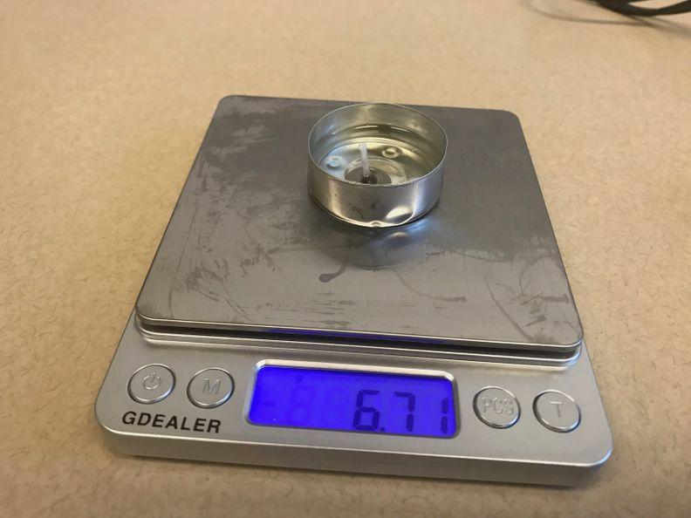
  3. Light the wick and set the timer for 1.5 minutes. Leave the open system on the balance. Let this burn while setting up the closed system. Then record the mass of the open system. | 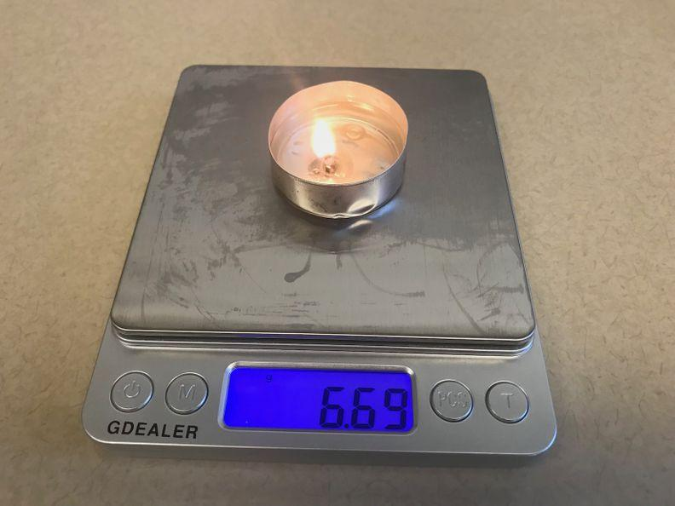
  4. Place a loop of tape on the back side of the lid of the airtight container. Stick the second tea candle holder assembly to this loop of tape on the lid. This helps secure the tea candle holder assembly to the lid so that it doesn’t slip and spill when you seal the lid on the container. Light the wick. Have another person place the clear part of the airtight container over this. | 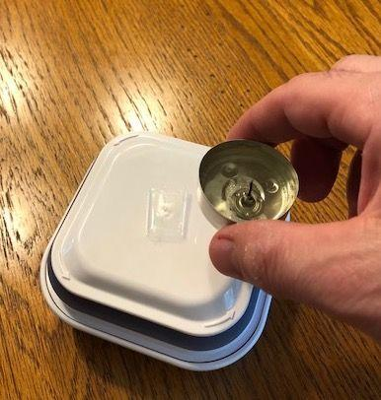
  5. Once the lid is seated into the container, press the button on the lid (which is now on the bottom) to seal the system. | 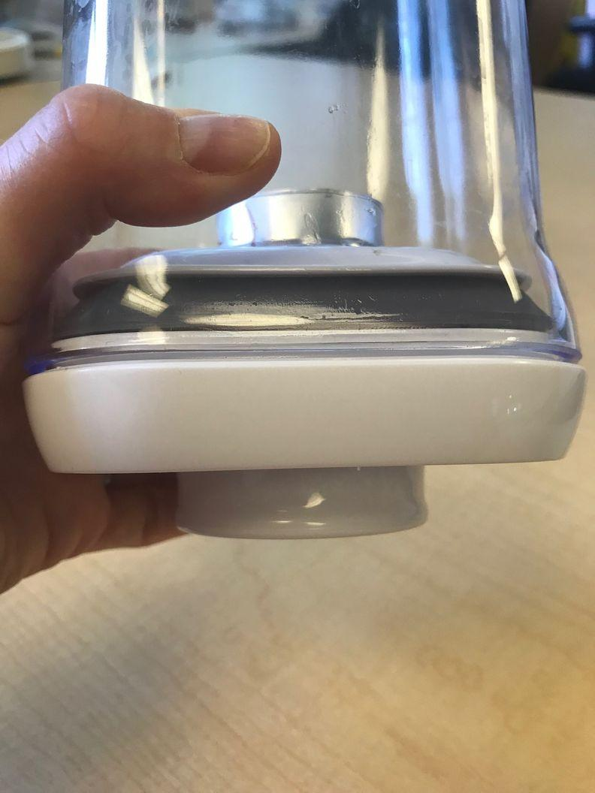
  After you press the button on the bottom of the lid should look flat. | 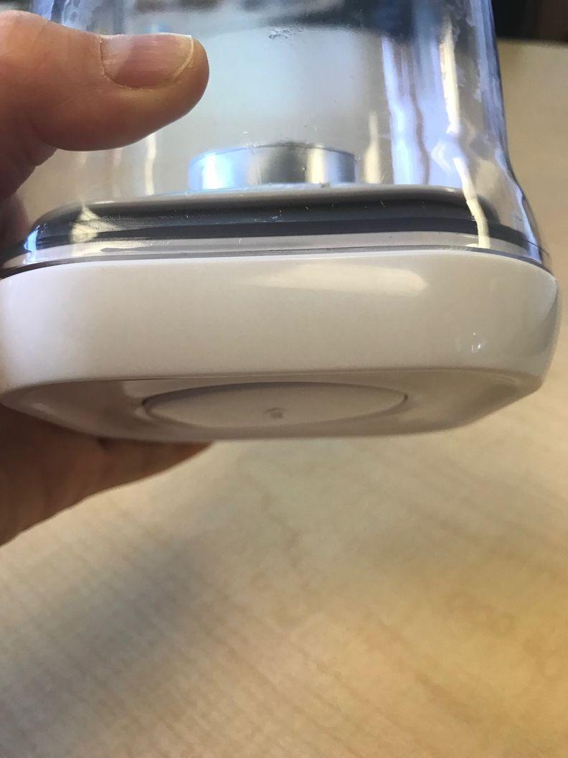
  6. Zero the second electronic balance. Then mass the entire closed system container with the food (vegetable oil) burning in the tea candle holder. Wait a few seconds for the numbers to stop changing and for the system to equalize on the balance. Have students record the initial mass of the closed system in their data tables. Leave the container on the balance. | 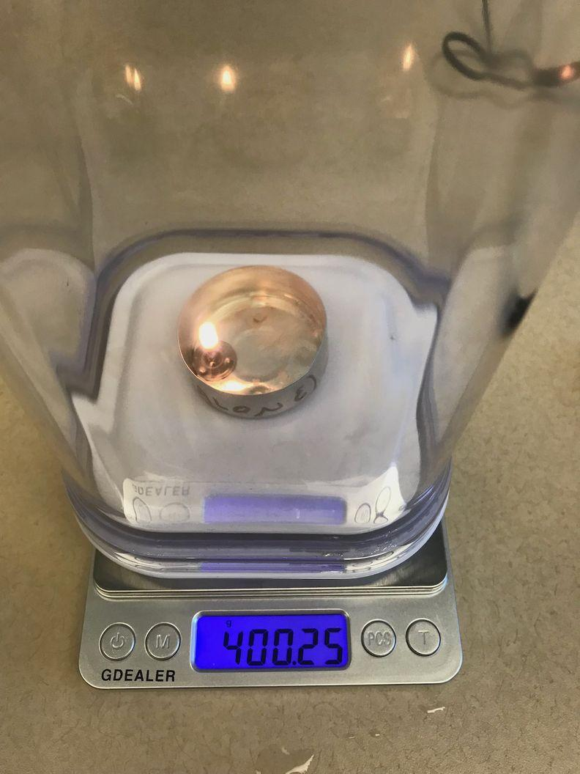
  7. In 1-2 minutes, the vegetable oil in the closed system will burn out. Have students start taking qualitative observations of this system and record them and the mass of the system now (it should have remained unchanged). Have students record the final mass of the closed system. | 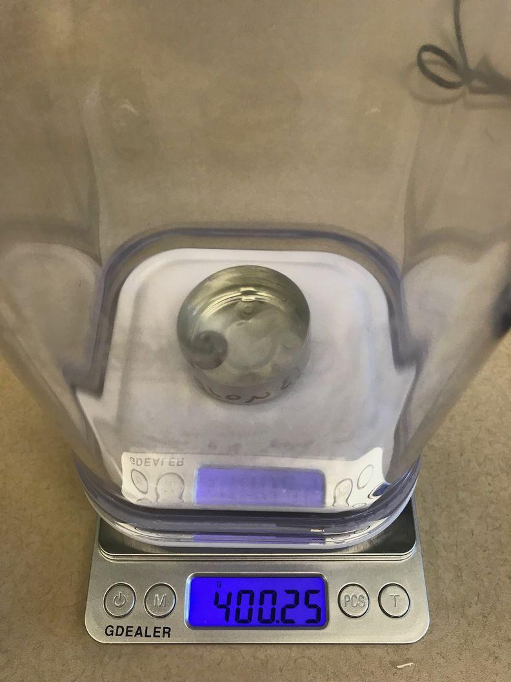
  8. Suggest that we keep letting the oil burn for another couple of minutes and see whether we notice any mass changes (or additional mass changes, as it will have already probably dropped by 0.1- 0.2 g by now). While this is happening, have students make additional observations of the closed-system container and record anything else interesting that they notice in it. After burning for about 4 minutes, blow out the flame and have students record the final mass of the open system.
  ADDITIONAL GUIDANCE | This electronic balance goes to the 0.01 g. It is very sensitive to movement (even of the air). If the mass seems to be fluctuating, have the students stand back and make sure they are not touching the table or moving air around. If you notice the mass start to increase, give the balance a few seconds to get to an amount and stay there before recording the mass. If mass continues to fluctuate, take the entire system off the balance, zero it, and place the system back on. You should get the same mass as when you started.
  ALTERNATE ACTIVITY | Students may suggest to let the wick-oil assembly continue to burn on the balance. This will get hot but it is OK to do and will support students in connecting the idea of the mass decreasing with the amount of fat decreasing.

3 · BUILDING UNDERSTANDING DISCUSSION: BURNING FAT IN OPEN AND CLOSED SYSTEMS | 8 min
MATERIALS: science notebook, Burning Fat in Open and Closed Systems
Have students develop explanations for their results. Students can now remove their safety goggles, but have them keep them out for the next investigation.  Project slide D. Tell students that you are assigning pairs of students to Turn and Talk about one of three questions—A, B, or C—and then report what they discussed in a couple of minutes to the whole group.  Count off pairs of students standing next to each other, “A, B, C, A, B, C. . .” Then have students find another student with the same letter. Give student pairs two minutes to discuss their question.✱    Facilitate a Building Understanding Discussion. Have students who discussed question A share an idea that they heard their partner share. Encourage all students to work with and build off their ideas, adding on, offering alternate explanations, or restating the ideas shared so far. Give a couple of minutes to discuss each of the questions (six minutes total).  Motivate students to look more closely at what is in the air around us.  Say, I’ve got some data that shows the most common substances found in the typical air around us. Let’s take a look and see what we find. | ✱ ATTENDING TO EQUITY  Depending on the needs of your students, you can determine if students should be in homogeneous ability groups or heterogenous (mixed) ability groups. Alternatively, you could have students find a partner who is different from them in some way—perhaps a person who attended a different elementary school or has a different type of hair.  ✱ ATTENDING TO EQUITY  Some students will probably know that fires need oxygen to burn from prior background knowledge, even though we don’t have empirical evidence for this yet. It is OK if students don’t say it is oxygen and just say air. We will look at data in Lesson 12 that shows levels of oxygen going down and being used in this chemical reaction.
  ADDITIONAL GUIDANCE | If nothing appears on the sides of the closed-system container, just count off pairs to discuss questions A and B. There should be some water condensation that appears, which is a product of burning oil. It’s OK if it doesn’t come up here. Students will see evidence of the humidity increasing in the next experiment.
  KEY IDEAS | Purpose of this discussion: Prompt students to share out what they think their results from burning fat in open and closed systems mean. Students should notice and wonder about why the flame went out so quickly in the closed system. This problematizes the next piece of the lesson during which students try to figure out what is being produced from this chemical reaction.  Listen for these ideas:  - The mass of the closed system did not change because we were able to trap whatever was going into the air. The open system mass still went down.  - The flame in the closed system went out sooner than the one in the open system because it ran out of something in the air that it needed.  - Liquid appeared on the sides of the closed-system container walls when the burn was done, and this liquid might be water.
  Suggested prompt | Sample student response
  A. When burning the fat, why did the mass of the closed system remain stable, while the mass of the open system changed? | In the open system, the stuff that used to be in the fat went into the air and spread out around the room, which is why the mass of the system decreased. So, since the mass decreased, that must mean the amount of fat left in the tea candle holder decreased.  But even if stuff went into the air in the closed system, we had it trapped, so we could still detect its mass inside the container.
  B. Why did the flame in the closed system go out so much sooner than the one in the open system? | It ran out of air.  It ran out of oxygen.✱  The oxygen got used by the fire.  There wasn’t enough oxygen left for the fire to keep burning.
  C. What did you see in the air and on the sides of the closed-system container walls when the burn was done? What do think that substance might be? | (Accept all responses, such as water, smoke, condensation, etc.)
  ASSESSMENT OPPORTUNITY | This is a midway point in building towards the Lesson Level Performance Expectation of Construct an explanation using both qualitative and quantitative data and scientific reasoning (that burning food produces energy, in the form of heat and light, and produces carbon dioxide and water) to describe why the mass of oil burned in an open system changes but in a closed system stays the same." Students should be able to compare the different experimental systems and explain that the open system changed because matter was going into the air, but the mass of the closed system stayed the same because we were able to trap the matter; instead of leaving the system, the matter stayed in the container, and thus could be read by the scale. If students do not make this connection, have them draw where they think the matter went in both the closed and open systems.
  Suggested prompt | Sample student response
  Why do you think the flame went out in the closed system but stayed lit in the open system? | The fire in the closed system probably ran out of air, but the open system could use as much air as it needed.
  So I hear you saying that, even though there was still fat (oil) in the container, the flame went out quickly in the closed system. Did I get that right? | Yeah, the flame went out because fire needs air (or oxygen), and it ran out of it in the closed system.
  So is oxygen the only thing in the air?  OR  What do you think is in the air that the fire needs? | I’m not totally sure.
  Do you know everything that’s in the air? | I think there is dust. I’m not really sure of everything that’s in the air.
  How could we find out what’s in the air? | Maybe someone has a list of what’s in the air.

4 · ANALYZE DATA TO DETERMINE WHAT IS IN AIR | 4 min
MATERIALS: science notebook
Notice and wonder about the gases in air. Project slide E. Ask students if they recognize any of these gases shown in the table on the slide and what they know about them. Then ask which of the atoms in the chemical formulas for these gases are ones we have encountered before in our investigations.✱  Problematize what we could do to figure out what gases are changing in the air when burning fat.  Say, I have a device that can detect a couple of the gases in the air. We can use this to measure the changes in the amount of gases in the air as a result of burning the oil. Let’s try this test again. | ✱ ATTENDING TO EQUITY  Depending on where you are located, students may be able to make connections to either low or high humidity based on familiarity with their local community. This is an opportunity to have your students come to a consensus definition to describe how much water is in the air and add to your word wall using their personal experiences with water vapor (or lack thereof) in the air.
  Suggested prompt | Sample student response
  What do you notice and wonder about the gases typically found in air? | There are a lot of different gases in the air!  Wow! There is so much nitrogen, 78%.  The humidity can vary. What does that mean?
  Which of these gases have you heard of before? | Nitrogen, oxygen, carbon dioxide, water vapor.  I haven’t heard of argon; what is that?
  Notice the symbols for the atoms that make up the molecules, N, O, C, H, Ar. Which of these symbols have we seen in our previous investigations? | N, O, C, H.
  Does anyone recall what atoms those symbols stand for? | Nitrogen, oxygen, carbon, hydrogen.
  ADDITIONAL GUIDANCE | Some students may notice that the possible percentages for water vapor in the air can range from 0 to 4 percent; but if it was 4 percent, then the other numbers wouldn't add up to 100 percent. If this arises, emphasize that this is a good noticing and important mathematical thinking. Ask students what they think will happen to the other percentages of other gases in the air, in conditions in which the water vapor in the air reaches 4 percent. Students should say that these will drop.
  Suggested prompt | Sample student response
  So, we think that this reaction might need oxygen from the air. We think that gases went into the air, which might be a result of the reaction. We think they did because the mass of the closed system did not change.  So, what gases do you think went into the air when we burned the food? | I don't know?! Maybe nitrogen?  Could oxygen also go into the air?  Carbon?
  How could we figure out what gases went into the air? | Remember when we wanted to know what food molecules were in different foods? We used something (an indicator) to help us see molecules that were there but were too small to see. Is there something like that for gases in air?

5 · PLAN AND CONDUCT A CLASS DEMONSTRATION TO MEASURE THE CHANGING GAS CONCENTRATIONS WHEN BURNING FAT | 10 min
MATERIALS: Burning Fat in Closed Systems and Measuring Gases lab, science notebook, Burning Fat in Open and Closed Systems
Introduce the second investigation system. Tell students that we will do the test again for just a closed system, following a similar procedure, but this time, we will use a tool to measure the gas levels in each system so that we can see whether the amounts are changing.✱  Make predictions for the second investigation system. Project slide F. Emphasize that there are detectors that can detect other types of gases, too, but this detector can only detect a subset of them (carbon dioxide and water vapor). If students wonder, “Isn’t it important to see if there are any changes in N₂ or Argon?” say that the detector you have can only measure CO₂ and water, but maybe they could think of a way to measure N₂ or Argon in our classroom.  Give students a minute to fill in the first column of the part 2 data table shown on the Burning Fat in Open and Closed Systems handout for the substances they have been investigating: something from the air, oil/fat, water vapor, and carbon dioxide.  Then project slide G. Demonstrate how to make predictions in column A by filling out what we think happens to the amount of something needed from the air in a sealed container as the flame burns and eventually goes out.  Ask students what they predict will happen to the mass of the food as it burns. Students will say, It decreases. Emphasize that, since we all agree on this prediction, we should fill in the first column with a down arrow ↓.  Take the initial measurements of the air and food in the closed system. If your school has a no-flame policy, use the TI-Nspire CX file, “OSE 7.3 Part 3”, found at www.ScienceNspired.com, with TI-Nspire CX Premium Teacher Software and/or TI-Nspire CX or CX II graphing calculators, or play https://youtu.be/zt_z0eyvxtM .  Add a tea candle holder with a wick. Then put it on the electronic balance. Zero the balance. Add oil using a pipette until the bottom of the wick is covered. Record the initial mass of the tea candle holder assembly with the oil.  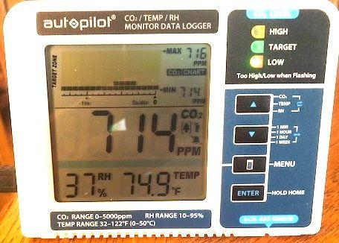  Show students the carbon dioxide and relative humidity detector. Show slide H to reference the different parts of the detector.  Tell students that we will be recording the values for the carbon dioxide and water vapor (humidity) in the air now and after the burn.  Practice running the investigation. Ask for a student volunteer to read the readings off of the detector for the amount of carbon dioxide and water vapor (relative humidity). Have them show the other students where they are getting the information on the detector. (The image above shows a carbon dioxide reading of 714 parts per million (ppm) and a relative humidity reading of 37 percent.)  Once values stabilize as much as possible, have students record the carbon dioxide and water vapor values on Burning Fat in Open and Closed Systems in column B before the burn. Project slide I.  In another minute the flame will burn out. Then place just the tea candle holder assembly on the balance and record the final mass of the tea candle holder assembly with the oil.  Refer to slide J and have students record the final values for each substance in their data tables. This is highlighted in the green cells in column C on the slide.  Have students individually add arrows in column D, showing them carbon dioxide and humidity going up ↑ (based on the results measured from columns B and C). | ✱ SUPPORTING STUDENTS IN ENGAGING IN PLANNING AND CARRYING OUT INVESTIGATIONS  Optional: If time permits, press your students to explain how you could run a control condition for this experiment. Students may suggest running the detector with an open system (with the glass bowl off and burning the same wick-oil assembly) or leaving the bowl on top and running the detector without burning a wick-oil assembly.
  SAFETY PRECAUTIONS | Ensure student safety.  - Have students put their safety goggles back on.  - Students should still be in a circle around the demonstration table at least four feet away from it (for safety and so that everyone can see).
  ADDITIONAL GUIDANCE | A nonessential idea in this lesson is to understand what relative humidity measures. But it is worth pointing out that 100 percent humidity does not mean that the air is filled with only water vapor molecules. Here is a short summary you can share with students to explain what it is measuring. Say: Relative humidity isn’t a measure of the percentage of water in the air, but rather how close the amount of water in the air is to the maximum that can be in the air before it reaches the maximum that can be held in the air. For example, 100 percent relative humidity means that the air can’t hold any more water vapor without it clumping together and coming out in little droplets. On some days, 100 percent relative humidity could mean that the air has reached that 4 percent value we saw in the range of possible amounts of water vapor found in the air from day-to-day and place-to-place.
  1. Place the tea candle holder with oil and wick on the upside-down cover for the Pyrex bowl. Place the detector next to the candle holder so that there is enough room to place the Pyrex bowl upside down over both things and still have the edge of it sitting on the cover. The cord of the detector should run through the slot that you have cut in the lid. | 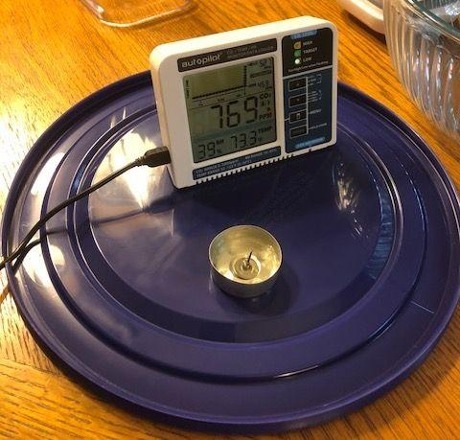
  2. Have a couple of student volunteers get ready to read off carbon dioxide and humidity values from the monitor every 10 seconds when you say “Go.” Have one person read off carbon dioxide readings, one person read off relative humidity readings, and one person say “Now” every 10 seconds. Have another student record these on the board or on a piece of chart paper for the class to reference. | 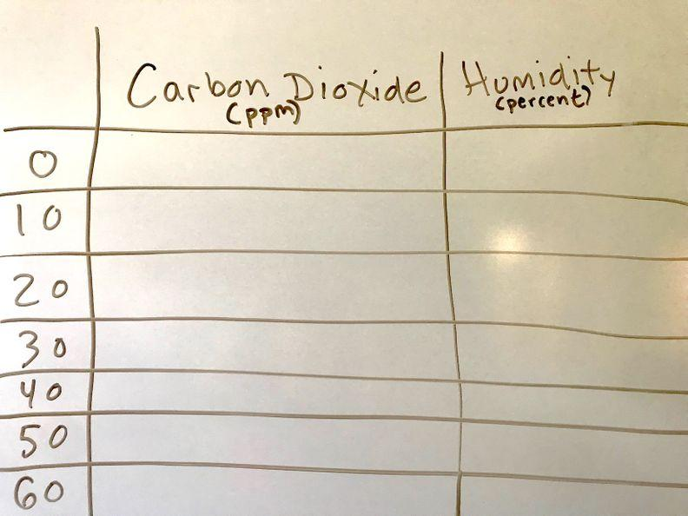
  3. Have a piece of tape ready to tape over the hole where the cord enters the bowl, and seal the system closed. | 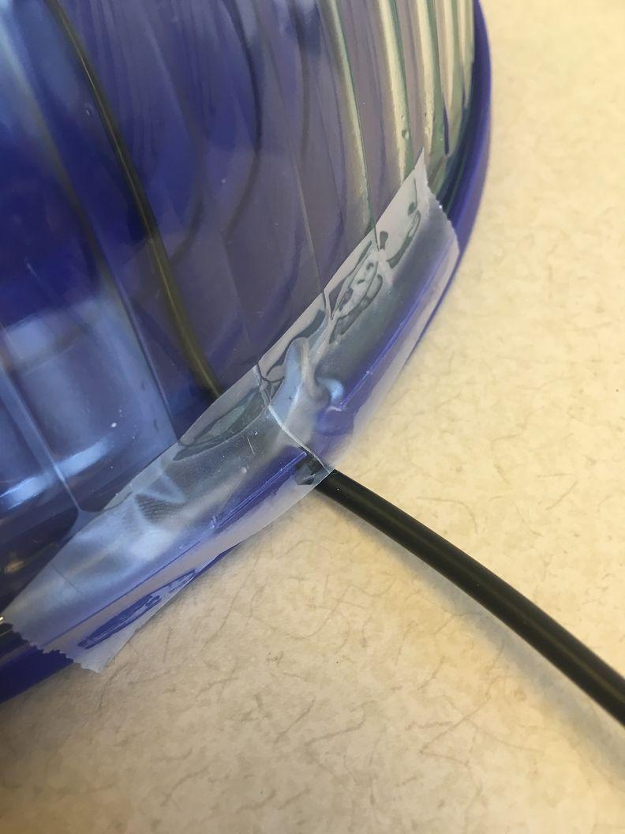
  4. Light the wick. Now place the Pyrex bowl upside down over both the tea candle holder assembly and detector and set it in the lid. Tape over the hole where the cord enters the bowl. This is not an airtight system, but it will suffice for capturing the buildup of gases from the burn. Say, “Go.” Now have students read off and record carbon dioxide readings every 10 seconds. | 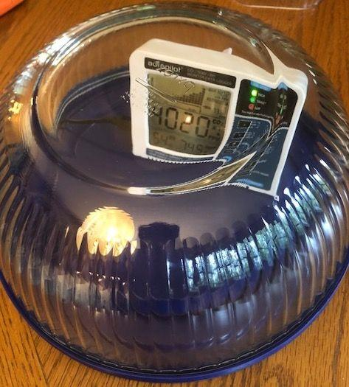
  5. After about a minute, the carbon dioxide reading in the container will get above 4,000. This will be the last reading students will be able to report before the “high” warning light comes on.

6 · MAKE SENSE OF OUR CLOSED VERSUS OPEN SYSTEM RESULTS | 5 min
MATERIALS: science notebook, Making Sense of Burning Fat Investigation Results
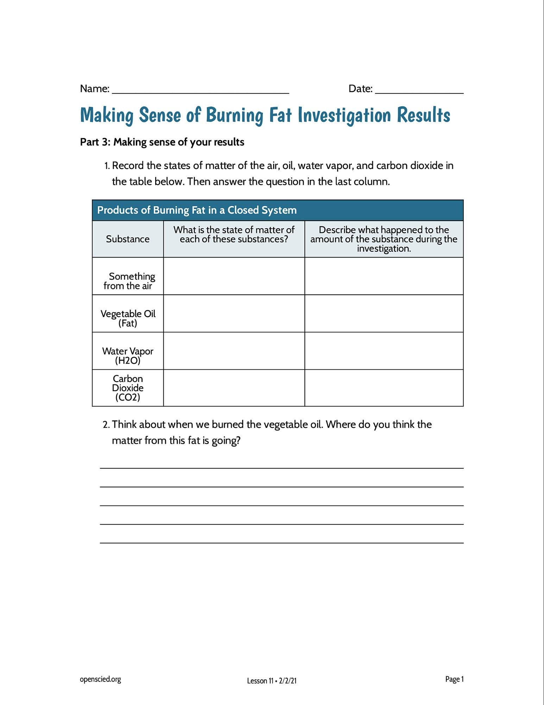
Project slide K. Hand out Making Sense of Burning Fat Investigation Results.

Assign the “Making Sense of Your Results” questions (part 3) as home learning. If time permits, have students return their chairs to their regular tables and work on the questions on Making Sense of Burning Fat Investigation Results. If time is short, or some students are not done, assign the completion of these questions for home learning. Emphasize that sharing their responses to these questions will be what we do at the start of the next class.

End of day 1
7 · NAVIGATION | 10 min
MATERIALS: science notebook, Making Sense of Burning Fat Investigation Results
Have students review and share their answers to Making Sense of Burning Fat Investigation Results. Present slide L, which has the four questions from the handout that students will discuss in small groups.  Once all students have found their responses and read through them once to themselves, present slide M, which outlines a small-group discussion protocol for students to share their ideas about the ”Making Sense” questions.✱  Assign students to groups of three and give them about seven minutes to share their ideas in small groups, following the protocol on slide M. | ✱ ATTENDING TO EQUITY  The talking stick protocol is used to ensure equitable floor time for all students in the discussion. The later rounds of discussion encourages students to work with and build off of each other’s ideas that are shared in the group.

8 · CONSENSUS DISCUSSION ABOUT WHAT HAPPENS TO MATTER WHEN IT’S BURNED | 10 min
MATERIALS: discussion norms poster, chart paper, markers
Facilitate a Consensus Discussion. Project slide N. Gather the class in a Scientists Circle. Review the class created discussion norms and have students pick one to focus on during this Consensus Discussion. Use this opportunity to establish agreement on the ideas that groups were converging on related to the questions discussed in the previous step.✱ | ✱ STRATEGIES FOR THIS CONSENSUS DISCUSSION  You may want to stagger the arrangement of students in the circle so that students are talking to new people next to them in the discussion. It is important to use words that the class agrees upon to capture the essential ideas outlined here, rather than using the exact wording in this teacher guide.
  KEY IDEAS | Purpose of this discussion: See what we can agree upon regarding what happens to matter and energy when fat is burned in a closed system.  Listen for these ideas:  - Light and heat energy were produced.  - Water appeared on the walls of the container.  - Carbon dioxide increased.  - In order for some substances to increase, other substances had to decrease.
  Suggested prompt | Sample student response
  What connections about matter and energy did you make to other students’ ideas during the talking stick protocol? | My partner said that the matter of some substances went down, and I said the matter of other substances went up.  My partner said that energy was produced.
  Can you be more specific? | We saw that the mass of the oil decreased, and the amount of carbon dioxide and water increased.
  How do we know energy was produced in this reaction? | We could see the light and feel the heat.
  Where did that energy come from and what evidence do we have that there was energy there to start? | The food! The energy was in the oil, and we saw in Lesson 10 that vegetable oil has a lot of calories from fat (which we can use to measure energy).
  So what about other foods we eat besides vegetable oil—can those be burned for energy, too? | If we know that other foods have calories, then we should be able to burn those as well.

9 · ANALYZE NUTRITION LABELS TO DETERMINE IF OTHER FOODS PROVIDE ENERGY | 5 min
MATERIALS: None
Examine nutrition labels to determine if other foods also have energy in the form of calories. Project slide O. Ask students to make noticings about how the food labels for carbohydrates and proteins compare to fat as a source of energy. Ask students to recall the fat label from Lesson 10. | ✱ ATTENDING TO EQUITY  Add this working definition of fuel to your class word wall so that all students can have a consensus on what the class means when using the word ‘fuel.” To support Emergent Multilingual learners, make sure to write and draw examples of different fuels. You can also ask students to say the names of fuels in their home language and add those words to the word wall.
  Carbohydrate food label: Marshmallow | Protein food label: Tuna
    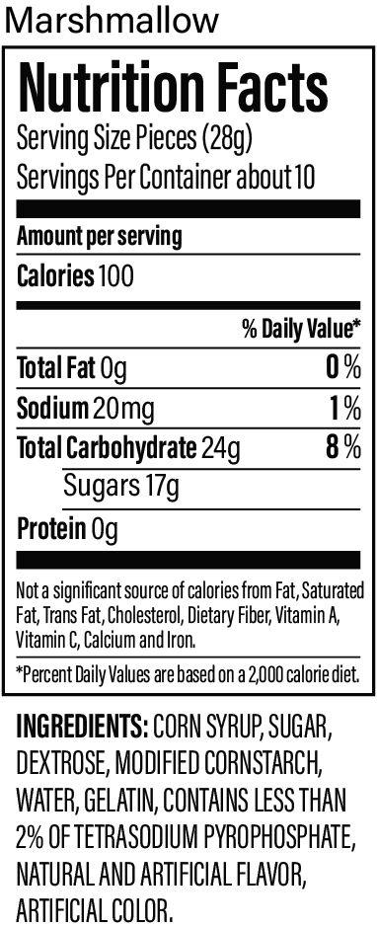
    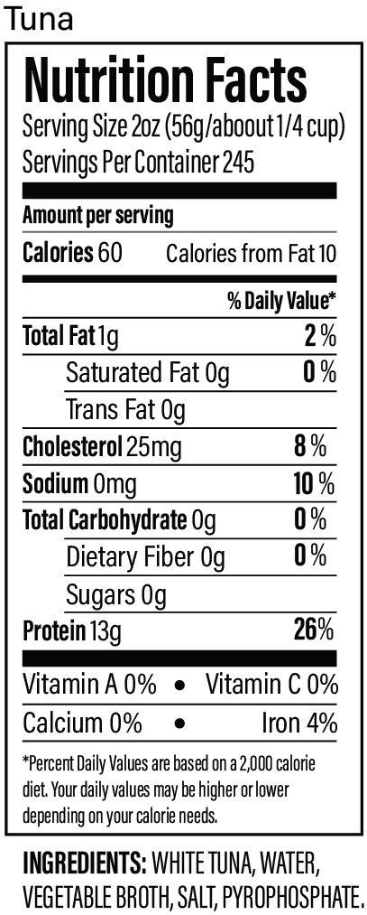
  Suggested prompt | Sample student response
  What food molecules are these mostly made up of? | Marshmallows are mostly made of carbohydrates. Tuna is mostly made of protein.
  Do they contain other substances besides fat? | They have a few other things like sodium, but sodium isn’t a food molecule and neither are those weird chemical names we can’t pronounce in the marshmallow.
  What else do you notice? | Both marshmallows and tuna have calories!
  Can you remind us what you mean when you say “calories?” | Calories are the energy our bodies need to do things like play basketball. Like fat, it has a lot of calories.
  So, do you think that, if we burn these foods, the same thing would happen as when we burned the oil? | We were able to burn the fat and transfer energy as light and heat. So maybe we could burn these foods and they would transfer energy as light and heat, too.
  Do you think we could burn other non-food things and get energy from them? | Answers will vary.  We could burn a candle.  Gasoline is burned by cars and can catch fire.  We burn fuel in our grill or on the stove.  Wood.
  So, you are saying that all of these food items, like marshmallows, duck fat, and vegetable oil, and non-food items, like wood and gasoline, have something in common? We could burn any of these things, and we would get energy out of the system? | Yeah, I guess that’s right!
  So, these are all types of “fuels.” A fuel is any material/matter that can react with other substances so that it releases energy.✱  If you burned these other foods as fuel, what do you predict would be the products? | Well, when we burned fat, we made carbon dioxide and water, so if we burn these foods, we might make those same things.
  ALTERNATE ACTIVITY | Students may want to burn other specific foods (such as marshmallows or cheese puffs) to determine if they provide energy. If time permits, students can build a stand to burn food using a paper clip tapped to a piece of cardboard that is wrapped in tinfoil or in a chunk of clay.  There is also an optional home learning https://www.mprnews.org/story/2008/04/16/frenchfry_bus or possible substitute day reading about using different fuels to power vehicles (such as a french fry bus) any time after Lesson 11.

10 · COMPARE CARBON DIOXIDE AND WATER TO FOOD MOLECULES | 5 min
MATERIALS: science notebook, Air Molecule Reference
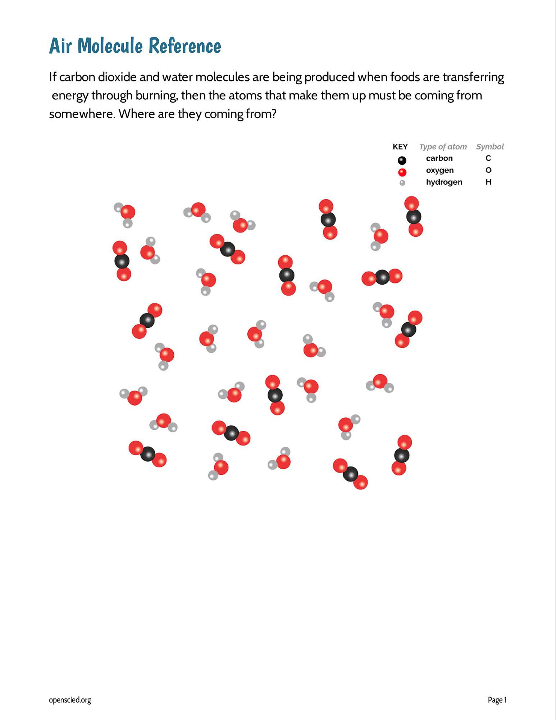  Revisit the molecular representations of food to look for evidence for the source of matter in the products of carbon dioxide and water. Use Air Molecule Reference and Analyze Data from Eating a Graham Cracker. Project slides P and Q.  Pose the question, If carbon dioxide and water molecules are being produced when foods are transferring energy through burning, then the atoms that make them up must be coming from somewhere. Where are they coming from?  Hand out Air Molecule Reference to each pair of students. Tell elbow partners to use this reference to help them discuss this question further.  After a minute, have students share their ideas with the whole class. | ✱ ATTENDING TO EQUITY  If your word wall from the OpenSciEd Unit 7.1 is still up, walk over to the definitions that your class created for reactants (the substances you start with in a chemical reaction) and products (the new substances that occur after a chemical reaction); if not, add “reactants” and “products” to the word wall for this unit.
  Suggested prompt | Sample student response
  Where do you think the atoms that make up the carbon dioxide and water molecules that started appearing in the container came from as we burned the food? | They came from the food molecules that were burned!  Maybe they came from the air, too.
  How is that possible? Who can say more about that? | When we burned the food, the molecules that were part of the food got broken apart, and those atoms rearranged to make new molecules when they reacted with the air.  Carbon dioxide and water are made of similar atoms to fat!
  So, I hear you saying we started with one substance and ended up with more of other substances through a reaction? | We said that a chemical reaction must be occurring because the substances we ended up with are different than the ones we started with.
  Can someone remind me what we call the stuff we start with in a chemical reaction? | We call what we have at the beginning of a reaction the reactants.
  And what do we call the stuff we end up with at the end of the reaction? | We call what is left over or produced from a chemical reaction the products.✱
  So what would be our reactants and products when we burn fat as a fuel? | We start with the air (oxygen) and fat/food as our reactants.  During the reaction, light and heat are released, and we end up with an increase in carbon dioxide and water as our products.

11 · ADD TO OUR PROGRESS TRACKERS | 10 min
MATERIALS: science notebook, Progress Tracker, markers, chart paper
Ask students to return to their seats to update their Progress Trackers. Hand out the three-column Progress Tracker.

Present slide R. Say, Wow, we have really figured out a lot about changes in energy and matter when burning fat. Before we take a few minutes to individually capture our thinking in our 3-column Progress Trackers, let’s summarize our consensus ideas. Can someone give me a 30-second speech summarizing everything we have figured out about burning fat today? The rest of the class will listen to make sure we have evidence to support those ideas and be ready to agree or disagree.

Tell students that we have just spent a lot of time building understanding and then coming to a consensus on what we think is happening to food molecules when fat is burned. Now, we are going to individually construct an explanation in the form of a model (or some other representation) for showing how what we have figured out helps explain what happens to food molecules when they are burned.

Have students add what we have figured out to their Progress Trackers along with the lesson question and source of evidence that led to these findings.

Here is one representation of what students might write.

Question | Source of evidence
11. What happens to matter when it is burned? | - Burning food in open and closed systems and measuring the mass of both systems.  - Burning food in a closed system and measuring the change in concentrations of gases in the air.  - Molecular composition of air.
What we figured out in words/pictures
- When food is burned, a chemical reaction occurs because energy is released in the form of heat and light, and different substances are made.
- The concentration of gases in the air changed when the oil was burned. Both carbon dioxide and water increased.
- Matter is also conserved when the new substances are made because the mass of the closed system remained the same before and after burning the oil.

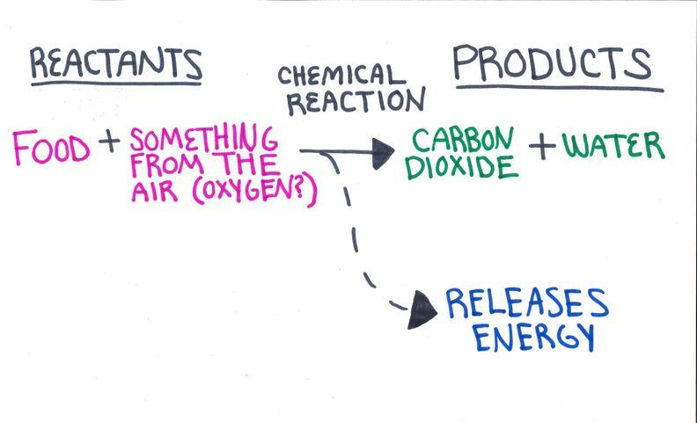

12 · NAVIGATION | 5 min
MATERIALS: None
Have students brainstorm next steps with a partner. Have students return their chairs to their desks. Present slide S.

Say, But now we are wondering, how does this work in our body system? The data we observed shows this for burning fat in a dish, but is this how it happens in our bodies?

Ask students to turn and talk about ideas for the two questions on the slide for a couple of minutes.

Have students share out their ideas in the last three minutes.

Suggested prompt | Sample student response
Do you think a similar kind of chemical reaction is happening in our bodies to provide us with energy from food to do things? | Maybe, since I have heard that you breathe these gases in and out.  Some sort of chemical reaction must be happening, but I don’t know how similar it is to this one.
Are we having little fires to burn things, like fat, protein, and glucose, for energy inside our bodies? | No, because there isn’t a flame inside of us, is there?  Wait, is this why we get hot when we exercise?
What additional evidence could we collect to help us investigate this? | We could measure the air we breathe out.  We could see if these gases are in our bodies.  We could get data from inside different parts of the body to see if a chemical reaction with food is happening there.

