The goal of this activity is to help you understand how the graph of a function can be translated vertically (up or down) and horizontally (left or right) by adding to or subtracting from the output or the input. | 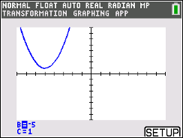

In this activity, the movements of the parent functions $f\left(x\right)= x^{2}$ and $f\left(x\right)= x^{3}$will be explored. You will be using the Transformation Graphing App and the program MOVEIT, downloaded by your teacher. First, access the App by pressing apps and selecting Transfrm. Press any key to start. You will now access the MOVEIT program by pressing prgm. If you are using a TI-84 Plus CE without Python, you will select MOVEIT. If you are using a TI-84 Plus CE with Python, you will press
1: TI-Basic and then select MOVEIT. On the Home screen, two options will appear. Option 1 will graph the parent function $f\left(x\right)= x^{2}$ and option 2 will graph $f\left(x\right)= x^{3}$. Press 2nd [quit] to exit a graph. Press enter immediately to run the program again. For each problem in this activity, look at the transformation of both types of functions.

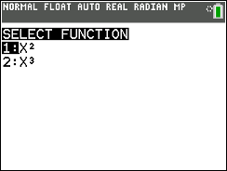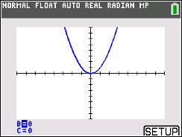
Problem 1 – $f\left(x\right)→f(x-b)$
Use the left and right arrow keys to change the value of B only. Leave C = 0. You will need to first determine the value of B in each question.

Let’s see what you remember about transforming $f\left(x\right)→f(x-b)$:
In questions 1 and 2, describe the transformation for each graph as compared to the graph of the parent function $f(x)$, use your handheld to verify your answer.
1. $f(x-2)$ __________________________________________________________

2. $f(x+5)$ __________________________________________________________
3. In general, describe the transformation of $f\left(x\right)→f(x-b)$ and explain your reasoning.
____________________________________________________________

____________________________________________________________

Problem 2 – $f\left(x\right)→f\left(x\right)+c$

Use the up and down arrow keys to toggle to C and then the left and right arrow keys to change the
value of C only. Leave B = 0.

Let’s see what you remember about transforming $f\left(x\right)→f\left(x\right)+c$:
In questions 4 and 5, describe the transformation for each graph as compared to the graph of the
parent function $f(x)$, use your handheld to verify your answer.

4. The graph of $f\left(x\right)+4$ ________________________________________________________

5. The graph of $f\left(x\right)-3$ ________________________________________________________

6. In general, describe the transformation of $f\left(x\right)→f\left(x\right)+c$ and explain your reasoning.
____________________________________________________________

____________________________________________________________

Problem 3 – $f\left(x\right)= {(x-b)}^{2}+c$

7. Describe the transformations of $f\left(x-7\right)+6$ as compared to the parent function $f(x)$.

____________________________________________________________

____________________________________________________________

8. In general, describe the transformations of $f\left(x\right)= {(x-b)}^{2}+c$ when:

b and c are both positive _______________________________________________________

b and c are both negative ______________________________________________________
b is positive and c is negative _______________________________________________________

b is negative and c is positive _______________________________________________________

Problem 4 – $f\left(x\right)→af(x)$

In order to transform your function through the multiplication of a, press Y = and enter AX² next to Y₁ and AX³ next to Y₂. Press enter on the = sign to choose the function you want to graph. Press graph to explore the transformations.

9. Describe the transformation of $0.5f(x)$ as compared to the parent function $f(x)$.

_______________________________________________________________

With a classmate, create a table of values comparing the y-values for given x-values for the functions $f\left(x\right)= x^{2}$ and $f\left(x\right)=0.5x^{2}$. For example, when x = 2, the corresponding values for the functions are 4 and 2 respectively. In other words, the y-values are “pushed lower” as a result of multiplying by 0.5. This is known as a _____________________________________.

10. Describe the transformation of $2f(x)$ as compared to the parent function $f(x)$.

______________________________________________________________

11. In general, describe the transformation when $0< \left|a\right|<1$ for the graph of $af\left(x\right)$ as compared to
the parent function $f(x)$.

______________________________________________________________

12. In general, describe the transformation when $\left|a\right|>1$ for the graph of $af(x)$ as compared to the
parent function $f(x)$.

______________________________________________________________

13. Change the coefficient of the quadratic and cubic functions to -0.5 and then to -2. Describe the
graph of $af\left(x\right)$ when a is negative as compared to when a is positive.

______________________________________________________________

Problem 5 – $f\left(x\right)→f(ax)$

In order to transform your function through the multiplication of a, press Y = and enter (AX)² next to Y₁ and (AX)³ next to Y₂. Press enter on the = sign to choose the function you want to graph. Press graph to explore the transformations.

14. Describe the transformation of $f(2x)$ as compared to the parent function $f(x)$.

_______________________________________________________________

With a classmate, create a table of values comparing the y-values for given x-values for the functions $f\left(x\right)= x^{2}$ and $f\left(x\right)=(2{x)}^{2}$. For example, when x = 2, the corresponding values for the functions are 4 and 16 respectively. In other words, instead of it taking x = 4 to get y = 16, it took x = 2 to get y = 16, therefore x-values are “pushed lower” as a result of multiplying the x-value by 2 or the x-value was halved. This is known as a _____________________________________.

15. Describe the transformation of $f(0.5x)$ as compared to the parent function $f(x)$.

______________________________________________________________

16. In general, describe the transformation when $0< \left|a\right|<1$ for the graph of $f\left(ax\right)$ as compared to
the parent function $f(x)$.

______________________________________________________________

17. In general, describe the transformation when $\left|a\right|>1$ for the graph of $f(ax)$ as compared to the
parent function $f(x)$.

______________________________________________________________

18. Change the sign of the value being multiplied by x for the quadratic and cubic functions to -0.5
and then to -2. Describe the graph of $af\left(x\right)$ when a is negative as compared to when a is
positive.

_______________________________________________________________________

_______________________________________________________________________

Further IB Applications

The following diagram shows the graph of the function $y=f(x)$, for $-5≤x ≤4$. The points (-5, 4) and (0, 3) both lie on the graph of $f$. There is a minimum at point (-2, -1).

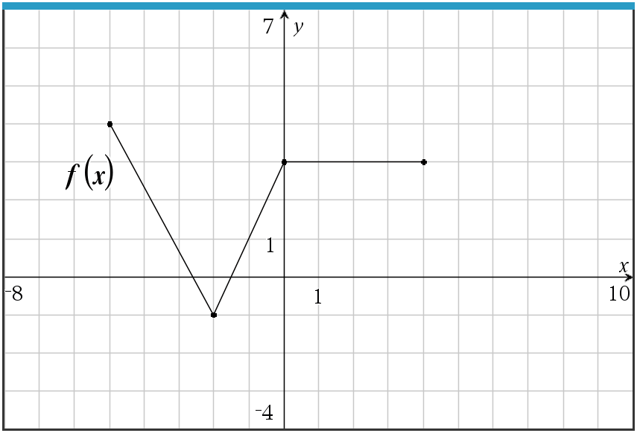

Let $g\left(x\right)= -f\left(x-3\right)+2$.

(a) Write down the domain of $f$. ____________________________________

(b) Write down the range of $g$. ____________________________________

(c) On the graph above, sketch the graph of $g$.

Let $h\left(x\right)=f(-3x)$.

(d) Describe the transformations of $h\left(x\right)$ as compared to $f(x)$.

_____________________________________________________________________________

_____________________________________________________________________________

