In this activity, you will use an observation wheel to apply transformations to periodic functions and write an equation for a trigonometric function. | 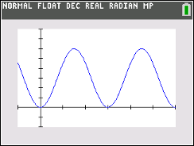
____________________________________________________________________________________

Problem 1 – Creating a Trigonometric Model for the London Eye

The London Eye is an observation wheel (aka, Ferris Wheel) in London that can carry 800 passengers in 32 capsules. It turns continuously, completing a single rotation once every 30 minutes. When the capsule has rotated a quarter of the way around the wheel, it is approximately 225 feet from the platform.

1. If you were to follow one capsule around the wheel and graph its heights vertically from the platform as a function of time, what type of function was created as a result of the capsule’s rotation?
2. If you were to graph the function discussed in question 1, what would the units of the x- and y-axes be?

3. a. What is the maximum height a capsule reaches from the platform?

b. The horizontal line halfway between the maximum and minimum of the function is called the midline of the graph. What is the equation of the midline? Explain your reasoning.

4. The function y = –A · cos(Bx) + D can be used to model the capsule’s height above the platform at time x. This is a transformation of a basic cosine curve.
a. Use your knowledge of transformations to explain why there is a negative sign in front of the variable A.

b. The variable A represents the amplitude, which is the vertical distance between the midline and the maximum or the minimum. What is the amplitude of the “observation wheel” function, and how did you find the value?

c. Which variable of the equations represents the midline of the function? Explain your reasoning.

d. The period of a function is the time it takes to complete one cycle of a periodic function. What is the period of the “observation wheel” function, and how is it visible in the graph?

5. What characteristic of the observation wheel does the amplitude represent? Explain your reasoning.

6. The variable B represents angular frequency. Angular frequency is the measure of the arc (in radians) traveled by the capsule divided by the time traveled (in minutes).

a. What is the measure of the arc traveled by the capsule in one complete revolution?

b. How long does it take for a capsule to complete one revolution?

c. What is the frequency for the “observation wheel” function?

7. Using y = –A · cos(Bx) + D and the variable information found in Question 5, write the equation representing the height of a London Eye capsule at time x. Verify your answer by graphing the function on your handheld.

8. Imagine the boarding platform for the observation wheel stands 10 feet above the ground. If your function takes this height into consideration, what parameters of the equation would change? What parameters would stay the same?

Problem 2 – Creating a Trigonometric Model for an Electric Train

The following diagram shows the electric train set that Timmy received for his birthday. Once it is put together, it will travel in an almost perfect circle. Timmy found a space in his playroom right next to a wall to build the set.

P

Train Track
wall

After Timmy puts the train set together, he notices some patterns about the train’s movement. If Timmy starts the train at the wall, t = 0 seconds, it takes the train 12 seconds to travel from the wall to the farthest point from the wall, point P. The distance the train travels from the wall increases and decreases periodically. He measures that point P is ten feet from the wall.

The sinusoidal function $g$ models the distance, in feet, the train is from the wall as a function of time $t$ in seconds.

- The graph of $g$ and its dashed midline for two full cycles is shown below. Five points, F, H, J,
K, P, are labeled on the graph. No scale is indicated, and no axes are presented. Determine
possible coordinates $\left(t, g(t)\right)$ for the five points shown.

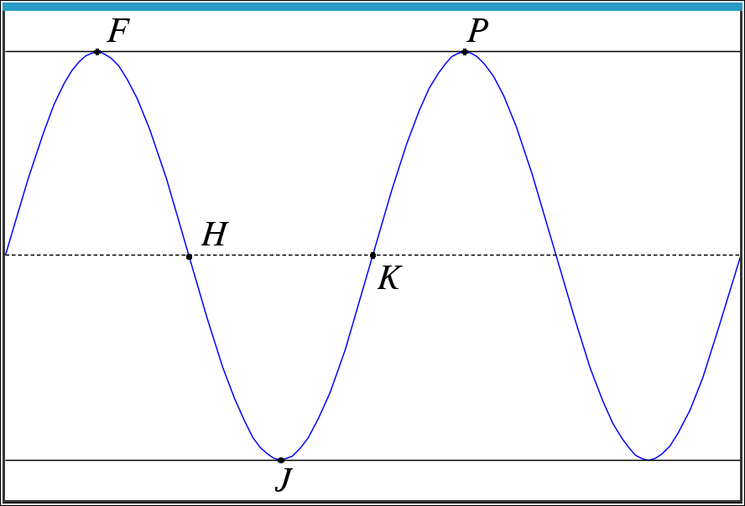
F__________ H __________ J __________ K __________ P __________

- The function $g$ can be written in the form $g\left(t\right)=a\cos\left(b\left(t\right)\right)+d$. Find values of the constants a, b, and d.

- Using the points from the graph above, when is $g(t)$ positive and increasing? Positive and decreasing?

- How is the rate of change of $g(t)$ changing for the intervals found in question 12?

