Open the TI-Nspire document Make_SENSE_of_This.tns.  Every day when you are riding the bus to school, playing an online video game, or taking your dog for a walk, your body is bombarded by hundreds of messages from the environment. What messages is your environment sending to you right now? Is the classroom cold or hot? Is it noisy or quiet? Is it bright or dim? These different messages are called stimuli. In this activity, you will explore some of the different stimuli that your body experiences. | 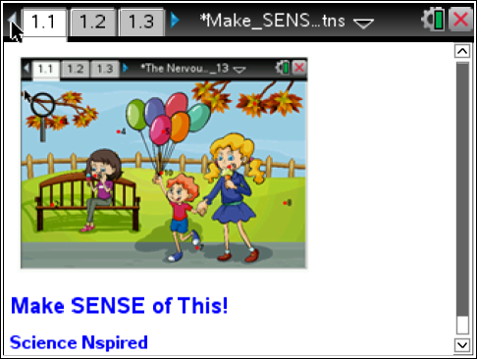
Move to pages 1.2 – 1.4 and read the background information for this activity.
Your body’s nervous system includes many different types of sensory receptors that detect stimuli. Each type of sensory receptor responds to a different type of stimulus. There are four types of sensory receptors that you will explore in this activity. Electromagnetic receptors detect light and allow us to see. Mechanoreceptors detect pressure changes in the environment, allowing us to hear and touch. Thermoreceptors detect temperature and allow us to feel hot and cold. Chemoreceptors detect molecules in the environment, allowing us to experience taste and smell. After a sensory receptor detects a stimulus, the signals are sent to the brain. Your brain then interprets the signals. Your brain may then store this information as a memory, and it may also cause your body to move or respond in some way.
For example, when the bell rings at the end of class, mechanoreceptors in your ear will detect the sound of the bell. Auditory nerves will transmit the signal to your brain. Your brain will interpret the signal as the bell ringing for lunchtime. In response, you will exit the classroom and head for the cafeteria..
As you walk down the hallway, familiar odors from the cafeteria enter your nose. Chemoreceptors in your nose detect the odors and olfactory nerves transmit the signal to your brain. Your brain will interpret the smell as pizza. In response, you hurry to get in line and choose the pizza slice with the most cheese and pepperoni.
Move to page 1.5.
Read the directions for the simulation.
- Select and drag the magnifying glass over the hot spots on the screen. Select the hot spot to view the type of stimulus at that location. Record the stimulus in the data table below.  - Repeat this process until you have located ten different stimuli. |  | 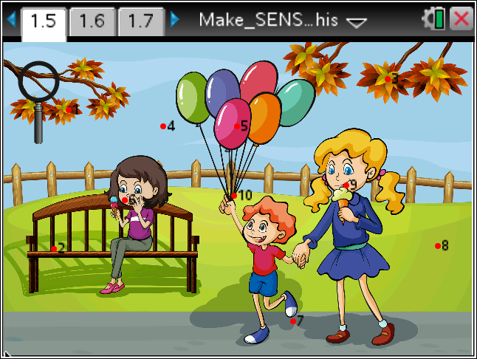
Tech Tip: To access the Directions again, select > Make SENSE of This > Directions.

Tech Tip: To access the Directions again, select b or Document Tools () > Make SENSE of This > Directions.
Q1. Record your data in the table below.

NUMBER | STIMULUS
1

2

3

4

5

6

7

8

9

10

Q2. Classify each stimulus from question one according to the type of receptor that receives it.

ELECTROMAGNETIC  RECEPTOR (sight) | MECHANORECEPTOR  (touch, hearing)
THERMORECEPTOR  (temperature) | CHEMORECEPTOR  (taste, smell)

Q3. The brain is divided into specific sensory regions. Label the auditory and olfactory regions.

