About the Lesson  When a ball is dropped, it does not rebound to the same height from which it is dropped. But how high does it bounce? In this activity, students will examine the relationship for maximum bounce height as a function of bounce number for a ball bouncing under a motion sensor. The equation that describes this height versus bounce number relationship is an exponential equation of form y = a(b)^{x}, where a is the initial drop height and b is the average rebound percentage. Students will:  - Collect motion data and graph scatter plots.  - Determine the maximum height of each bounce.  - Compute the ratio of the height of each bounce to the height of the preceding bounce to determine rebound percentages.  - Determine the average rebound percentage.  - Use the average rebound percentage and the height of the first bounce to estimate the initial drop height.  - Determine the exponential equation that describes the relationship between bounce number and the maximum height of each bounce.  Vocabulary  - Rebound percentage  - Exponential function  Teacher Preparation and Notes  - This activity provides an opportunity for math-science connections.  - This activity is best performed with at least three students: one to hold the CBR™ 2 and press the trigger, one to release the ball, and one to run the calculator.  Activity Materials  - CBR 2 motion sensor, USB CBR 2 to handheld cable, and TI-Nspire CX II  - Bouncing ball (Avoid using a soft or felt-covered ball such as a tennis ball.)  - Recommended: TI-Nspire™ CX Premium Teacher Software or TI-Nspire™ CX CAS Premium Teacher Software | 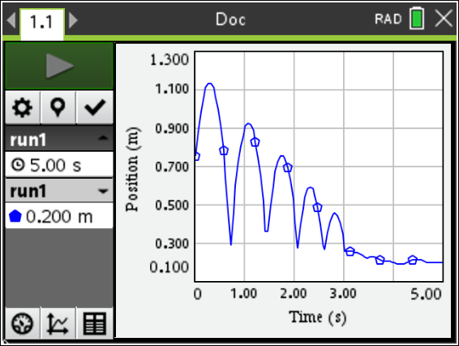  Tech Tips:  - This activity includes screen captures taken from the TI-Nspire™ CX II. It is also appropriate for use with the rest of the TI-Nspire CX family. Slight variations to these directions may be required if using other handheld models.  - Access free tutorials at http://education.ti.com/calculators/pd/US/Online-Learning/Tutorials
Introduction
When you drop a basketball, it does not rebound to the same height from which you dropped it. But how high does it bounce? The rebound height of a basketball can be used to determine whether the ball is inflated to the correct pressure. You will sometimes see basketball referees drop the ball from a certain height to see if it rebounds correctly prior to officiating a game.

In this activity, you will determine the rebound percentage of a ball and how that percentage and the drop height relate to the height of a ball bounce as a function of bounce number.
Setup
See Student Activity.
Data Collection
See Student Activity.
Data Analysis
- Use the tracing cursor to determine the maximum height of the first bounce. Record it in the data table as the maximum height for Bounce Number 1. Then move the cursor to each successive maximum bounce height, and record the maximum heights of bounces 2 – 5 in the table below.
Record each maximum bounce height in meters, rounded to three decimal places.
Sample Data
Bounce Number | Maximum Bounce Height (m) | Ratio of Bounce Heights
1 | H₁ =1.137
2 | H₂ = 0.926 | 0.81
3 | H₃ = 0.755 | 0.82
4 | H₄ = 0.596 | 0.79
5 | H₅ = 0.460 | 0.77

- Examine the maximum bounce height data in the table. Is the relationship linear? How can you tell?
Answer: The relationship is not linear. The bounce numbers increase by one unit, but the heights do not decrease by a constant amount.
- Is the relationship quadratic? How can you tell from the differences in heights?
Sample Answer: The relationship is not quadratic. If the data set were quadratic, the second differences would be constant. They are not constant.

Note: To answer questions 2 and 3, it might be helpful for students to compute and record the first and second differences of the height data.

- Divide each bounce height by the previous bounce height. For example, divide the height of Bounce 2 by the height of Bounce 1. Write each ratio as a decimal value, rounded to two decimal places, in the right column of the table.

- What do you notice about the bounce height ratios shown in the right column of the table?
Sample Answer: Answers will vary. For the sample data, the ratios are close to 0.80.

- Find the average of these bounce height ratios. _____________________
Sample Answer: Answers will vary. For the sample data, the average is 0.80 (rounded to 2 decimal places).

- How could you use the average of the bounce height ratios and the height of the first bounce (H₁) to estimate the drop height of your ball? Show your work and record the drop height (in meters). Round your answer to two decimal places.
Sample Answer: Divide the height of the first bounce by the average bounce ratio. For the sample data, the estimated drop height is 1.42 meters.

- If you didn’t know the height of the first bounce, H₁, you could use the average of the bounce ratios and the estimated drop height of your ball to predict that height.
H₁ = (drop height) * (average bounce ratio)

If you didn’t know the height of the second bounce, H₂, you could still use the average of the bounce ratios and the estimated drop height of your ball to predict the height of the second bounce.
Since H₂ = (H₁) * (average bounce ratio), we know that
H₂ = ((drop height) * (average bounce ratio)) * (average bounce ratio)

How could you predict the height of Bounce 3 using only the estimated drop height and the average bounce ratio?
Answer: H₃ = (drop height) * (average bounce ratio)³

- Using only your estimated drop height and the average of your bounce ratios, write an equation for each bounce height in the table below.
Sample data:

H₁ = 1.42(0.8)
H₂ = 1.42(0.8)²
H₃ = 1.42(0.8)³
H₄ = 1.42(0.8)⁴
H₅ =1.42(0.8)⁵

- Exponential decay (this type of relationship) and exponential growth occur when an amount decreases or increases, respectively, at a rate proportional to the preceding amount. An exponential function has the form $y=a*b^{x}$y = a(b)^{x} . In this example, b is the average rebound percentage written as a decimal. What is the value of a?

Sample Answer: The value for a is the height of the ball when it is dropped.

- Write the equation for the height of the ball at any bounce as a function of bounce number, x, for your data.
Sample Answer: For the sample data, y = 1.42(0.8)^{x}

- To check your equation, create a graph of bounce height as a function of bounce number. Enter the data into the Lists & Spreadsheet application by adding a new page to the document. Press / ~ to add a new page, and select Add Lists & Spreadsheet.
- Name the first column number and the second column height.
- Enter bounce numbers 1 – 5 in the number column.
- Enter the maximum heights of bounces 1 – 5 in the height column.
- Add another new page and select Add Data & Statistics. Click on the horizontal axis and select number for the independent variable. Click on the vertical axis and select height for the dependent variable.
- Sketch the graph of your data at the right.  - How does it compare with the prediction that you made prior to data collection?  Sample Answer: Answers will vary. | 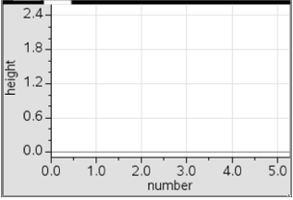
- Check to see how well the equation you found in Step 11 matches the data.
- On the Data & Statistics page, select Menu > Analyze > Plot Function.
- Enter your equation for the maximum bounce height as a function of the bounce number. You must use x for the bounce number in the equation. Press · to graph.
- Is the function you entered a good model the data? If not, make adjustments in the equation, and regraph. If any adjustments were made, record your new equation.

- Use your equation to predict the height of a tenth bounce. Show your work. Is your answer reasonable?
Sample Answer: Answers will vary. For the sample answer, the height of the 10th bounce is 1.42(0.8)¹⁰ or approximately 0.15 meters.

- Jackie bounced a different type of ball and determined that it had an average rebound percentage of 71%. Her drop height was 1.45 meters.

- Write an equation for bounce height, y, as a function of bounce number, x.

Answer: y = 1.45 * (0.71)^{x}

- Predict the height of the ball’s 7th bounce.

Answer: 0.13 meters

- At what bounce number would the height of the bounce be approximately 0.5 meters?

Answer: Bounce 3

