Problem 1 – Is it Freezing?
- When the sun comes up, the temperature is 62 degrees. At 10 a.m. the temperature has risen 9 degrees. At 12 p.m., a rain storm comes through and the temperature drops 18 degrees. By 4 p.m., the sun has come back out and the temperature rises another 14 degrees.
Find the temperature at 4 p.m. ____________
Draw a number line to show the changes in value.

- Winter is coming in Diluth, MN. The forecast has been given based on the changes expected per day instead of the actual temperatures. How much should you bundle up each day? Find the actual temperatures for each day.
Day | Forecast | Temperature
Dec 14 |  | 25 degrees
Dec 15 | 7 degrees cooler than Dec 14
Dec 16 | 3 degrees warmer than Dec 15
Dec 17 | 14 degrees cooler than Dec 16
Dec 18 | 2 degrees warmer than Dec 17
Dec 19 | 12 degrees cooler than Dec 18
Dec 20 | 4 degrees warmer than Dec 19

- What happens between Dec 18 and 19? Between Dec 19 and 20? ___________________________________________________________________
___________________________________________________________________
- Draw a NumberLine screen from the TI-73 that shows the changes in temperature for each day and the final temperature on December 20.

Problem 2 – Finding a Treasure
You are on a treasure hunt! You must make at least 3 moves to go from your starting location. The size of moves are 6 steps forward, 4 steps back and 3 steps forward.
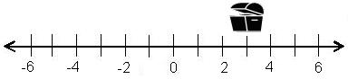
- What starting number did you use to end up at the treasure chest? _____________
- What order did you take the steps? ______________________
Discuss with a neighbor. Did they take the steps in the same order? ____________
Did you both end up at the treasure? Explain. ______________________________
___________________________________________________________________
- Start over and show a second order of steps to get to the treasure.
___________________________________________________________________
- Does this always work? Why or why not? _________________________________
___________________________________________________________________
___________________________________________________________________

Problem 3 – How Did I Get Here?
Write a number sentence that is represented by each image below.
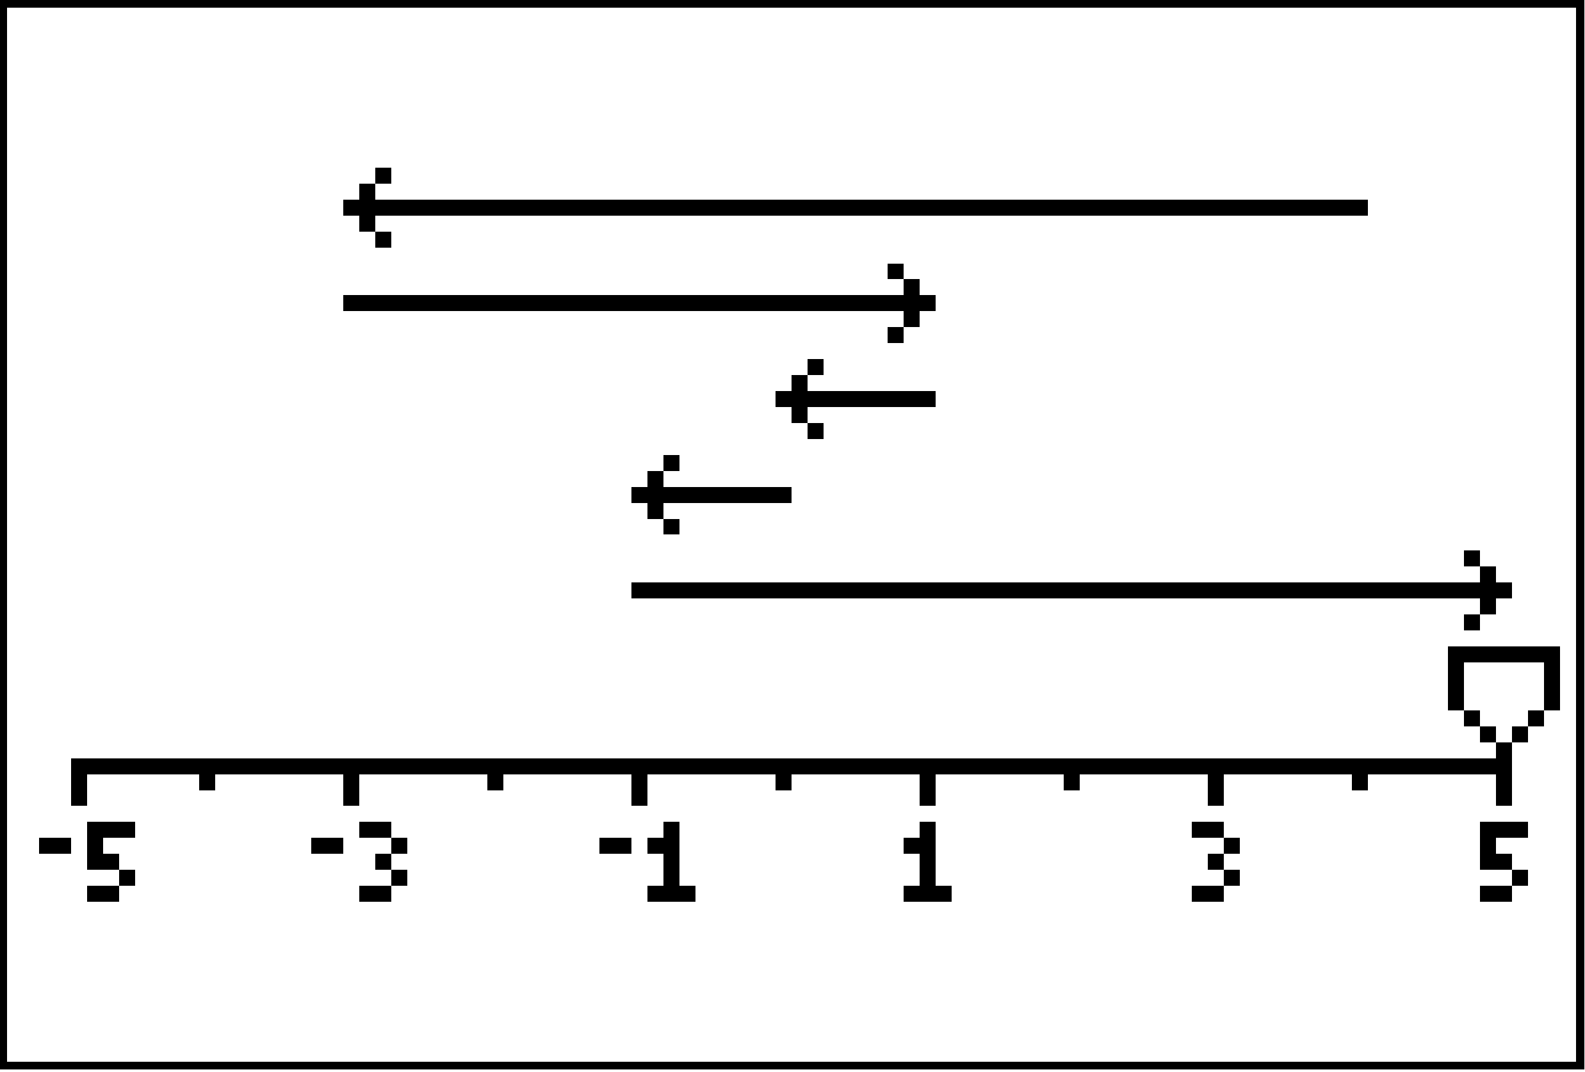  Sentence: ____________________ | 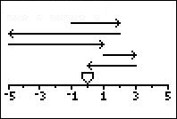  Sentence: ____________________

