Open the TI-Nspire document Corresponding_Parts_of_Similar_Triangles.tns.  This activity asks you to change the scale factor (r) between similar triangles and move one of the similar triangles to find corresponding parts and establish relationships between them. | 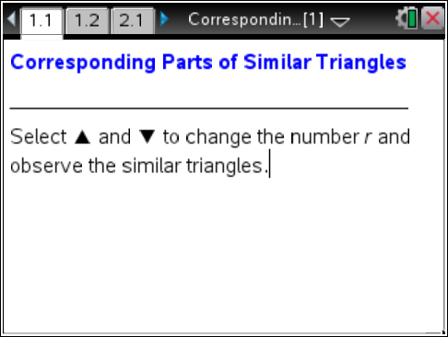

Move to page 1.2.

- The triangles pictured are similar. Select ∆ and ∇ in the bottom left corner of the screen.
- What happens to ΔDET as the scale factor r changes?

- What happens to and as r changes?

- Use ∆ and ∇ to change r.
- What is the relationship between the two triangles when r = 1?

- What is the relationship between the two triangles when 0 < r < 1?

- What is the relationship between the two triangles when r > 1?

Move to page 2.1.

- a. Move point S around the circle. What happens to ΔDET?
b. Move point C. What happens to ΔDET?

- Move ΔDET by dragging points S and C. Position ΔDET on top of the other triangle so that a pair of corresponding angles match up (are coincidental).
- List the three pairs of corresponding angles.

- List the three pairs of corresponding sides.

- Write a similarity statement for the two triangles and justify your answer.

Move to page 3.1.

- Change the value of r and drag copies of ΔAMY. How many copies of would it take to cover $\overline{\text{DE}}$ when
- r = 3?
- r = 0.5?
- r = 1.5?
- If $\overline{\text{AY}}$is 2 units, $\overline{\text{AM}}$is 4.25 units, and $\overline{\text{YM}}$is 3.25 units, what are the measures of $\overline{\text{ET}}$, $\overline{\text{DE}}$, and $\overline{\text{DT}}$ when
a. r = 1?

b. r = 0.75?

c. r = 4?

