Exploring Hyperbolas  TI-Nspire™ CX Family | Time required  45 minutes
Activity Overview
Students will explore the hyperbola by investigating links between its standard equation form and its graph. They will also discover the center and the focal lengths of the hyperbola as well as see applications of the hyperbola in the real world.

Topic: Hyperbola
- Investigate applications of the hyperbolas in the real world.

- Given the parabola equations,
(x − h)² a2
− (y − k )²
b2
= 1 or
(y − k )²
a2
− (x − h)² b2
= 1,

discover the effects that changes in a, b, h and k have on the graph while investigating
the differences between the graphs of the two equations.

Teacher Preparation and Notes
- Students should be familiar with solving quadratic equations prior to beginning this activity.
- This activity requires the use of CAS technology.
- This activity is designed to either be teacher-led or to allow the students to explore on their own.

Associated Materials
- ExploringHyperbolas.tns
- ExploringHyperbolas_Student.doc



Problem 1 – Hyperbolas in the Real World
This activity begins by giving allowing the students to see common images that depict the shape of a hyperbola. | 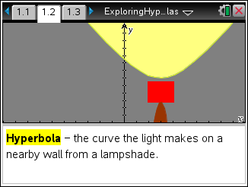
Page 1.4 students can drag either set of circles until the intersection points form a hyperbola or multiple hyperbolas. | 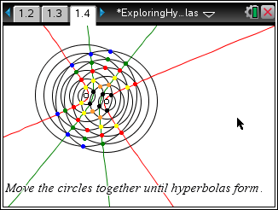
TI-Nspire Navigator Opportunity: Class Capture
See Note 1 at the end of this lesson.
Problem 2 – The Hyperbola as a Conic Section
On page 2.2, students can manipulate several sliders that will specifically change the orientation and the slope of the plane that slices through the conjoined cones.  By pressing A, students can auto rotate the sliced cones. By using the arrow keypad, students can view the 3D image from many different angles.  (Press dto stop the automatic rotation.) | 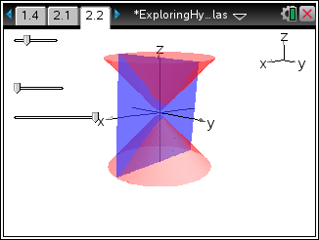
TI-Nspire Navigator Opportunity: Quick Poll
See Note 2 at the end of this lesson.

Problem 3 – The Standard Form of the Equations of a Hyperbola
On page 3.1, students are exposed the standard forms of the hyperbola:  (x − h)² − (y − k )² = and (y − k )² − (x − h)² =  1 1  a2 b2 a2 b2  and on page 3.2, students have the opportunity to manipulate moveable points, one for each hyperbola with the different orientations, and investigate the effects those changes have on the equation of each hyperbola. | 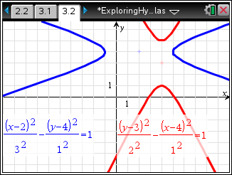
TI-Nspire Navigator Opportunity: Quick Poll
See Note 2 at the end of this lesson.
Pages 3.3 and 3.4 will ask students a pair of questions concerning the role the value h plays in the hyperbola’s position as well as what the standard form of the equations says about the orientation of the hyperbola. | 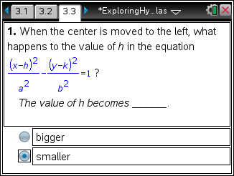
Pages 3.5 through 3.7 will show students a real-world example of a hyperbola in the form of the cooling towers of a nuclear power plant.  The graph of the hyperbolic form used to create the sides of a tower is superimposed on an image of the tower on page 3.6. Students are asked to manipulate the moveable point to align the hyperbolas with the sides of the tower.  Then students are to use b> Graph Entry/Edit > Equation to find an equation that would graph the hyperbola the students previously aligned with the tower’s sides. This may take a bit of trial and error, but with each attempt students should begin to see the roles the values of a, b, h and k have on the graph of  their hyperbola. | 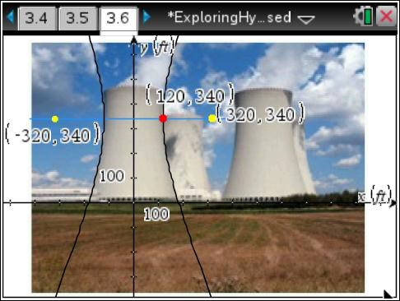

Problem 4 – Focal Length of a Hyperbola
On the last two pages, 4.1 and 4.2, students will use the equation c² = a² + b² to investigate the focal length of a hyperbola while also seeing the asymptotes of a hyperbola.  On page 4.1, the location of the moveable point at (c, 0) will show students the effect it has on the value of b for a horizontally-oriented hyperbola with a fixed center at the origin. | 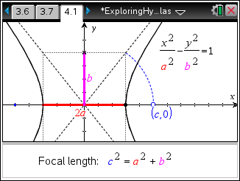
Page 4.2 allows students to manipulate two sliders, one for the value of a and one for the value of b. The hyperbola’s graph will change accordingly allowing students to explore the role those two values play.  Additionally, students can see both the graphs and the equations of the asymptotes to the hyperbola change while a and b are manipulated. | 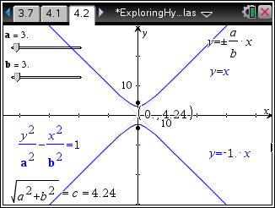
Solutions – Student Worksheet
- smaller

- left and right
- (x − 0)² − (y − 340)² =
120² 300² 1
- The foci become further apart, the vertices become further apart, and the width of the graph decreases.
- The foci become further apart, the vertices stay the same, and the width increases.

TI-NspireTM NavigatorTM Opportunities

Note 1
Problem 1, Class Capture
Use class capture to verify students are able to manipulate the moveable points and sliders correctly. Student progress may be monitored throughout the activity.

Note 2
Problem 2, Quick Poll
Use Quick Poll to assess student understanding of Questions 1 and 2.

