Introduction
By dropping objects of different masses from the Leaning Tower of Pisa and observing that they reached the ground at the same time, Galileo tried to show that an object’s mass has no effect on the rate at which it falls. But his assumption that all bodies fall with the same acceleration due to gravity doesn’t take air resistance into account. No one would expect a feather and a rock to fall to the ground in the same amount of time because their different shapes meet different levels of air resistance. But what if the air resistance on two objects was the same? If they had identical shapes but different masses, would they fall at the same speed? |  | 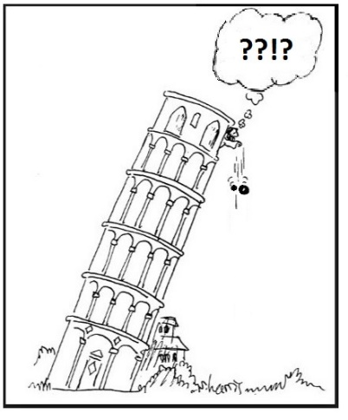
Terminal velocity is the fastest speed of a falling object attains. When an object has obtained its terminal velocity, the forces of air resistance are balanced by the force of gravity, and the acceleration of the object is zero (The speed is constant.).
Objectives  In this activity you will:  - Drop an object and determine the average speed the object reaches.  - Observe whether or not changing the mass and keeping the same shape have an effect on the average speed of the object. |  |  | 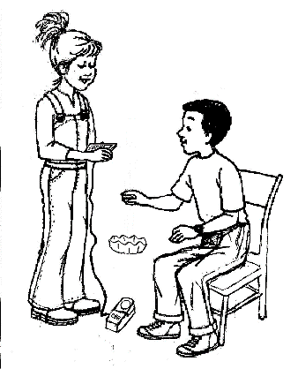
You'll Need

- TI 84 Plus CE, with Vernier EasyData™ App
- CBR 2™ motion sensor unit with mini-USB connecting cable
- Six large basket-style coffee filters
Using the CBR 2™ motion sensor and EasyData™ App  Connect the handheld with the CBR 2 using the USB cable. EasyData will immediately open, and the CBR 2 will begin collecting distance data every time it clicks. In the EasyData app, the tabs at the bottom indicate the menus that can be accessed by pressing the keys directly below the tab. For example, to go to File to select New, press o. To change the Setup, press p. To Start, press q. To see the Graph, press r. To Quit the app, press s. |  |  | 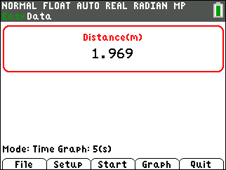
Collecting the Data  - To change the amount of time the CBR 2 collects data for each trial, press p to change the and select Time Graph. Ask your teacher for the duration of data collection. |  |  | 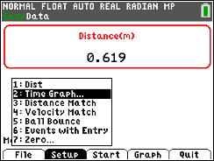
2. the settings by pressing q and enter the values shown or the ones provided by your teacher. When the changes are done, press s to the settings. This determines experiment length or the range of the x-axis. |  |  | 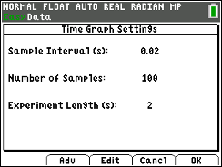
3. You will be making six height-time graphs. After each graph is displayed, if you are not satisfied with your graph, select (s). Note: When you select , you will get a warning message, “The selected function will overwrite the latest run.” As soon as you select, , the CBR 2 will immediately start collecting data. |  |  | 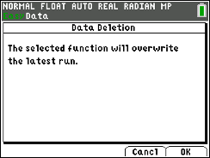
4. Starting with one coffee filter about 1 meter directly above the CBR 2, start the CBR 2 by selecting . Then drop the filter so that it lands on top of the CBR 2. The last portion of the graph will be random data because the filter is too close to the CBR 2. Use the right and left arrow keys ~| to find the coordinates of the straight part of the filter’s descent. This is when the filter is descending at its terminal velocity. Use the coordinates of the two points to calculate how far the filter fell and the amount of time it took to fall that distance. Record in the data table and calculate the speed. |  |  | 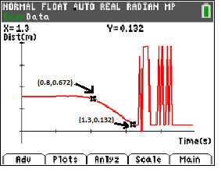  Distance=0.540 m, Time=0.5 s  Speed =1.08 m/s
5. On each of the next five trials, stack or nest one more coffee filter inside the other(s) and repeat the previous step. Record the results in the data table.
Looking at the Results
1.Record your data from the six trials in the table below:
Mass (# of filters) | Distance (m) | Time (s) | Average Speed (m/s)
1
2
3
4
5
6

2. Describe any patterns that you see relating the mass with the speed in the data table.
3. If one object travels at a higher average speed at terminal velocity than another object and both are dropped simultaneously from the same height, will the object with the higher average speed always reach the ground first? Justify your answer.
4. Look at these two height-time graphs.
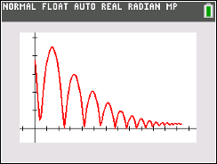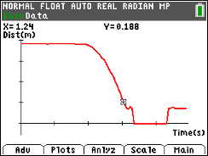

Which one shows an object that achieved terminal velocity? How do you know?

5. Think about how quickly the coffee filters reach terminal velocity as compared to Galileo’s cannonballs. Galileo concluded that cannonballs of different mass would hit the ground at the same time. Did your results with the filters contradict Galileo’s conclusions? Explain your answer carefully.
Going Further  1. Suppose instead of dropping the filters onto the CBR 2, one person in your group held the CBR 2 at eye level pointing downward. After the CBR 2 starts, a second student releases the filter (concave side up) from about 0.15 m below the CBR 2. Sketch what the height-time graph would look like. | 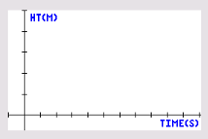
2. Would the average speeds in the data table be the same? Why or why not?
3. Investigate further: acceleration due to gravity and terminal velocity.

