Problem 1 – Exploring trigonometric ratios
Start the Cabri Jr. app by pressing Œ and choosing it from the menu. |  | 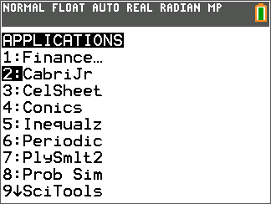
Open the file TRIG by pressing o to open then F1: File menu, choosing Open, and choosing it from the list. |  | 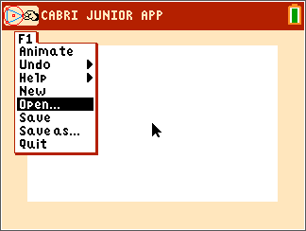
In right triangles, there is a relationship between the ratios of the side lengths and the trigonometric functions.  Using the triangle in the Cabri Jr. app, find the following ratios and trigonometric values to three decimal places.  1. $\frac{CB}{AC}= _______ ≈$_____; $\frac{AC}{AB}= _______ ≈$ _____;  $\frac{CB}{AB}= _______ ≈$ _____  $\sin{A}$ = ______ ; $\cos{A}$ = ______ ; $\tan{A}$ = ______ |  | 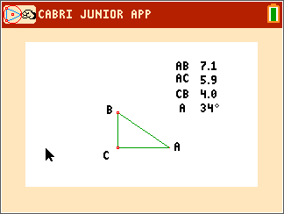
2. Based upon your answers, match each ratio with its correct trigonometric operation.
$\frac{CB}{AC}$ $\sin{A}$
$\frac{AC}{AB}$ $\tan{A}$
$\frac{CB}{AB}$ $\cos{A}$

Test your hypothesis to see if your chosen relationships holds true. Repeat this for two more different triangles by moving either point A or B to a different location. To resize the triangle, place the cursor over either point A or B. Press ƒ to grab the point and use the arrow keys to move it to any desired location.

Triangle #2  3. $\frac{CB}{AC}= _______ ≈$_____; $\frac{AC}{AB}= _______ ≈$ _____;  $\frac{CB}{AB}= _______ ≈$ _____  $\sin{A}$ = ______ ; $\cos{A}$ = ______ ; $\tan{A}$ = ______ | Triangle #3  4. $\frac{CB}{AC}= _______ ≈$_____; $\frac{AC}{AB}= _______ ≈$ _____;  $\frac{CB}{AB}= _______ ≈$ _____  $\sin{A}$ = ______ ; $\cos{A}$ = ______ ; $\tan{A}$ = ______
Based upon your answers hypothesize which ratio goes with each trigonometric function.
5. $\sin{A}$ = ______ ; $\cos{A}$ = ______ ; $\tan{A}$ = ______

A good acronym to use to help remember these relationships is SOHCAHTOA.  $$\sin{A}= \frac{opposite}{hypotenuse}$$  $$\cos{A}= \frac{adjacent}{hypotenuse}$$  $$\tan{A= \frac{opposite}{adjacent}}$$ | 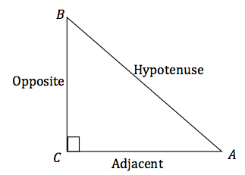
Problem 2 – Trigonometry, what is it good for?
One of the uses of trigonometry is finding missing side lengths of a triangle. In questions 6 – 12, all of the triangles given are right triangles.

6. a. To find the length of side BC in the triangle to the right,  write the sine relationship.  b. Now solve for BC and calculate using your calculator. |  | 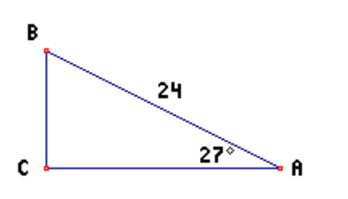
7. a. To find the length of side AC in the triangle to the right, write the cosine relationship.  b. Now solve for AC and calculate using your calculator. |  | 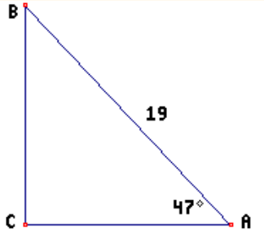
8. a. To find the length of side AC in the triangle to the right, write the tangent relationship.  b. Now solve for AC and calculate using your calculator. |  | 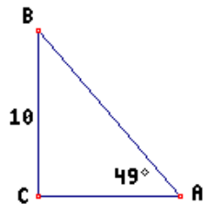
Write the correct trigonometric function for each triangle below and solve for the missing side.
9. Find AC.  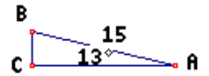 | 10. Find BC.  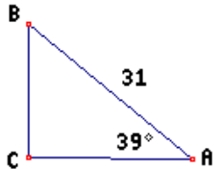
11. Find AC. | 12. Find AC.

Further IB Extension
Another use of trigonometry is to use the ratio of sides of a right triangle to find the acute angles of a
right triangle. In the following problem, you will not only find missing sides, but also missing angles of
a right triangle.

First, let’s do an example of finding a missing angle of a right triangle given its sides.
Find angle $θ$:

7 Since the sides given with respect to angle $θ$ are the opposite side
$θ$ and the adjacent side, you will need to use tangent.
8 $\tan{θ= \frac{7}{8}}$
How do we find the missing angle $θ$, given the sides? We will use
The inverse tangent function $\left(\tan^{-1} or arctan\right)$.
$\tan^{-1}\left(\frac{7}{8}\right)=41.2°$
Problem
Suzie has realized that there is a problem with her dog. She loves to sleep in the bed with her, but she is too small to jump up on the bed or jump down off the bed. Being handy, she decides to construct a ramp that will allow her dog to easily get on and off the bed. Suzie realizes that she needs to do a little trigonometry to make this work. Unfortunately her bedroom is not very large so she does not have unlimited space for the ramp. She measures the height of the bed to be 3 feet high and that there is 5 feet of floor space for the ramp.
Using the trigonometric relationships discussed earlier in the activity, in parts (a) and (b) find:
(a) The angle of the ramp created with the floor, also known as the angle of elevation.

(b) The length of the ramp.

(c) With a classmate, discuss other ways to find the length in part (b) and what other
considerations you must think of for the ramp.

