Math Objectives  - Students will evaluate the exponential function $f\left(x\right)=a∙b^{x}$ for any value of $x$.  - Students will calculate the exponential curve of best fit to model bivariate data and use it to predict a value of one variable corresponding to a value of the other.  - Students will solve a system of equations, by hand, in order to solve for the parameters,$a$and $b$, of an exponential function.  - Students will use appropriate technological tools strategically (CCSS Mathematical Practice).  Vocabulary  - exponential function • growth rate • decay rate  - regression equation • parameters  About the Lesson  - This lesson involves analyzing real world population data that has been downloaded onto the handheld.  - As a result, students will:  - Examine the data, find an exponential model by hand, and discuss the parameters of the model in the context of the problem.  - Find an exponential regression model on the handheld, compare this model to the one discovered by hand, and use this model to make predictions about future world populations.  TI-Nspire™ Navigator™  - Transfer a File.  - Use Class Capture to examine patterns that emerge.  - Use Live Presenter to demonstrate.  - Use Teacher Edition computer software to review student documents.  - Use Quick Poll to assess students’ understanding  Activity Materials  Compatible TI Technologies: TI-Nspire™ CX Handhelds,   TI-Nspire™ Apps for iPad®,  TI-Nspire™ Software | 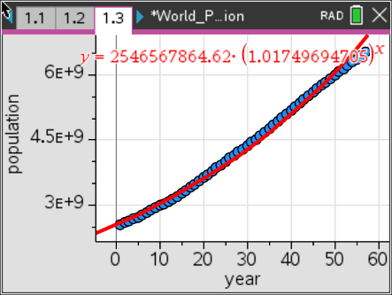  Tech Tips:  - This activity includes screen captures taken from the TI-Nspire CX II handheld. It is also appropriate for use with the TI-Nspire family of products including TI-Nspire software and TI-Nspire App. Slight variations to these directions may be required if using other technologies besides the handheld.  - Watch for additional Tech Tips throughout the activity for the specific technology you are using.  - Access free tutorials at http://education.ti.com/calculators/pd/US/Online-Learning/Tutorials  Lesson Files:  Student Activity  World_Population_Nspire_Student.pdf  World_Population_Nspire_Student.doc  World_Population.tns

Population growth can be modeled using various  exponential functions. In this activity, students will use two different methods to find the best model for given data. The data will represent the midyear world population from the years 1950 – 2023, where year 1 represents the year 1950.  The data will be downloaded from the file World_Population.tns. | 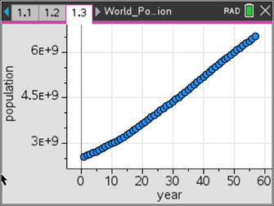
____________________________________________________________________________________

Teacher Tip: Make sure that the data is downloaded on the handhelds prior to starting this activity. A good idea might be to review the skills to open a file, create a scatter plot, and find regression models. The data was found at U.S. Census Bureau, Population Division/International Programs Center.

Problem 1 – Find an exponential equation by hand using two points.
In this part, you will find an exponential equation using two points. Begin observing the data.  Move to page 1.2. You will now see the world population data in columns A and B.  - What kind of function would best model the data?  Solution: The data looks somewhat linear or exponential. |  | 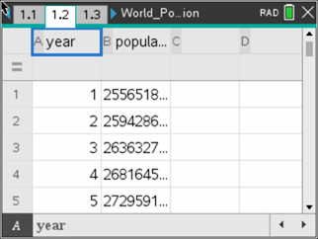
To examine the data, you will make a scatter plot.  Move to page 1.3. Add the horizontal (year) and vertical (population) variables to fit the data to the screen. See the picture to the right. |  | 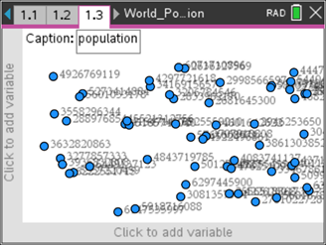
- Now find an exponential model to fit the data by using two points (x1, y1) and (x2, y2). To do this on the scatter plot, press menu, 4 Analyze, A Graph Trace and use the left and right arrows to see the coordinate values.
- Pick two points that are spread throughout the data and write the values in the space provided:
Sample Solutions:
Coordinate 1: x1 = __10_____ y1 = _____2998566597_________________
Coordinate 2: x2 = __50_____ y2 = _____5995599889_________________
Teacher Tip: As you are looking at the population data in the table and cannot see the whole value, you can scroll through the values and the actual number will be shown at the bottom of the screen. It will be beneficial to have students use different values so as to compare their results with their classmates.

The general formula for an exponential function is y = a(b^{x}) where a is the initial value
and b is the multiplier or in this case the growth rate.
- Find the equation through the two points by substituting the values into the general exponential formulas:
y1 = a(b^{x1}) ___2998566597_____ = ____$a∙b^{10}$________
y2 = a(b^{x2}) ___5995599889_____ = ____$a∙b^{50}$________
Then divide the equations and solve for b.
_____$\frac{5995599889}{2998566597}= \frac{a∙b^{50}}{a∙b^{10}}$___________________
Teacher Tip: Ultimately, the students will solve for $b$ by using the following setup: $b= \sqrt[x2-x1]{\frac{y2}{y1}}$.

- What happens to the value of a when the two equations are divided?
Solution: The $a$ values divide out.

- What is your value of b?
Solution: $b=1.017473159$

Move to page 1.4 and store this value in for the letter b. Type in the value for b and
press ctrl, var (sto), enter.
- According to your b value, by what percent is the world population growing?
Solution: The percent of growth, or growth rate, is 1.017473159%
Now substitute the value of b back into either of the equations above to find the value of
a. Follow the steps above to store this value as a.
- What is your value of a?
Solution: $a=2,521,648,662$
- What is your exponential equation?
Solution: $y=2,521,648,662∙{(1.017473159)}^{x}$

- Look at your equation, what is your initial population?
Solution: The initial population is 2,521,648,662.

To graph your equation with the data, go back to the scatter plot on page 1.3, press menu, 4 Analyze, 4 Plot Function. Type in the function $a ∙b^{x}$ and press enter.  - How well does your equation model the data? Explain.  Solution: The model fits well in the beginning but not as well at the end of the data.  - What will the population be in the year 2030?  Solution: In the year 2030, the population is 10,257,568,950.  - What was the population in the year 1890?  Solution: In the year 1890, the population was 891,880,950.  Problem 2 – Finding the exponential regression. | 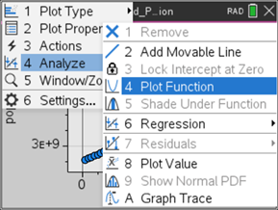
  Teacher Tip: This would be a great place to introduce and discuss the pros, cons, and differences between interpolation and extrapolation.

Now you will find an exponential regression equation to fit the data.  - On page 1.4, press menu, 6 Statistics, 1 Stat Calculations, A Exponential Regression. Make sure the X and Y lists are year and population, respectively, the equation is stored in $f2(x)$, and then press enter.  - Discuss with a classmate which model seems to fit the data more accurately. Summarize your discussion here.  Sample Discussions: Students should be discussing which model passes through the most data, which model is above the data, which is below the data and which situation is better. | 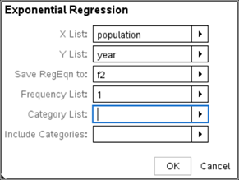

- What is the exponential regression equation?
Solution: $y=2614076114∙{(1.016314152)}^{x}$

- What is the initial population?
Solution: 2,614,076,114
- By what percent is the world population growing?
Solution: 1.016314152%

- How do these two values compare with the ones in Problem 1?

Solution: The exponential regression has the initial population at about 92 million more people and the percentage of growth at 0.001159007 less.

- How well does the exponential regression equation model the data?
Solution: The exponential regression again fits very well in the beginning but goes up even sharper at the end.

- What will the population be in the year 2030?
Solution: In the year 2015, the population is 9,695,808,955

- What was the population in the year 1890?
Solution: In the year 1890, the population is 1,006,161,780.

- Which model do you feel is best? Why?
Solution: For interpreting the population in the earlier years, you could use the exponential regression; however, to predict the population in the later years, you would use the equation found by hand.

- How would you find out what year the world’s population will reach 8.9 billion people?
Solution: To find the year when the population reaches 8.9 billion, you would need to change the window settings and graph a line at y = 8,900,000,000 and then find the intersection point between the two graphs by using the intersection function on the handheld (2nd, calc, 5: Intersect).
- Graphically use the exponential regression equation to find the year.

Solution: The is approximately 2024.708, so between 2024 and 2025.
Problem 3 – Extension beyond population
A botanist has been studying the rare plant called the Lady’s Slipper Orchid that was at first thought to be extinct but was once again discovered in the 1930s. She is trying to foster its growth. In 2020 (t = 3), she has 36 plants, and in 2024, she has 108 plants.
The number of plants being cultivated and studied can be modeled by the function $L\left(t\right)=a∙b^{t}$, where $L(t)$ is the number of plants during year $t$, and $t$ is the number of years after 2017.
- (a) Use the given data to write two equations that can be used to find $a$ and $b$.

Solution: $36=a∙b^{3}$ and $108=a∙b^{7}$

(b) Find the values of $a$ and $b$ as decimal approximations.
Solution: $\frac{108}{36}= \frac{a∙b^{7}}{a∙b^{3}} → b^{4}=3 → b= \sqrt[4]{3} ≈1.31607…$
$36=a∙b^{3} → 36=a∙{\left(\sqrt[4]{3}\right)}^{3} → a= \frac{36}{{\left(\sqrt[4]{3}\right)}^{3}} ≈15.792888…$

(c) Use your function, $L(t)$, to approximate the number of plants the botanist will have in
2028.
Solution:
$L\left(t\right)=15.793∙{\left(1.316\right)}^{t} → t=10 → L\left(10\right)=15.793∙{\left(1.316\right)}^{11} =324$,
therefore, there will be approximately 324 plants in 2028.
(d) Using your function, $L(t)$, when will the number of plants reach 200 plants.

Solution: $200=15.793∙{\left(1.316\right)}^{t} → t ≈9.243507…$
Therefore the botanist will have 200 plants in the year 2026.

Teacher Tip: Students can graph the left and right side of the equation and find the point of intersection or this could be a perfect time to review or introduce solving exponential equations using logarithms.

