Parameter Changes in Quadratic Functions
Student Handout

Go to APPS and choose Transfrm and press ENTER.

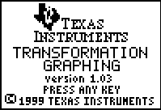

It may seem like nothing happened, but if you press Y=, there is change to the screen. Can you see what is different?

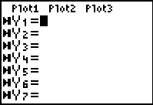

On Y1= enter the quadratic function y = x². This is the parent function for all quadratic functions. Look at your graph and answer the following questions:
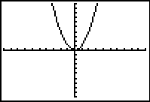
What is the vertex of the parabola?

What is the y-intercept of the parabola?

What is (are) the x-intercept(s) of the parabola?

Describe the graph.

All parabolas are variations or transformations of this one graph. There are several parameters that will affect the position and shape of the graph. In the following activity, we will discuss how different parameter changes in the function affect the graph.

Investigating y = ax²

Compare the equations y = ax² and y = x².
What is different?
What is the same?
Make a prediction on how the value of a will affect the graph?

On Y2 enter y = AX² then press GRAPH
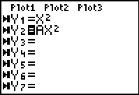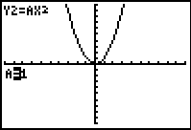

Pressing the left and right arrows will decrease and increase the value of a, respectively. The value of a can also be changed by typing in a value and pressing ENTER. When a=1, the parent function is graphed, since y = 1X² = X² .

Change the value of a, analyze how the change of a affects the graph and complete the sentences below. When describing the changes, describe them as related to the parent function, for example: the graph of y = 0.5x² is wider than the graph of y = x².

Complete the following sentences:
1. When a is increasing the graph ___________________________________________

_____________________________________________________________________

2. When a is decreasing the graph __________________________________________

_____________________________________________________________________

3. When the value of a is between 0 and 1, the graph ____________________________
___________________________________________________________

4. When the value of a is negative, the graph __________________________________
___________________________________________________________

5. When the value of a is positive, the graph ___________________________________

_______________________________________________________________________

Investigating y = x² + c

Compare the quadratic equations y = x² + c and y = x².
What is different?
What is the same?
Make a prediction on how the value of c will affect the graph?

On Y2 enter y = X² + C then press GRAPH
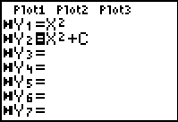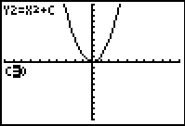

Pressing the left and right arrows will decrease and increase the value of c, respectively. The value of c can also be changed by typing in a value and pressing ENTER. When c=0, the parent function is graphed, since y = X² + 0= X² .

Change the value of c and analyze how the change of c is affecting the graph, then complete the sentences below. When describing the changes, describe them as related to the parent function, for example: the graph of y = 0.5x² is wider than the graph of y = x².

Complete the following sentences:
1. When c is increasing the graph ___________________________________________

_____________________________________________________________________

2. When c is decreasing the graph __________________________________________

_____________________________________________________________________

3. When the value of c is positive, the graph ____________________________

_____________________________________________________________________

4. When the value of c is negative, the graph ___________________________________

_____________________________________________________________________

Investigating y = (x-b)²

Compare the quadratic equations y = (x-b)² and y = x².
What is different?
What is the same?
Make a prediction on how the value of c will affect the graph?

On Y2 enter y = (X-B)² then press GRAPH
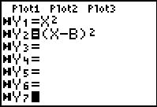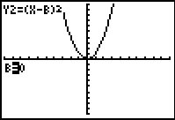

Pressing the left and right arrows will decrease and increase the value of b, respectively. The value of c can also be changed by typing in a value and pressing ENTER. When b=0, the parent function is graphed, since y = (X-0)²= X² .

Change the value of b and analyze how the change of b is affecting the graph, then complete the sentences below. When describing the changes, describe them as related to the parent function, for example: the graph of y = 0.5x² is wider than the graph of y = x².

Complete the following sentences:
1. When b is increasing the graph ___________________________________________

_____________________________________________________________________

2. When b is decreasing the graph __________________________________________
____________________________________________________________________

3. When the value of b is positive, the graph ___________________________________

_____________________________________________________________________

4. When the value of b is negative, the graph ___________________________________

_____________________________________________________________________

Summarize what you have learned about the parameter changes for each situation presented. Predict the graph of the following quadratic function: y = -2(x – 3)² +5.

