In this activity, students will find an approximation for the value of the mathematical constant $e$ and to apply it to exponential growth and decay problems. To accomplish this, students are asked to search for the base, $b$, that defines a function $f\left(x\right)= b^{x}$ with the property that at any point on the graph, the slope of the tangent line (instantaneous rate of change) is equal to $f(x)$. The result is approximating the value of $e$ — Euler’s number and the base of the natural logarithms. | 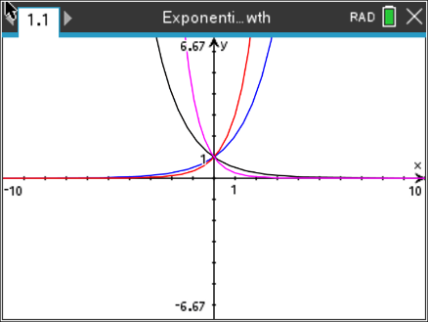

____________________________________________________________________________________
Problem 1 – Comparing Growth and Decay Functions
Before beginning this activity, open a Graphs page and change your window settings to match those to the right.  Enter the function $f\left(x\right)= b^{x}$ with 5 different values of b (for b > 0). Choose some values that are greater than 1 and some values that are less than one. Remember to press tab to get the entry line and enter to graph each function. | 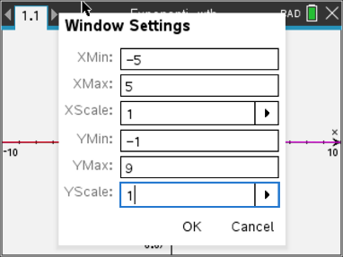
Press menu, Trace, Graph Trace to observe how the value of b affects the shape of the graph. Use the up and down arrows to move among the curves. Use the left and right arrows to move along the curves.
- Write at least three observations about the effect of the value of b on the graph of $f(x)$.

- What value of b results in a constant function? Explain.

- Explain why the value of b cannot be negative.

Problem 2 – Finding the Slope of a Tangent Line
Now you are going to graph function $f\left(x\right)= b^{x}$ along with its tangent line. Start by adding a new Graphs page (ctrl, doc). Enter the function $f\left(x\right)= 2^{x}$. Then, press enter to view the graph of the function.
Press menu, 8 Geometry, 1 Points & Lines, 8 Tangent  Move your cursor over the function and click it. This will create a tangent line at that point where you clicked. Now, press menu, Geometry, Points & Lines, 2 Point On. Move your cursor over the point where the tangent meets the function and click on it twice. | 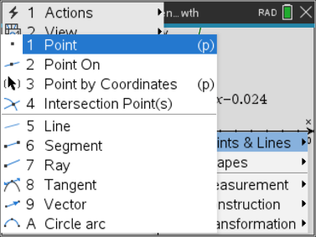
The calculator draws the tangent line, displays the equation of the line, and displays the coordinates of the point of tangency. Record the x-value, y-value $\left(f(x)\right)$, and the slope of the tangent line.
- x: ________________

- $f(x)$: ________________

- slope of tangent: ________________
- How does the slope of the tangent line at this point compare to the value of the function, $f(x)$?

Press tab and the up arrow once. Change the value of b to a nonnegative number of your choice and graph the new function. The tangent line and coordinates of the point of tangency will remain on the graph of $f(x)$.
Record the values of b, x, $f(x)$, and the slope of the tangent line at x in the table below along with your earlier observations.
b | x | f(x) | slope of tangent at x
2
3

Press tab and the up arrow and change the value of b again. Observe the tangent line for each curve and record your results in the table.
- Write at least two observations about the graph and/or the slope of its tangent at T.

Problem 3 – Euler’s Number
Slope is a measure of rate of change in a function. In this example, sometimes the slope is less than y, and sometimes it is greater than y. There is only one value of b for which the rate of change of the function y = b^{x} at any point is equal to the value of the function itself. Can you find an approximate value of this number?  When the rate of change of y = b^{x} is equal to the value of the function, the ratio will equal one.
  b
  2
  3
To begin the search for this value of b, use the data you have collected to complete the table.
Value of b that is closest to 1 and greater than 1: _____
Value of b that is closest to 1 and less than 1: ______
The value of b we are looking for must be between these two.
Choose some values of b that are between two numbers and repeat the process of graphing the function, drawing a tangent line, recording the value of the function and the slope of the tangent line at that point, and calculating the ratio. Narrow in on the value of b that yields a ratio of 1 as closely as you can.
b | x | f(x) | slope of tangent at x

What is this value of b? b ≈ _________
Applications
The number you found is an approximation for the mathematical constant e. As you discovered, it is unique in that it is the only value of b such that y = b^{x} changes at a rate that is equal to the value of the function itself. It also shows up in a number of functions that model natural phenomena.
Some examples are:
(a) the growth of populations of people, animals, and bacteria;
(b) the value of a bank account in which interest is compounded continuously;
(c) and radioactive decay.
The common feature is that the rate of growth or decay is proportional to the size of the population, account balance, or mass of radioactive material. Growth and decay situations can be modeled by equations of the form P = P₀e^{kt}, where P is the current amount or population, P₀ is the initial amount, t is time, and k is a growth constant. An amount is growing if k > 0 and declining if k < 0.
The following are examples of exponential growth or decay. For each exercise, write an equation to represent the situation and solve your equation to find the answer.
- Suppose you invest $1,000 in a CD that is compounded continuously at the rate of 5% annually. (Compounded continuously means that the investment is always growing rather than increasing in discrete steps.) What is the value of this investment after one year?
Two years? Five years?

- A colony of bacteria is growing at a rate of 50% per hour. What is the approximate population of the colony after one day if the initial population was 500?

- Suppose a glacier is melting proportionately to its volume at the rate of 15% per year. Approximately what percent of the glacier is left after ten years if the initial volume is one million cubic meters? (This is an example of exponential decay.)

4. A snowball is rolling down a snow covered hill. Suppose that at any time while it is rolling down the hill, its weight is increasing proportionately to its weight at a rate of 10% per second. What is its weight after 10 seconds if its weight initially was 2 pounds? After 20 seconds? After 45 seconds? After 1 minute? What limitations might exist on this problem?

