PROJECT OVERVIEW: Building Paper Bridges
In this project, you and your group will collect data to explore the relationship between force, mass and acceleration due to gravity, g. In the context of the challenge, you will be engaged in a competition to determine which group can build the strongest bridge, and then predict and verify a model for the system prior to making any measurements on the system. Finally, we will collect the data and determine how well your model fits the outcome you observe.
PROJECT OUTLINE:
The goal:
The goal here is to explore two things: First, which group can build the strongest bridge while following the guidelines and then to verify that the model that you predict for relating mass and force makes sense. The intent is for your group to model the system prior to building or taking measurements. You should think about what kind of data you are collecting, how increasing the mass in the cup will show up in the force measurements and how the two are related. The coolest part – the slope and y-intercept will have real physical meaning.
The challenge:
Build the strongest bridge possible using only one sheet of paper. You may use only a single sheet of paper to fold the strongest bridge you can following the guidelines.
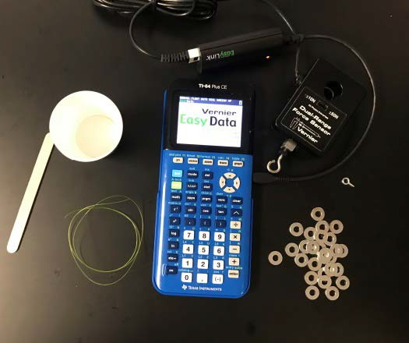
Materials list (per group):
- 1 – 8.5”X11” sheet of paper
- 1 sheet of graph paper
- 20 identical washers (or other small weights)
- 1 – popsicle stick
- 12” to 24” of string or fishing line
- 1 – ½” screw eye
- 1 – small paper cup
- 1 – Vernier Dual Range Force sensor (in 10 N mode)
- 1 – Vernier EasyLink™ adapter

Rules for building your bridge:
- You must span a gap of 8”;
- You have 1 sheet of 8.5”X11” paper and no other materials (no tape, no glue, etc.);
- Your bridge must have a “guardrail” that is at least 0.5” high on both sides;
- You have one “car” represented by the popsicle stick;
- The “car” is at the very middle of the bridge while data is collected;
- The screw eye goes through the bridge and attaches to the “car” and the force sensor hangs from the screw eye;
- Secure the cord for the force sensor so it doesn’t interfere with the data collection.

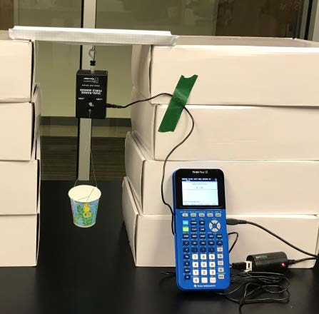
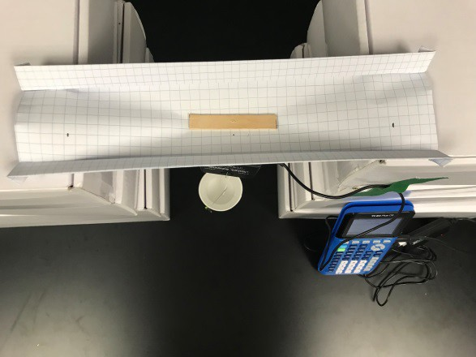

Think it through and build a mathematical model:
Decide what type of relationship you expect to see between the force measured and the number of washers in the cup (linear, quadratic, inverse?). On the piece of graph paper, write down a generic equation to model this relationship and sketch the graph you expect to see from your data.
Ready for Data Collection:
Once you have a model you think will work, begin collecting data. First, you should determine, using a balance, the mass (in kg) of the force sensor and empty cup. You should also measure and record the mass (in kg) of a single washer. How do you expect to see this information turn up in your data?
Setting up EasyData App:
With the setup as pictured above, plug the sensor into the TI-84 calculator using an EasyLink™ cord. The EasyData app will open and you will need to setup the force sensor by selecting Setup, and then choosing 4. Selected Events.
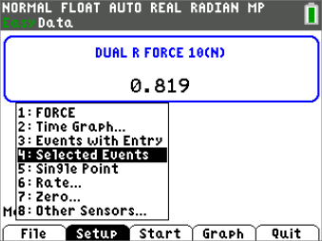
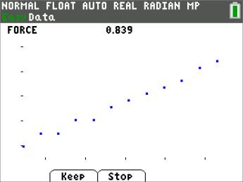
Data Collection:
For data collection, select Start, and then select Keep to store a data point. You should start with one washer in the cup and take that data point. Then add washers one at a time, taking a data point with each new washer, until you run out of washers or the bridge breaks.
Interpreting the Data:
From EasyData, the data will be stored in L1 and L2, (number of washers and force in newtons, respectively.) Create a scatterplot of force vs. number of washers and discuss whether the model you wrote fits the relationship you see in their data. Using the regression capability of your calculator, make a linear regression model using L1 as the independent variable, and L2 as the dependent variable.

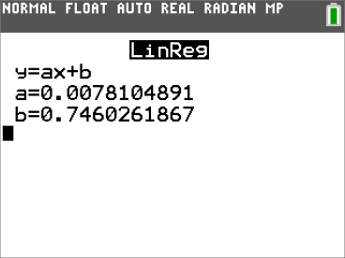
Remember to write down the values for a and b you get from the regression analysis.
- What is the value of the slope? What does it represent?
- What about the y-intercept? What does it represent?
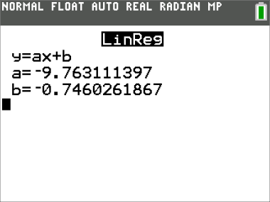
Fun Physics Extension
Instead of graphing newtons vs. washers, multiply the number of washers in L1 by the mass in kg of a single washer and store in L3. Then multiply the force from L2 by negative 1 since the force is in a downward direction, and store those values in L4. Then plot a new plot of inv_force vs. “kg in the car” (L3, L4).
Answer the following questions:
- What does the slope of this relationship (kg, newtons) represent? Could you have guessed it?
- Compare the y-intercept to the first model. Why do you think that happens?
Extension # 2: Changing Variables
As a challenge, change different factors in the setup and see how that impacts the outcome. Possible things to change:
- Length of the span
- Length of the popsicle stick

- Size of the washers
- Sheets of paper
- Different types of paper
- Height of the “guardrail”

