Activity Overview

Students will explore higher order derivatives, including being able to inspect a graph and give the intervals for concave up and concave down and find the point of inflection.

Topic: Derivatives of Higher Order
- Use the rules for differentiation to compute the higher order derivatives of differentiable functions.
- Interpret the second derivative of a function as the rate of change of the slope of its graph.
- Graph a function and identify the intervals in which f ″(x) > 0, f ″(x) < 0, and f ″(x) = 0.

Teacher Preparation and Notes
- This investigation uses nested derivatives. The students should be familiar with keystrokes for the derivative command. The student should also be able to graph functions and enter the tangent line.
- The calculator should be in radian mode before the trigonometric derivatives are taken.
- This activity is designed to be student-centered with the teacher acting as a facilitator while students work cooperatively. The student worksheet is intended to guide students through the main ideas of the activity and provide a place to record their observations.
- The ideas contained in the following pages are intended to provide a framework as to how the activity will progress. Suggestions are also provided to help ensure that the objectives for this activity are met.

Associated Materials
- HigherOrderDerivatives_Student.doc
- HigherOrderDerivatives.tns
- HigherOrderDerivatives_Soln.tns

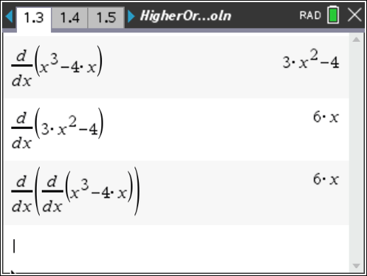
Problem 1 – The second derivative of functions
Students should open page 1.3 and find the second derivative of y = x³ – 4x, using the Derivative command (MENU > Calculus > Derivative) by finding the first derivative and then taking the derivative of that.
Then students can form a nested derivative command to obtain the second derivative. Students should see that the handheld is taking the derivative of the function and then taking the derivative of the result. This is the same procedure as done above and has the same result.
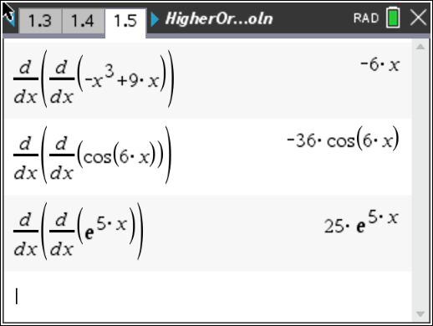
Open page 1.5 and allow students to find the second derivative of the following functions.
- g ( x ) = –x³ + 9x → g′ ( x ) = –3x² + 9 → g ′′ ( x ) = –6x
- h ( x ) = cos(6x) → h′ ( x ) = –6 sin(6x)
→ h ′′ ( x ) = –36 cos(6x)
- j ( x ) = e^{5x} → j ′ ( x ) = 5e^{5x} → j′′ ( x ) = 25e^{5x}

- k( x ) =
1
(x² − 1)

= (x² – 1)^{–1}

→ k′ ( x ) = –1 (x² – 1)^{–2}(2x)

d ⎛ −2x
⎞ 2(3x² + 1)

→ k ′′ ( x ) = ⎜ ⎟ =
dx ⎜ (x² − 1)2 ⎟
⎝ ⎠

Problem 2 – Concavity

(x² − 1)3

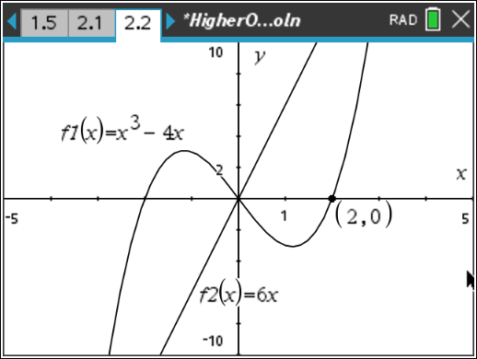
On page 2.2, have students graph the function f(x) = x³ – 4x. If they were to draw a line segment between two points in the section to the left of the
y-axis, the line segment would be below the curve. If they draw a line segment between two points in the section to the right, the line segment would be above the curve.

Students should notice that a function f is concave up when f ′′(x) > 0 and concave down when f ′′(x) < 0.
For this function, the second derivative is positive for x > 0. The second derivative is negative for x < 0.
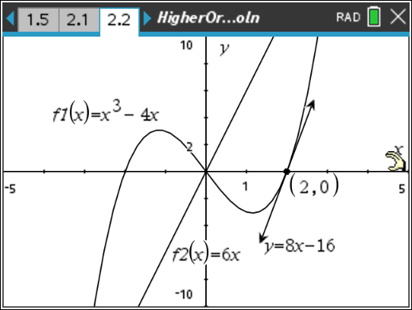
Students should use the Tangent tool to find the equation of the tangent line at a specific x-value. Place the tangent line anywhere on the graph. Then use the Coordinates and Equations tool to show the equation of the line and the coordinates of the point. Students can then edit the x-value of the coordinate to move the tangent line.

 | Equation of Tangent
x = –2 | y = 8x +16
x = –1 | y = –x + 2
x = –0.5 | y = –3.25x + 0.25
x = 0.5 | y = –3.25x – 0.25
x = 1 | y = –x –2
x = 2 | y = 8x – 16

Students should see that as x gets larger, the slope decreases and then increases. The negative x-values are in the concave down section.
The values of the slope increase as x moves to the right. Thus, these points are in the section where the function is concave up.

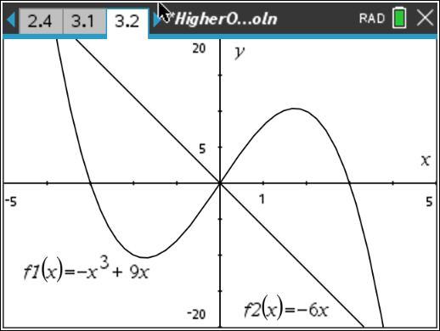
Problem 3 – Concavity for other functions
On page 3.2, students should graph the function
g(x) = -x³ + 9x and its second derivative g″(x) = -6x. Students should describe the following about the graph: It is concave up for x < 0
It is concave down for x > 0
There is a point of inflection at x = 0.

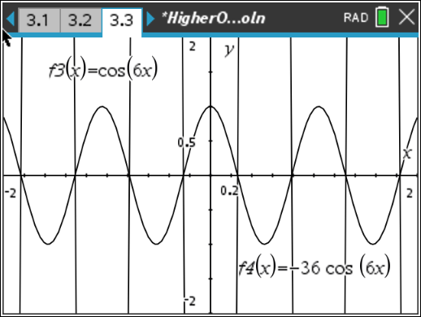
On page 3.3, students should graph both
h(x) = cos(6x) and its second derivative.
Encourage the students to change the window so they can see what is happening. The graph of
h(x) = cos(6x) is periodic with a period of π .
3

The function is concave down in the intervals ⎡ −π , π ⎤ and ⎡π , 5π ⎤ , however there are more
⎢⎣ 12 12 ⎥⎦ ⎢⎣ 4 12 ⎥⎦
such intervals. The function is concave up in the interval ⎡ π , π ⎤ and other intervals. There are

multiple points of inflection at
⎢⎣12 4 ⎥⎦
π ± n ⋅ π . Remind students that when we have periodic
12 6

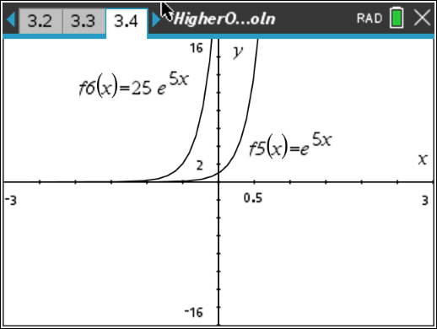
functions, there will be multiple intervals for concavity. Students will graph both j(x) = e^{5x} and j″(x) = 25e^{5x}.
They should see that the second derivative is always positive and thus the function is always concave up. There is no point of inflection since there is no change in concavity.

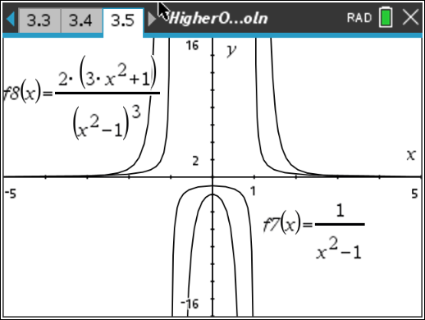

Students are to graph both k (x) =
derivative on page 3.5.
1

x² − 1
and its second

Students should see that the function is concave up in (–∞, –1) ∪ (1, ∞) and concave down in (–1, 1).
There is no point of inflection because the function is not defined at x = –1 or at x = 1. The function does change concavity at the asymptotes but since the function is not defined there, there is no point of inflection.

