Student Worksheet for G.G. 39

After turning on your handheld press  | Select CabriJr.  
scroll down to Open |  scroll to RHOMBUS  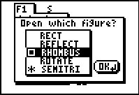
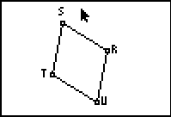 | Investigate the figure using the following instructions and then answer the questions below.

- Find the measures of the sides of the figure.
- Select, grab and drag the vertices.
- What conclusion can you draw from this investigation? ________________________________________________________
- Complete the following statement: If a quadrilateral is a rhombus then all ________ are equal in length.
- Is the converse true? _____________________
Reload RHOMBUS
scroll down to Open | scroll to RHOMBUS
 | 

- Find the measures of the four angles of the figure.
- Select, grab and drag the vertices.
- From this investigation what conclusion can you draw concerning the opposite angles? ______________________________________________
- From this investigation what conclusion can you draw concerning the consecutive angles ? ______________________________________________
- Find the sum of all four angles for any of the quadrilaterals you created. ______

Reload RHOMBUS
scroll down to Open | scroll to RHOMBUS

- Draw segments RT and SU. These are the diagonals of the rhombus.
Find the point of intersection of the diagonals.  scroll to Point Intersection  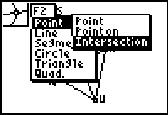 | Move cursor near the point of intersection. When both diagonals become “active” press  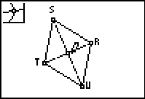

Label the point of Intersection X  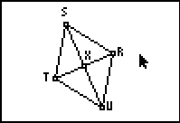 | Save as RDIAG  scroll to Save as …
Delete RHOMBUS and type RDIAG

- Find the measures of , ,,
- Drag any vertex. What conclusion can you draw concerning the diagonals of a rhombus? _______________________________________________________
- Open RDIAG
- Find the measure of segments TX and XR.
- Find the measure of segments SX and XU.
- Drag any vertex. What conclusion can you draw concerning the diagonals of a rhombus? _______________________________________________________
- What kind of triangles are formed by the intersection of the diagonals and the sides of the rhombus? __________________________

