Math Objectives  - Students will further discuss the idea of transformations and compare a transformed function to its parent function $\left(x^{2} and x^{3}\right)$, both graphically and algebraically.  - Students will discuss the difference between vertical and horizontal stretches and compressions.  - Students will try to make a connection with how to understand these topics in IB Mathematics courses and on their final assessments.  Vocabulary  - Translation • Dilation • Compression  - Stretch • Reflection  About the Lesson  - This lesson is aligning with the curriculum of IB Mathematics Applications and Interpretations HL and IB Mathematics Approaches and Analysis SL/HL  - This falls under the IB Mathematics Content Topic 2 Functions:  2.8 (AI HL only) and 2.11 (AA SL/HL):  (a) Translations $y=f\left(x\right)+b$; $y=f(x-a)$  (b) Reflections: in the x-axis $y= -f(x)$; in the y-axis $y=f(-x)$  (c) Vertical stretch with a scale factor p: $y=pf(x)$  (d) Horizontal stretch with a scale factor $\frac{1}{q}$: $y=f(qx)$  (e) Composite Transformations  As a result, students will:  - Apply this information to real world situations.  TI-Nspire™ Navigator™  - Transfer a File.  - Use Class Capture to examine patterns that emerge.  - Use Live Presenter to demonstrate.  - Use Teacher Edition computer software to review student documents.  - Use Quick Poll to assess students’ understanding  .  Activity Materials  Compatible TI Technologies: TI-Nspire™ CX Handhelds,  TI-Nspire™ Apps for iPad®, TI-Nspire™ Software | 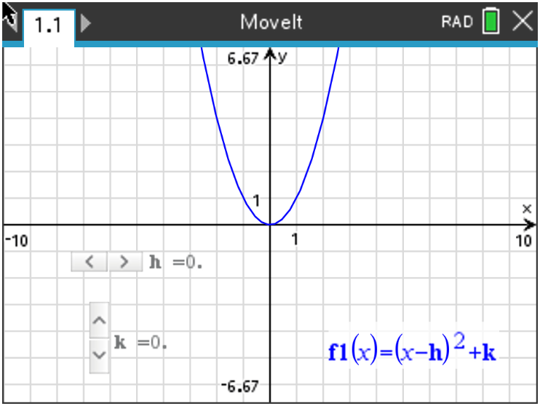  Tech Tips:  - This activity includes screen captures taken from the TI-Nspire CX II handheld. It is also appropriate for use with the TI-Nspire family of products including TI-Nspire software and TI-Nspire App. Slight variations to these directions may be required if using other technologies besides the handheld.  - Watch for additional Tech Tips throughout the activity for the specific technology you are using.  - Access free tutorials at http://education.ti.com/calculators/pd/US/Online-Learning/Tutorials  Lesson Files:  Student Activity  Just Move It_Student-Nspire.pdf  Just Move It_Student-Nspire.doc  MoveIt.tns
In this activity, the movements of the parent functions $f\left(x\right)= x^{2}$ and $f\left(x\right)= x^{3}$will be explored. You will be using the program MoveIt.tns, downloaded on or sent to your handheld by your teacher. On page 1.1 you will see the graph of the parent function $f\left(x\right)= x^{2}$ and on page 2.1 you will see the graph of the parent function $f\left(x\right)= x^{3}$. For each problem in this activity, you will use the sliders on each page to translate both types of functions. Simply press the slider to shift your function according to each problem.

Teacher Tip: This activity can be done without the MoveIt.tns file. Your students can simply type in the function $f1\left(x\right)= {\left(x-h\right)}^{2}+k$ and create their own sliders to use. You can show your students how to adjust the settings of the sliders by pressing ctrl, menu, settings. To add the second parent function, have the students add a new problem and not a new page so they can repeat the use of the same slider parameters (h, k).

Problem 1 – $f\left(x\right)→f(x-h)$
Use the horizontal slider to change the value of h only. Leave k = 0. You will need to first determine the value of h in each question.

Let’s see what you remember about transforming $f\left(x\right)→f(x-h)$:
In questions 1 and 2, describe the transformation for each graph as compared to the graph of the parent function $f(x)$, use your handheld to verify your answer.
1. $f(x-2)$ Solution: Horizontal translation to the right 2 units.

2. $f(x+5)$ Solution: Horizontal translation to the left 5 units.
3. In general, describe the transformation of $f\left(x\right)→f(x-h)$ and explain your reasoning.
Possible Explanation: When the transformation of the function is affecting the input values, the resulting transformation is a horizontal translation to the left $(negative h)$ or to the right $(positive h)$.

Teacher Tip: Teachers may use different words/language to describe these transformations. Please use your judgment with the expectations of what verbiage you will require from your students when it each transformation.

Problem 2 – $f\left(x\right)→f\left(x\right)+k$

Use the vertical slider to change the value of k only. Leave h = 0.

Let’s see what you remember about transforming $f\left(x\right)→f\left(x\right)+k$:
In questions 4 and 5, describe the transformation for each graph as compared to the graph of the
parent function $f(x)$, use your handheld to verify your answer.

4. The graph of $f\left(x\right)+4$ Solution: Vertical translation up 4 units.

5. The graph of $f\left(x\right)-3$ Solution: Vertical translation down 3 units.

6. In general, describe the transformation of $f\left(x\right)→f\left(x\right)+k$ and explain your reasoning.
Possible Explanation: When the transformation of the function is affecting the output values, the resulting transformation is a vertical translation up $\left(positive k\right)$ or down $\left(negative k\right)$.

Problem 3 – $f\left(x\right)= {(x-h)}^{2}+k$

7. Describe the transformations of $f\left(x-7\right)+6$ as compared to the parent function $f(x)$.

Solution: The quadratic has been horizontally translated to the right 7 units and vertically
translated up 6 units.

8. In general, describe the transformations of $f\left(x\right)= {(x-h)}^{2}+k$ when:

b and c are both positive Possible Explanation: right b units and up c units

b and c are both negative Possible Explanation: left b units and down c units

b is positive and c is negative Possible Explanation: right b units and down c units

b is negative and c is positive Possible Explanation: left b units and up c units

Teacher Tip: Some discussion time will be needed to explain that a positive b will look like (x – b) and that negative b will look like (x + b).

Problem 4 – $f\left(x\right)→af(x)$

In order to transform your function through the multiplication of a, go to pages 3.1 and 4.1. Press the sliders to explore how a transforms the graph.

9. Describe the transformation of $0.5f(x)$ as compared to the parent function $f(x)$.

Solution: This is a vertical compression by a factor of 0.5.

With a classmate, create a table of values comparing the y-values for given x-values for the functions $f\left(x\right)= x^{2}$ and $f\left(x\right)=0.5x^{2}$. For example, when x = 2, the corresponding values for the functions are 4 and 2 respectively. In other words, the y-values are “pushed lower” as a result of multiplying by 0.5. This is known as a _____vertical compression________________.

10. Describe the transformation of $2f(x)$ as compared to the parent function $f(x)$.

Solution: This is a vertical stretch by a factor of 2.

11. In general, describe the transformation when $0< \left|a\right|<1$ for the graph of $af\left(x\right)$ as compared to
the parent function $f(x)$.

Solution: A vertical compression by a factor of $\left|a\right|$.

12. In general, describe the transformation when $\left|a\right|>1$ for the graph of $af(x)$ as compared to the
parent function $f(x)$.

Solution: A vertical stretch by a factor of $\left|a\right|$.

13. Change the coefficient of the quadratic and cubic functions to -0.5 and then to -2. Describe the
graph of $af\left(x\right)$ when a is negative as compared to when a is positive.

Solution: The function is now reflected over the x-axis.

Problem 5 – $f\left(x\right)→f(ax)$

In order to transform your function through the multiplication of a, go to pages 5.1 and 6.1. Press the sliders to explore how a transforms the graph.

14. Describe the transformation of $f(2x)$ as compared to the parent function $f(x)$.

Solution: Horizontal compression by a factor of $\frac{1}{2}$.

With a classmate, create a table of values comparing the y-values for given x-values for the functions $f\left(x\right)= x^{2}$ and $f\left(x\right)=(2{x)}^{2}$. For example, when x = 2, the corresponding values for the functions are 4 and 16 respectively. In other words, instead of it taking x = 4 to get y = 16, it took x = 2 to get y = 16, therefore x-values are “pushed lower” as a result of multiplying the x-value by 2 or the x-value was halved. This is known as a ___horizontal compression____________.

15. Describe the transformation of $f(0.5x)$ as compared to the parent function $f(x)$.

Solution: Horizontal stretch by a factor of 2.

16. In general, describe the transformation when $0< \left|a\right|<1$ for the graph of $f\left(ax\right)$ as compared to
the parent function $f(x)$.

Solution: Horizontal compression by a factor of $\frac{1}{\left|a\right|}$.

17. In general, describe the transformation when $\left|a\right|>1$ for the graph of $f(ax)$ as compared to the
parent function $f(x)$.
Solution: Horizontal stretch by a factor of $\frac{1}{\left|a\right|}$.

18. Change the sign of the value being multiplied by x for the quadratic and cubic functions to -0.5
and then to -2. Describe the graph of $af\left(x\right)$ when a is negative as compared to when a is
positive.

Solution: The function is now reflected over the y-axis.

Further IB Applications

The following diagram shows the graph of the function $y=f(x)$, for $-5≤x ≤4$. The points (-5, 4) and (0, 3) both lie on the graph of $f$. There is a minimum at point (-2, -1).

$g(x)$

Let $g\left(x\right)= -f\left(x-3\right)+2$.

(a) Write down the domain of $f$. Solution: $-5≤x ≤4 or \left[-5, 4\right]$

(b) Write down the range of $g$. Solution: $-2 ≤y≤3 or \left[-2, 3\right]$

(c) On the graph above, sketch the graph of $g$. Solution: See graph above.

Let $h\left(x\right)=f(-3x)$.

(d) Describe the transformations of $h\left(x\right)$ as compared to $f(x)$.

Solution: The function has been reflected over the y-axis and horizontally compressed by a
factor of $\frac{1}{3}$.

TI-Nspire Navigator Opportunity: Quick Poll (Open Response)
Any part to any Problem in the activity would be a great way to quickly assess your student’s understanding of Transformations.

Teacher Tip: Please know that in this activity there is a lot of time dedicated to students talking with one another and sharing their thoughts with the class. The goal here is to not only review transformations of functions, but also to generate discussion.

**Note: This activity has been developed independently by Texas Instruments and aligned with the IB Mathematics curriculum, but is not endorsed by IB™. IB is a registered trademark owned by the International Baccalaureate Organization.

