In this activity, students discover the change of base rule for logarithms by examining the ratio of two logarithmic functions with different bases. It begins with a review of the definition of a logarithmic function, as students are challenged to guess the base of two basic logarithmic functions from their graphs. The goal of applying the properties of logarithms to add these two functions is introduced as a motivator for writing them in the same base. Students explore the hypothesis that the two functions are related by a constant first by viewing a table of values, then by exploring different values for the two bases. Finally, they prove the change of base rule algebraically and apply it to find the sum of the two original functions. | 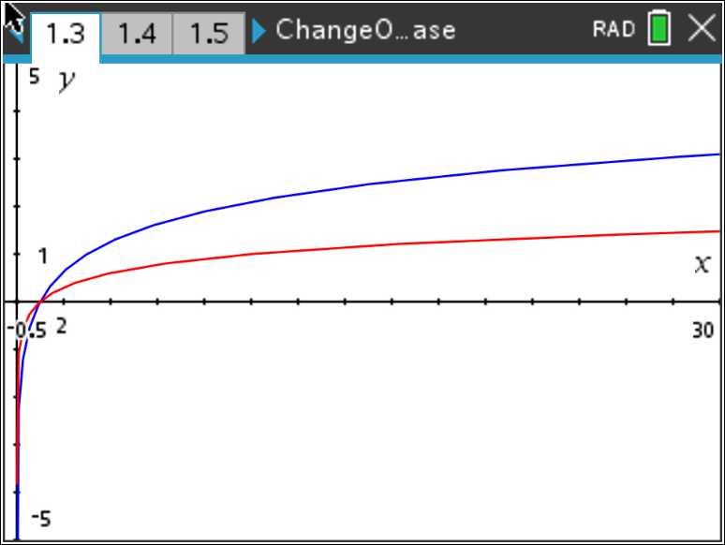
Problem 1 – Relating log functions with different bases
Open the file ChangeOfBase.tns. Move to page 1.3, you will see the graphs of two logarithmic functions with different bases:
$f1\left(x\right)= \log_{a}{(x)}$ and $f2\left(x\right)= \log_{b}{(x)}$.
- What are a and b? Trace the graphs to find out.

- What points on the graph are the best clues to the base of the logarithmic function?

Suppose we are interested in the sum of these two functions,
$\left(f1+f2\right)\left(x\right)= \log_{a}\left(x\right)+ \log_{b}{(x)}$.
How could we write this as a single logarithmic expression?
- We can’t apply the properties of logarithms unless the logarithms have the same base.
- We need to rewrite the functions with the same base.
- This means we want to find a function that is equal to $f1$, but has a log base b instead of log base a.
Maybe there is a constant c that could relate the two functions, like: $c∙f1\left(x\right)=f2(x)$. Then, we would have $f1\left(x\right)= \frac{f2(x)}{c}= \frac{1}{c}∙\log_{b}{(x)}$, which is a logarithmic function with base b.
We can’t be sure there is such a constant, but that doesn’t have to stop us from looking for one.
- Solve $c∙f1\left(x\right)=f2(x)$ for c and enter the result in $f3(x)$ on page 1.3 by pressing tab. What is c? Press ctrl T to view a function table to see.

Problem 2 – A closer look at c
Is c always the same? Enter two new values of a and b in the gray cells on page 2.2. The value of c is calculated for you. Is it the same as in Problem 1? Record your results in the table below. Be sure to try some values of a and b such that one is a power of the other, like 2 and 8 or 3 and 9.
- Can you guess a formula for c?
a | f1(x) | b | f2(x) | c

Formula:

Problem 3 – Deriving the Change of Base Rule algebraically

We are convinced now that there is a constant that relates $\log_{a}{(x)}$ to $\log_{b}{(x)}$ and that the constant depends on the values of a and b. We may even have an idea what the constant is. Time to use some algebra to find out for sure.
Two functions are equal if and only if their values are equal for every x-value in their domain. Let’s pick a point (x, y) on the graph of $f1\left(x\right).$ For this (x, y), $\log_{a}\left(x\right)=y$. If we can write y in terms of logs base b, we will have our function.
- Rewrite $\log_{a}\left(x\right)=y$ as an exponential function.

- We want an expression with base b log, so take log_{b} of both sides.

- Simplify using the properties of logs. Solve for y.

- What is c?

Check your equation for c against the value of c that you collected earlier. Enter it in the formula bar of Column D on page 2.2. When prompted, choose Column Reference, not Variable, for a and b.

- Is the equation correct? Explain.

You have found a formula for changing the base of a logarithm. To change a log base a expression to log base b, simply divide the expression by $\log_{a}{(b)}$. This can be written as
$\log_{a}{(x)}= \frac{\log_{b}{(x)}}{\log_{b}{(a)}}$.
- Use this formula to find $(f1+f2)(x)$ if $f1\left(x\right)= \log_{3}{(x)}$ and $f2\left(x\right)= \log_{10}{(x)}$.

Problem 4 – Further practice with the Change of Base Rule

- Use the Change of Base Rule to simplify the expression: $\frac{1}{4}\log_{9}{27}$.

- The function $f$ is given by $f\left(x\right)= \log_{4}{(x)}$. Without a handheld, use the Change of Base Rule to evaluate $f(8)$.

- If $f\left(x\right)= \log_{8}{x}$ and $g\left(x\right)= \log_{64}{x}$, given that the input values into each function are equal, describe the relationship between the output values of $f\left(x\right)$ and $g(x)$.

