Problem 1 – Match the graph, Part 1
The vertex form for the equation of a parabola is y = a(x – h)² + k.
- In vertex form or in standard form, what happens when 0 < a < 1?

- If a > 1, the graph will be narrow and open up. If a < –1, the graph will be what?

On page 1.5, you will see a parabola and a scatter plot. Your task is to grab and drag the parabola to match the shape of the data points. There are two ways to do this. First, if you move your cursor near the vertex of the parabola, the cursor changes to look like a plus sign (ö). When you press and hold the Click key (x), you can then move the vertex of the parabola using the TouchPad. The other way is to stretch or shrink the parabola. To do this, move your cursor over the parabola not near the vertex. The cursor will change to look like an X (õ). Press and hold the Click key and then move the cursor around using the TouchPad. When you have moved the vertex to where you want, press the Click key again.
- What is the vertex of the parabola?

- What was your value of a for the parabola?

- What is the equation of the parabola you fit to the data on page 1.5?

Problem 2 – Match the Graph, Part 2
On page 2.1, you will see another parabola and a new set of data. Repeat the process from Problem 1 to find the equation of a parabola that matches the data.
- To make the parabola open down, what must be true about the value of a?

- To make the parabola wide, what must be true about the value of a?

- What is the equation of your parabola on page 2.1?

Problem 3 – Match the Double Arches
Once again, on page 3.1, you are to match the parabola to the set of data points. There are two parabolas on this page. One is already done for you.
- What do you notice about the two parabolas that formed the double arches?

- The vertex of the left arch is (–2, 5.5). What is the vertex of the right arch?

- What is the equation of your parabola?

Problem 4 – The Main Cables of a Suspension Bridge
On page 4.1, you will see a picture of a suspension bridge. Several loops of cable are represented here. On the pages 4.2 and 4.3, you will be matching an equation to a particular piece of the graph.
- What is the equation of the piece of the graph labeled A?

- What is the equation of the piece of the graph labeled B?

Extensions/Homework – The St. Louis Arch
The St. Louis Arch, the “Gateway” to America, is a shape that looks like a parabola to the casual observer.  - Use what you know about the vertex form to write an equation to match its shape and dimensions. The dimensions are given in feet on page 5.2. | 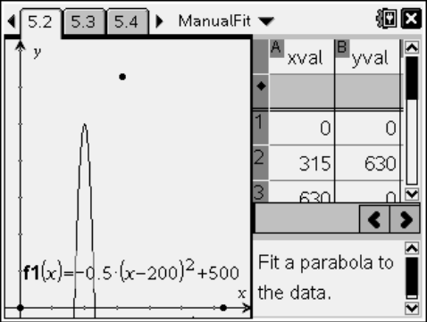
Using the same data, match the graph in standard form by dragging the parabola. Important things to remember are; what does the value of a do to the graph, and what would your y-intercept be (c in the equation)?  - What is your equation in standard form? | 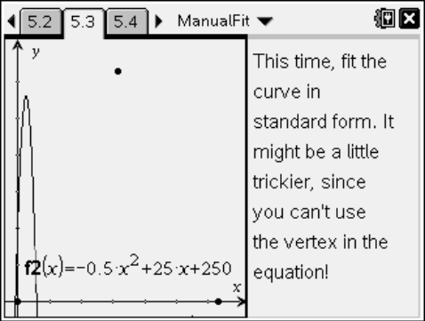
- How are the two equations similar?

- How are the two equations different?

- Expand the vertex form and convert it to standard form to make a final comparison:

Extensions/Homework – Other Arches
- Hang a chain (or necklace) against a piece of graph paper and trace its graph (or take a digital photo). Write an equation in vertex form to match the shape of the curve.

- Place a laminated piece of graph paper behind a drinking fountain and take a digital photo. Write an equation to match the shape of the curve.

